

**ENTERPRISE WEB SOFTWARE DEVELOPMENT**

**COMP1640**

**Group Report**

|  |
| --- |
| **Name** |
| *Vu Hoang Ha* |
| *Mai Van Duc* |
| *Phan Bao Hoang* |
| *Nguyen Van Duc* |
| Usman Ibrahim |

**Team Members**

***Lecturer***

*Nguyen Dinh Tran Long*

|  |
| --- |
| **ID** |
| *001248974* |
| *001248944* |
| *001251043* |
| *001249270* |
| 001251008 |

|  |
| --- |
| **Email** |
| *vh2420h@gre.ac.uk* |
| *md5515p@gre.ac.uk* |
| *ph1578k@gre.ac.uk* |
| *nd1849d@gre.ac.uk* |
| ui2948n@gre.ac.uk |

**Table of Contents**

1 Information of Management System Collect Ideas 7

2 Introduction 8

3 Requirement 8

3.1 Functional 8

3.1.1 Admin 8

3.1.2 Staff 8

3.1.3 Quality Assurance Manager 8

3.1.4 Quality Assurance Coordinator 9

3.2 Use case diagram 9

3.2.1 Admin 9

3.2.2 Staff 10

3.2.3 QA manager 11

3.2.4 Quality Assurance Coordinator 11

4 Database 12

4.1 ERD 12

4.2 Data security 13

4.3 Data validation 14

4.4 Database normalization 14

1.1.1 Define 14

1.1.2 Rules 15

5 Design 18

5.1 Sitemap 18

5.2 Wireframes 18

6 Implementation 27

6.1 Techniques 27

6.1.1 Wireframe design tool 27

6.1.2 Front-end 27

6.1.3 Back-end 29

6.2 Features 30

6.2.1 System flow 30

6.2.2 Back end 30

6.2.3 Front end 34

6.3 Flowcharts 48

6.4 Activity diagram 54

7 Interface (screenshots) 55

8 Testing 69

8.1 Test Plan 69

8.1.1 Scope 69

8.1.2 Quality Objectives 69

8.1.3 Test Approach 69

8.1.4 Roles and Responsiblities 69

8.1.5 Test Strategy 70

8.1.6 Resource And Environment Needs 71

8.2 Test case 72

8.3 Test log 74

9 Agile 82

9.1 Product backlog and User story 83

9.2 Sprints backlog 84

9.2.1 Sprint 1 84

9.2.2 Sprint 2 86

9.2.3 Sprint 3 88

9.2.4 Sprint 4 90

9.2.5 Sprint 5 92

9.3 Team challenges 94

9.4 Meeting minutes 95

9.4.1 Meeting 1 95

9.4.2 Meeting 2 96

9.4.3 Meeting 3 97

9.4.4 Meeting 4 98

9.4.5 Meeting 5 99

9.4.6 Meeting 6 100

9.4.7 Meeting 7 101

10 Conclusion 102

11 References 103

**List of Figures**

Figure 1. Use Case Admin 9

Figure 2. Use Case Staff 10

Figure 3.QA Manager Use Case Diagram 11

Figure 4. Quality Assurance Coordinator 11

Figure 5. ERD 12

Figure 6. Login website 14

Figure 7. Data 14

Figure 8. First normal form 15

Figure 9. Second normal form 16

Figure 10. Third normal form 17

Figure 11. Site map of Idea Collect System 18

Figure 12. Wireframe-Login 18

Figure 13. Wireframe-Change password 19

Figure 14. Wireframe-Create New Idea 19

Figure 15. Wireframe-Staff homepage 20

Figure 16. Wireframe-Idea post detail page 21

Figure 17. Wireframe-Admins create account 22

Figure 18. Wireframe-Admin creates deadline 22

Figure 19. Wireframe-Admin edit account 23

Figure 20. Wireframe-Document download page with zip and CSV formats for manager 23

Figure 21. Wireframe-Manager's homepage 24

Figure 22. Wireframe-Add a category of ideas for managers 25

Figure 23. Wireframe-Manager Dashboard 26

Figure 24. Drawio 27

Figure 25. Display code ReactJS by VSCode 28

Figure 26. ReactJS file organization 28

Figure 27. Material UI of ReactJS 29

Figure 28. Code directory structure 29

Figure 29 Create new idea 37

Figure 30 Idea Reducer 38

Figure 31 Comment reducer 44

Figure 32. Activity diagram 54

Figure 33. Login 55

Figure 34. Change Password 56

Figure 35. Admins create user account 57

Figure 36. Admin creates deadline 58

Figure 37. Admin edit user account 59

Figure 38. Staff homepage 60

Figure 39. Staff posted ideas 61

Figure 40. Before posting the idea, the terms and conditions will be popup 62

Figure 41. Post details 63

Figure 42. Comment 64

Figure 43. Manager's homepage 65

Figure 44. Managers create the topic 66

Figure 45. File download manager 67

Figure 46. Manager dashboard page 68

**List of Table**

Table 1. Roles of team members 7

Table 2. Account Information 7

Table 3. Test case 73

Table 4. Test log 81

**List of Code**

Code 1. Back-end create idea 30

Code 2. Update category 30

Code 3. Back end Delete category 31

Code 4. Notify email about reaction and comment 31

Code 5. Back-end update user 32

Code 6. Back-end change password 32

Code 7. Back-end delete user 33

Code 8. Back-end create user 33

Code 9. Login 34

Code 10. Set role 34

Code 11. Load user 35

Code 12. AuthReducer 36

Code 13. Post Reaction 40

Code 14. Like 41

Code 15. Dislike 42

Code 16. Comment 43

Code 17. Create topic 43

Code 18. Topic reducer 45

Code 19. Update topic 46

**Table of Flowchart**

Flowchart 1. Login 48

Flowchart 2. Log out 49

Flowchart 3. Change password 50

Flowchart 4. Admin 51

Flowchart 5. Staff 52

Flowchart 6. Set date for post idea and comment 53

# Information of Management System Collect Ideas

|  |  |
| --- | --- |
| Team Members | |
|  | |
| Name | **Role** |
| Vu Hoang Ha | Scrum master, Database, Tester |
| Nguyen Van Duc | Backend, Database |
| Phan Bao Hoang | Fontend |
| Mai Van Duc | Design interface, Tester |
| Usman Ibrahim | Tester |

Table 1. Roles of team members

* *Site URL:* [*https://drive.google.com/drive/folders/19BJxb4uGO8BqgHOLk1jYv37FwUQyFbot?usp=sharing*](https://drive.google.com/drive/folders/19BJxb4uGO8BqgHOLk1jYv37FwUQyFbot?usp=sharing)
* *Repository:* [*https://github.com/haiduc100/COMP1640*](https://github.com/haiduc100/COMP1640)
* *Product Backlog:*

*<https://docs.google.com/spreadsheets/d/1_2VSygRRL8VPLPvyU7j4GzxL1Zjpgl5fzFJHsRmGHBo/edit?usp=sharing>*

* *Screencast:*

*<https://drive.google.com/drive/folders/1W3J61jMGQEXgX7lDlNEF7fegYJA8w7A1?usp=sharing>*

|  |  |  |
| --- | --- | --- |
| Account Information | | |
|  | | |
| User Roles | **User Name** | **Password** |
| Admin | admin | gree123 |
| Staff | staff | gree123 |
| Quality Assurance Manager | qamanager | gree123 |
| Quality Assurance Coordinator | qacoordinator | gree123 |

Table 2. Account Information

# Introduction

Currently, corporate social networking is a trend so that internal communication can be more effective in this 4.0, it is also a tool for internal employees to contribute to building and developing corporate culture. Besides, it promotes the interaction between employees so that businesses can understand all the thoughts and aspirations of employees, thereby helping businesses have a stronger staff.

Our team's responsibility now is to build a secure web system to gather innovative ideas from staff in a university. In this report, our team will demonstrate how to effective teamwork based on a scrum model and lay out the processes for developing a secure web system.

# Requirement

## Functional

### Admin

* Admin can create accounts with user roles as QA manager, QA coordinator, staff
* Admin can set the first closing date and the last closing date
* Admin can see the statistical data (staff details, dealine time...)
* Admin can see the popular list of ideas

### Staff

* Staff can post ideas
* When posting ideas, they can upload 1 or more documents with a file format of word or pdf until the first closing date
* Before submitting documents, staff need to agree to the terms and conditions in advance
* When submitting a document, they can choose to post publicly or anonymously
* Staff can see all the other employee's ideas
* You can make a comment on any idea
* When commenting staff can choose to comment anonymously or publicly
* Staff may like or dislike any idea
* Staff will be notified of the email if someone comments on their post
* Staff can see a list of popular ideas.

### Quality Assurance Manager

* Add idea categories or delete ideas categories when not in use
* Dashboard can be viewed such as (the number of ideas of each division / year, the total number of popular ideas by month, the number of people contributing ideas to each department ...)
* Download all the idea data on the last closing date in CSV file format
* Download all uploaded idea documents in Zip format
* Can see popular ideas.

### Quality Assurance Coordinator

* When department employees post ideas, the system sends an email notification to the coordinator
* Quality Assurance Coordinator can see popular ideas

## Use case diagram

### Admin

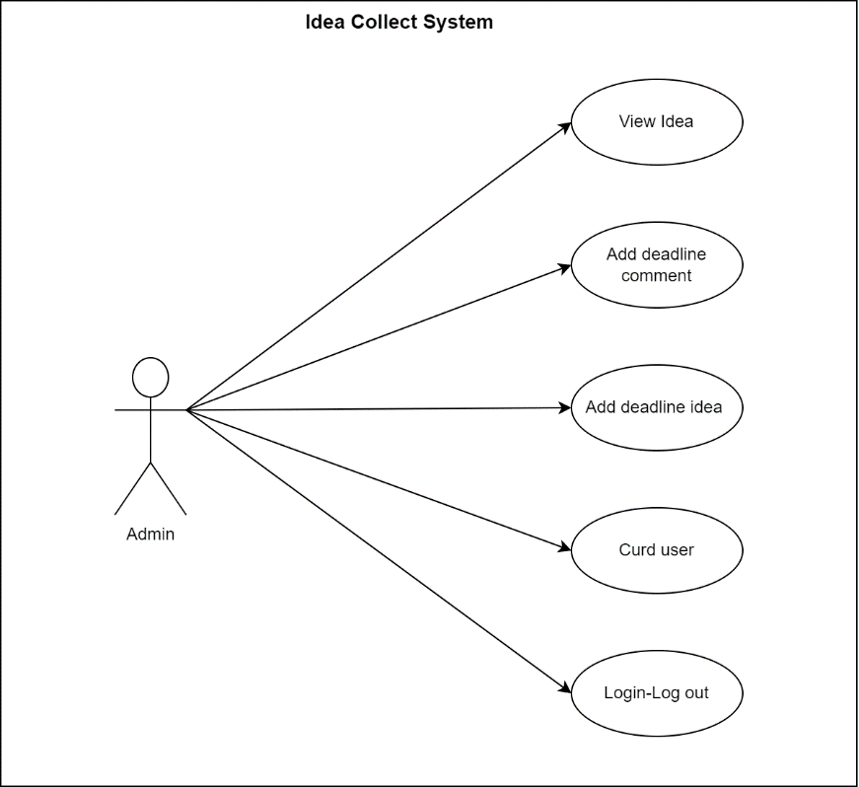

Figure 1. Use Case Admin

Admin has basic functions such as view Idea, add deadline comment, add deadline idea, crud user, login logout:

* View Idea: can see all ideas posted by staff
* Add deadline can extend the deadline for submitting ideas. When the deadline for submitting ideas expires, people are not allowed to submit ideas.
* Add comment: can add comment time for posts, when the time expires, users are not allowed to comment
* Crud user: admin has the right to create, edit, delete, and view accounts for users
* Login: used to log in to the website account
* Log out: used to log out the software

### Staff

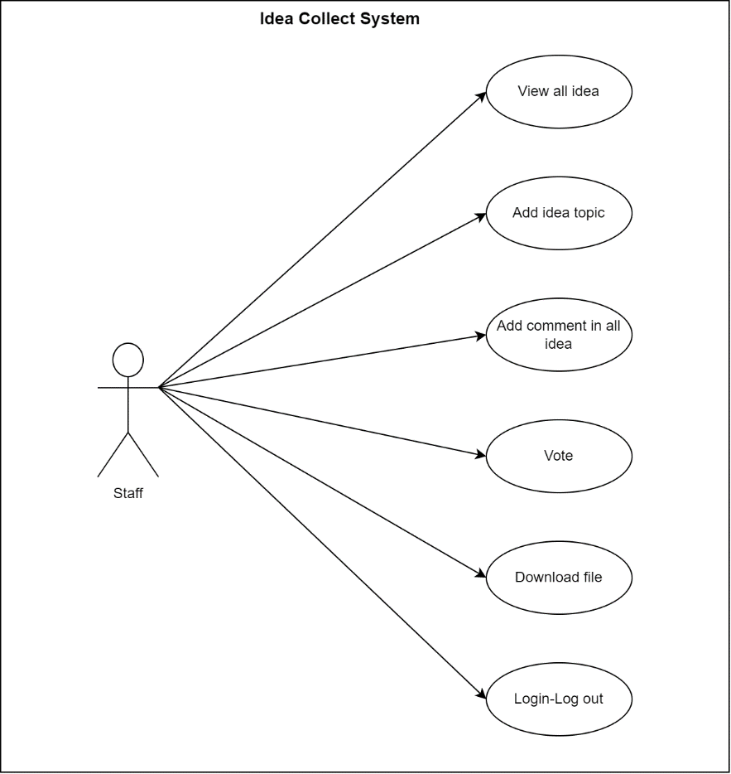

Figure 2. Use Case Staff

Staff has functions such as view all idea, add idea for topic, add comment on idea, vote, download file, login log out

* View all ideas: staff can see all previously posted ideas and can see the comments and votes of each idea.
* Add idea for topic: when there is a topic, the staff can add ideas for that topic while it is not overdue
* Add comment: the staff can comment above any idea posted if it is not past the comment period given by the admin
* Vote: when you see a good or bad idea, the staff has the right to vote like or dislike for that post, each idea, the staff can only vote once to like or dislike
* Download ideas: when some ideas are posted with files attached, the staff can download those files to view
* Login, logout: like admin, staff also have separate accounts used to log in to the website

### QA manager

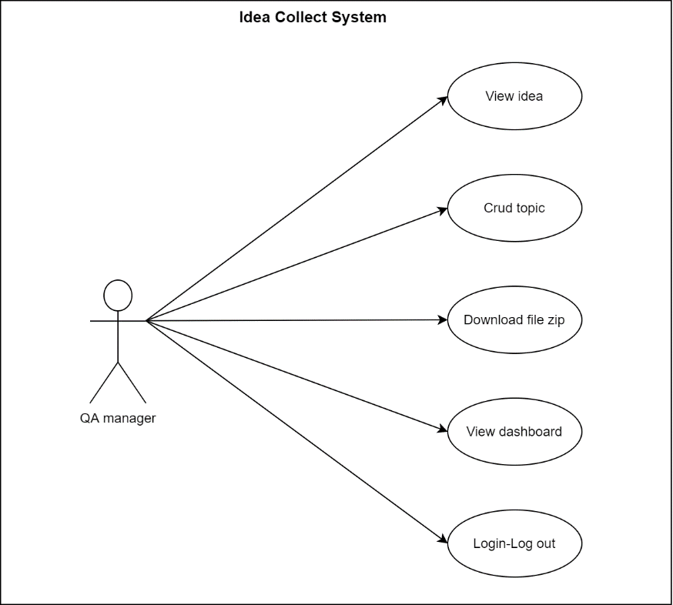

Figure 3.QA Manager Use Case Diagram

QA manager has basic functions like view idea, crud topic, download file, view dash broad, login, logout

* View idea: QA manager can view all ideas posted as well as its attachments
* Download: QA manager can download all uploaded files
* View dash broad: this is where the QA manager can see the parameters of the ideas posted
* login, logout: used to login to the website

### Quality Assurance Coordinator

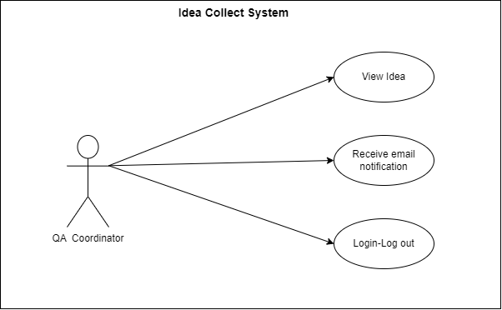

Figure 4. Quality Assurance Coordinator

Quality Assurance Coordinator can log in to the system to be able to see information about ideas posted as well as the number of likes and dislikes of posts. In addition, the Quality Assurance Coordinator will receive email notifications for new submissions from staff.

# Database

## ERD

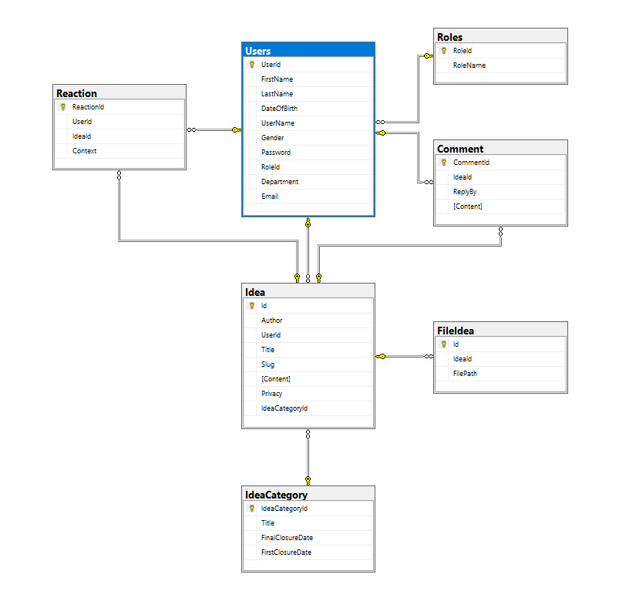

Figure 5. ERD

Database includes 6 main states: idea, Comment, User, Roles, IdeaCategory, Reaction

* User: this table includes the user's information fields, firstnaem is the user's name, lastname is the user's last name, DateOfBirth is the user's date of birth, Username is the account name used to log into the system, gender is the user's gender, password of the account, roleID this person's position in the system, department is the user's room, Email is the user's email to receive mail. And have Userid as the id of this table.
* Reaction: have reactionID as key field of this table, userid and ideaid are subkey of this table, context is the content of this table.
* Idea: the idea table includes fields where id is the primary key, Author is the name of the post author, userid is the secondary key of the table title is the title of the idea, content is the content of the post, privacy is the field used to Post in incognito mode, ideacategory is the subkey of this table associated with the ideaCategory table.
* IdeaCategory: includes 4 fields: ideaCategory is the primary key of this table, title is the title of this table, finalClosuerDate and FirstClosuerDate is the time when the idea starts and ends.
* FileIdea: id is the primary key of this table, ideaid is the secondary key of this table related to idea, filepath is the address to store the uploaded data file.
* Comment: the comment table consists of 4 fields. CommentID is the primary key of this table, useid is the secondary key of this table used to link to the user replybe table, which is the field used to reply to comments. Context is the content of the table
* Roles: includes 2 fields, roleID is the primary key and roleName is the name of the roles

**Relationship**

* The reaction board has a one-to-many association with the idea board and a one-to-many association with users
* The roles table has a one-to-many association with the users.
* The comment table has a one-to-many association with the users table, the comment has a one-to-many association with the idea table
* The fileIdea table has a one-to-many association with the idea table
* The IdeaCategory board has a one-to-many association with the idea board
* The idea table has a one-to-many association with the fileIdea, ideaCategory, reaction, users, and comment tables
* The users table has a one-to-many relationship with the roles, comment, reaction, idea tables

## Data security

The increasing abuse of computers by people and the increasing threats to personal information through the internet, leading to more people's concern about data protection. There are contingency safeguards:

* Control the classification of user access and control the data the user is using can read or write.
* Controls the adjustment of common value flows between the data sets that can be accessed.
* 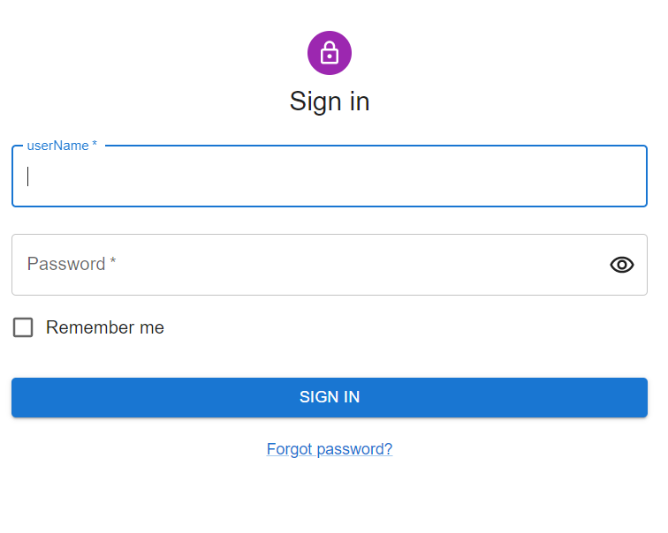Inference control is used to prevent the questioner from being able to infer information by posing a designed statistical query string and the correlation of the answers (Denning, 1979).

Figure 6. Login website

The requirement to login before accessing the website is also a way to secure the data so that it is not stolen by those who do not have the rights and obligations about the website's information.

## Data validation

Data authentication is a way of checking and protecting people's data, it is usually used to check your information when you use it on an unknown client, or it can also be used to recover some data that you don't remember. This validation helps you to know that your data is still complete (not null data). Data validation often occurs in processes such as ETL, login, password recovery or lost credentials. it can also sometimes appear in checking if you are the owner of the information being accessed (Denning, 1979).

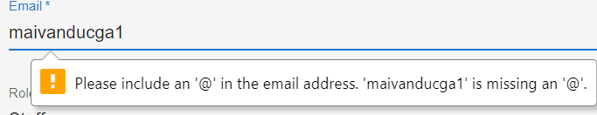

Figure 7. Data

## Database normalization

### Define

Database normalization is the design of data in tabular form so that the use of database data becomes easier to use, clear and correct. Normalization is the theoretical nature of relational databases. it has the effect of duplicating data leading to the creation of more tables (Beeri, 1989).

### Rules

Data normalization makes it possible to reduce redundant data (remove unnecessary data duplication). This is a process of editing and reducing as well as removing unnecessary things for data and identifying data objects that are necessary for the job.

**Relational database tables normalization levels**

First normal form (1NF) is the most basic level and it is often used to define database tables:

* It is two-dimensional (with columns and rows).
* Columns for attributes or objects
* The rows are the information representing the attributes or objects of the columns

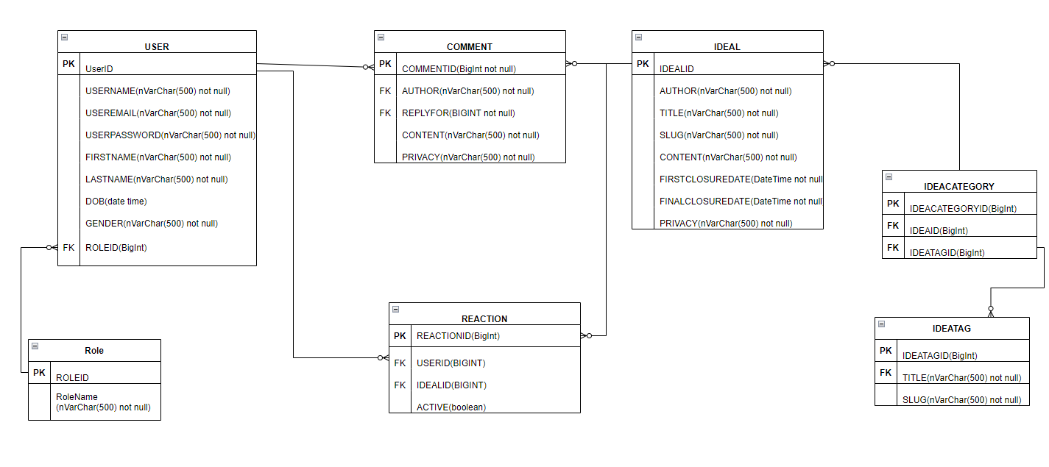

Figure 8. First normal form

This is the first database designed by our team for this website.

Second normal form (2NF):

* Each column in the table will not determine the content of another column, but it is a function of the other columns in the table. In the Second normal form there are dependencies that are not present in the First normal form. Next, in these tables there is usually a column that is included as the primary key because it is used to uniquely identify the rows in that table, and it cannot be null or undefined.

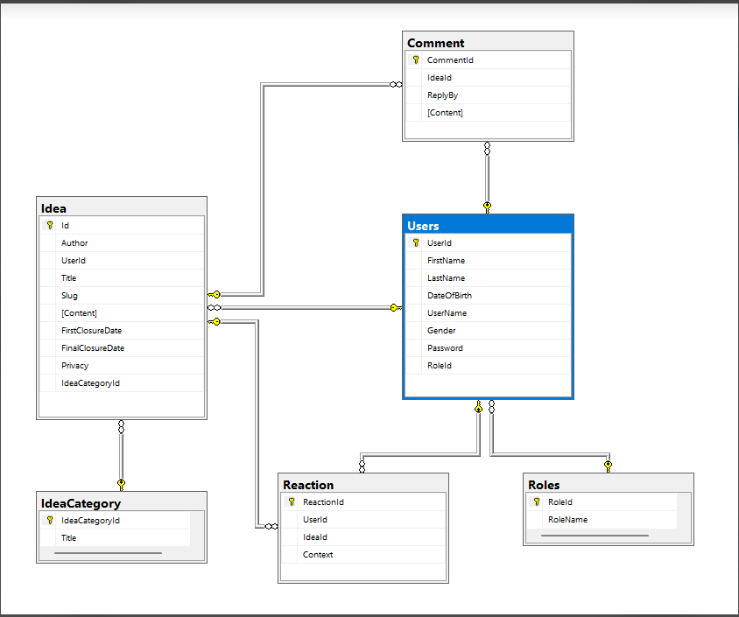

Figure 9. Second normal form

This is the database that was supported by the instructor to edit after seeing the first database

Third normal form (3NF):

* In the first two forms, it is still possible to change rows in the table that can affect the data referencing information in other tables, but for the third normal form these tables will be divided into smaller tables that are linked together to be able to monitor.
* Database normalization to avoid or reduce data instability, data redundancy and duplication, and improve data integrity (Beeri, 1989).



Figure 10. Third normal form

This is the final database after getting to work and adding what we found missing in the previous 2 tables in the website.

# Design

## Sitemap

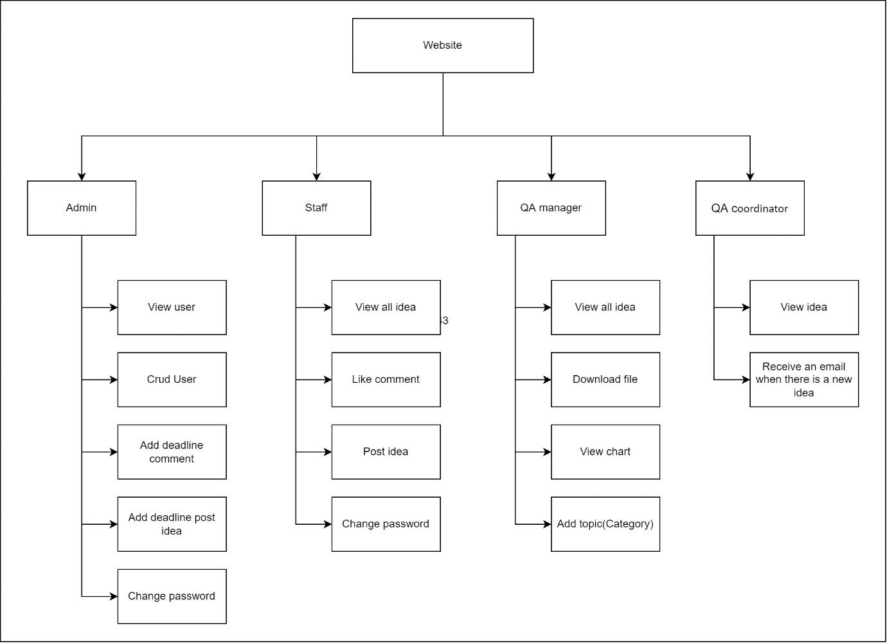

Figure 11. Site map of Idea Collect System

## Wireframes

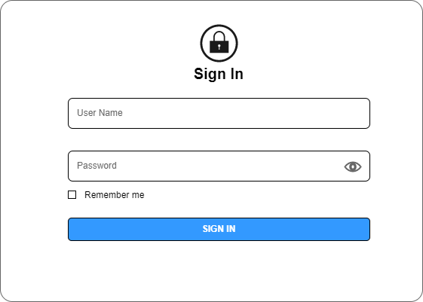

Figure 12. Wireframe-Login

The login part includes username, password so that users can enter their account and password to log in to the system. remember password so that users can click on it to remember the password for the next login for the website's system.

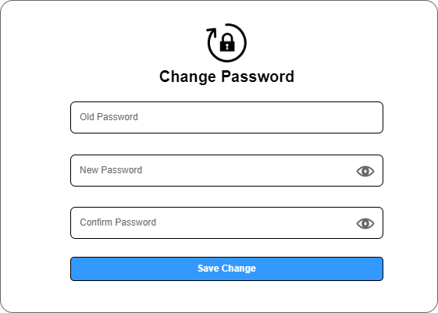

Figure 13. Wireframe-Change password

Here the user will be asked to enter the old password then the password to change finally click on the change button to change if the old password is wrong or the new password does not match, the system will display a message and ask the user to re-enter.

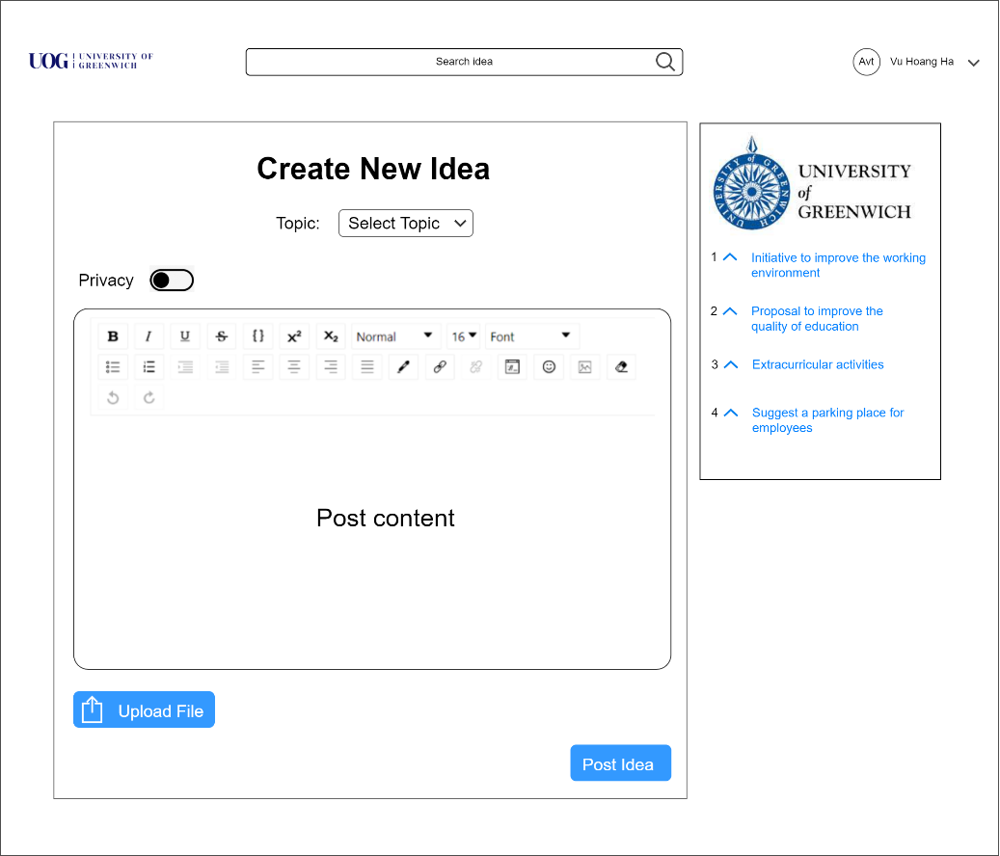

Figure 14. Wireframe-Create New Idea

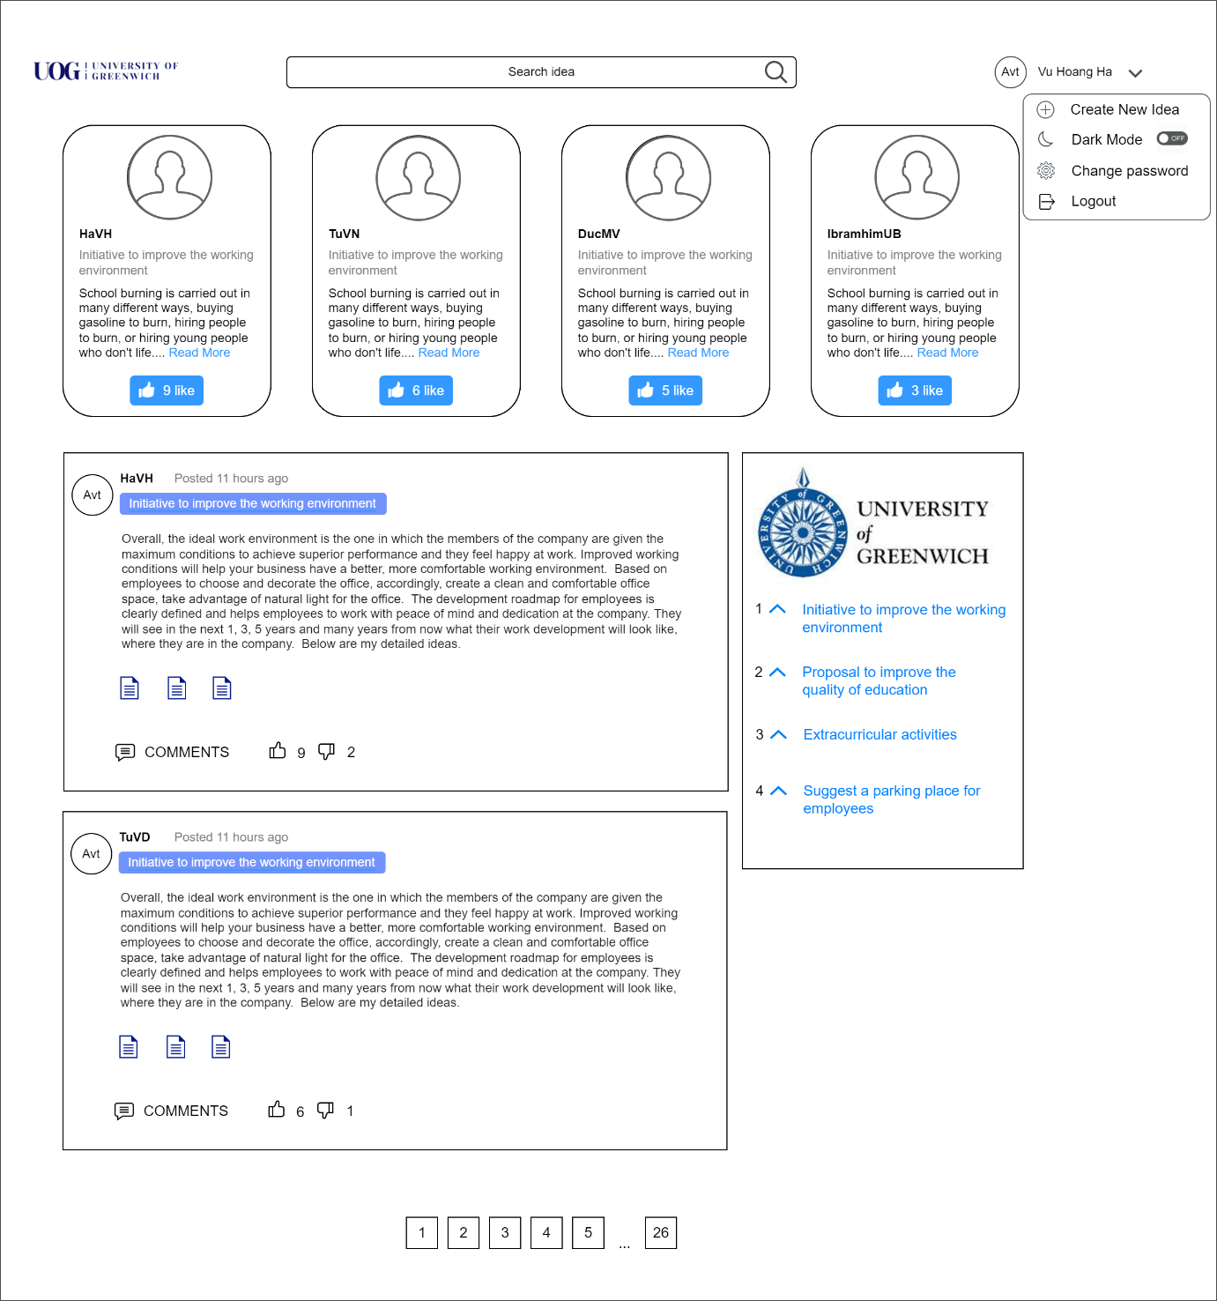

Figure 15. Wireframe-Staff homepage

This is the home page of the user when successfully logging into the website that we designed when reading the system's requirements. It includes a header where the website's logo, a search bar, and some functions of the website. user. The lower part is the main part of this page, it includes posts by users, those posts include ideas, attachments, number of likes, dislikes and comments of each post.

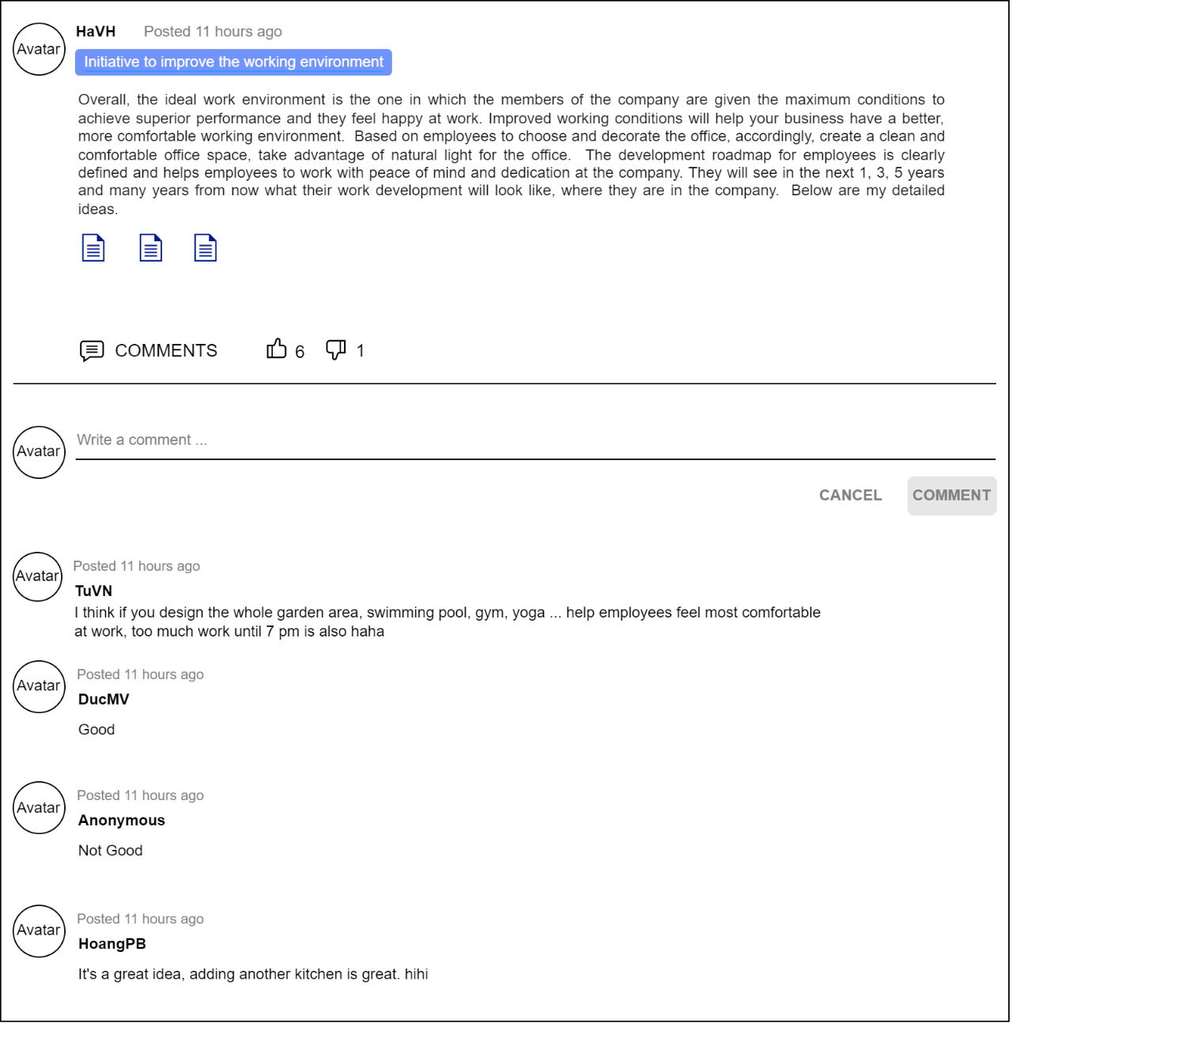

Figure 16. Wireframe-Idea post detail page

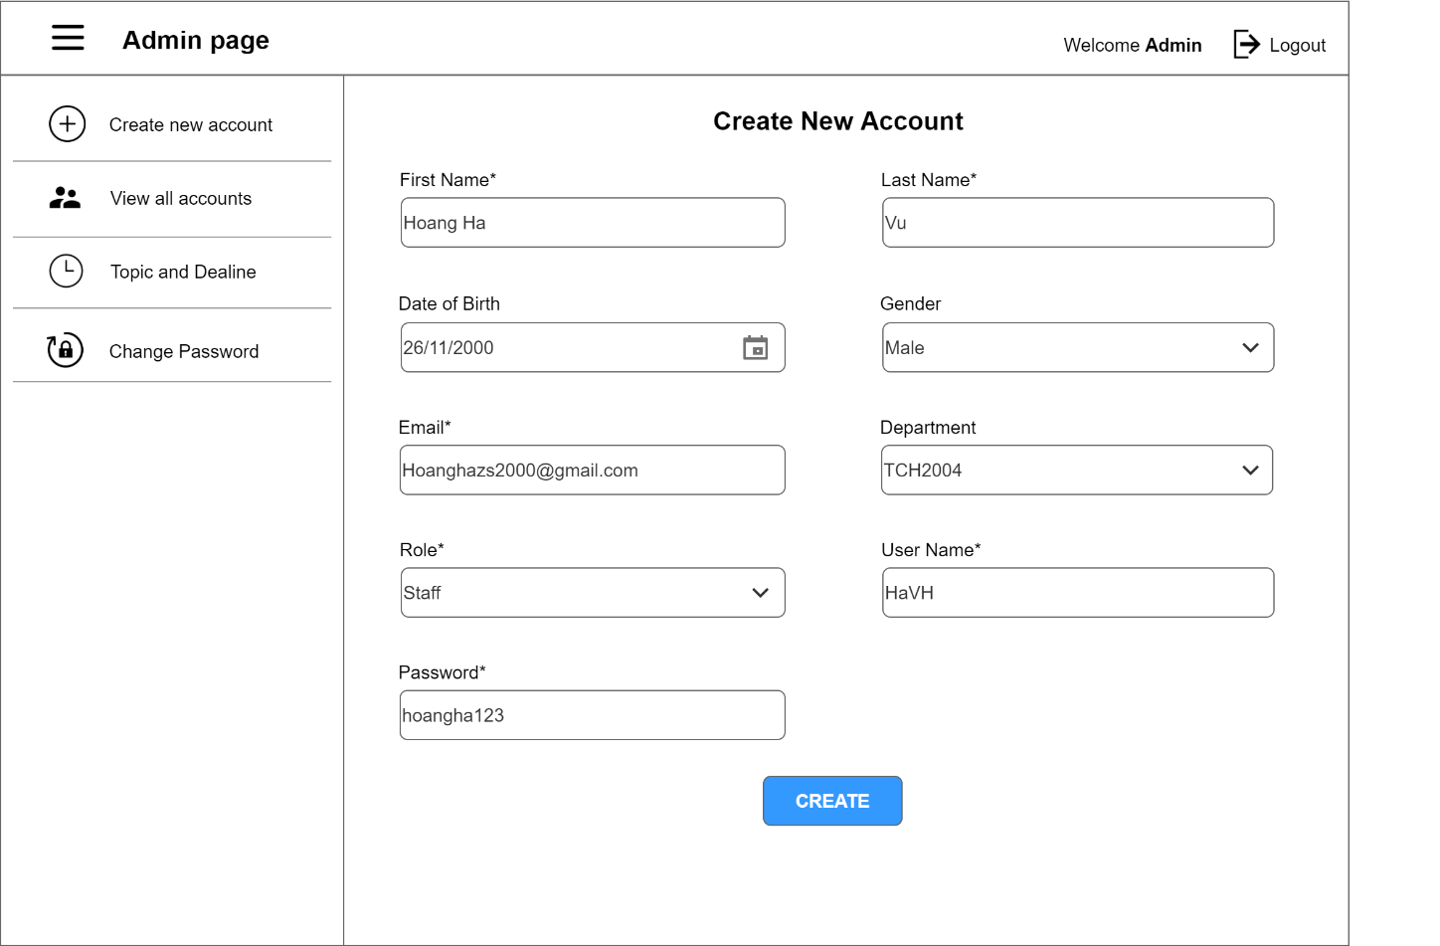

Figure 17. Wireframe-Admins create account

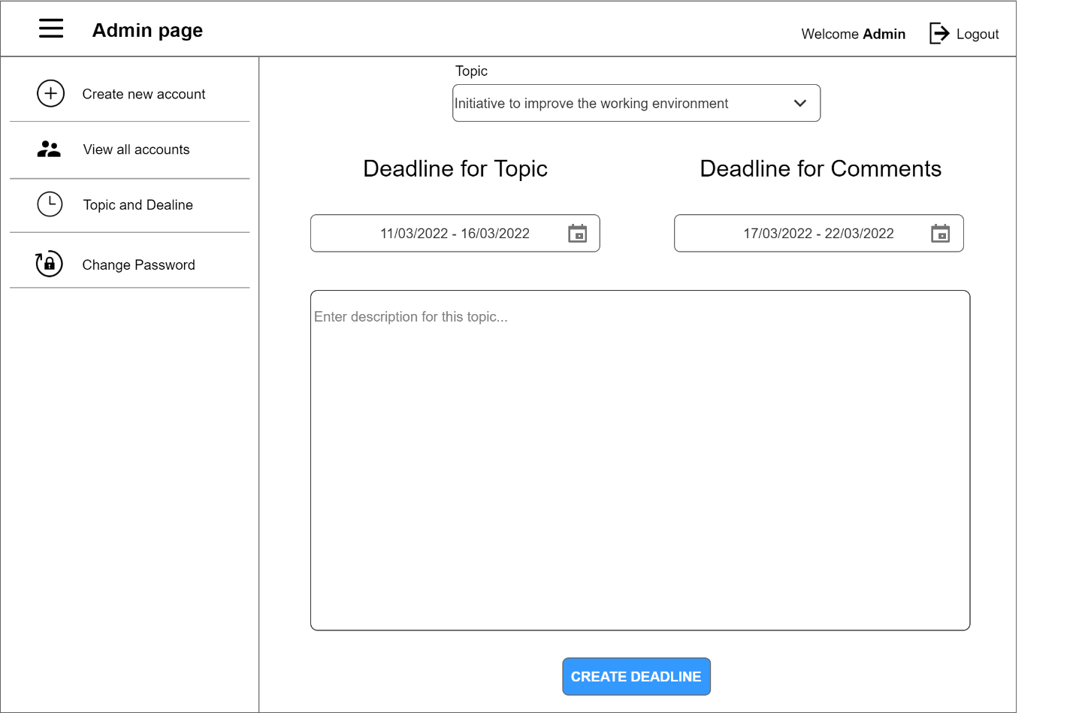

Figure 18. Wireframe-Admin creates deadline

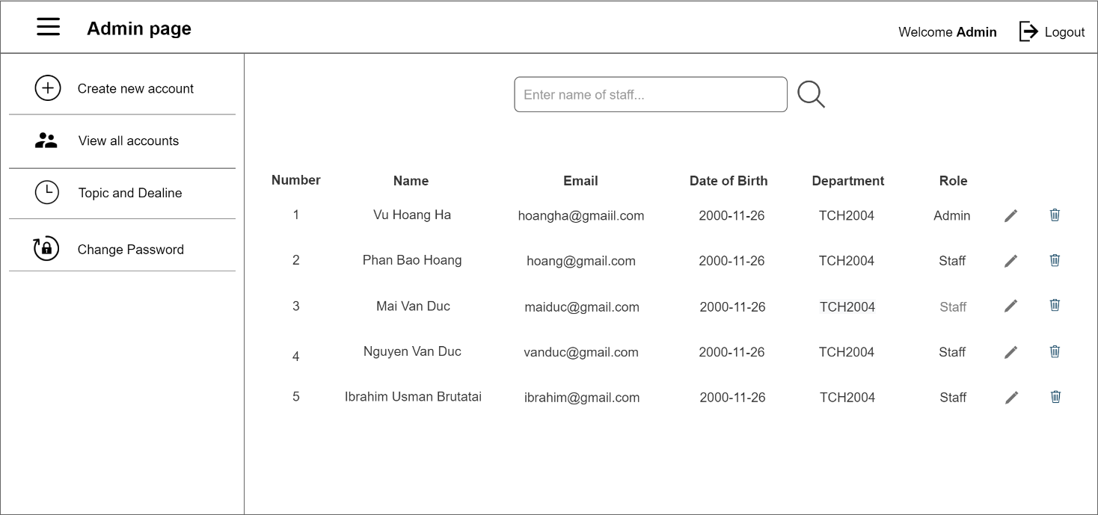

Figure 19. Wireframe-Admin edit account

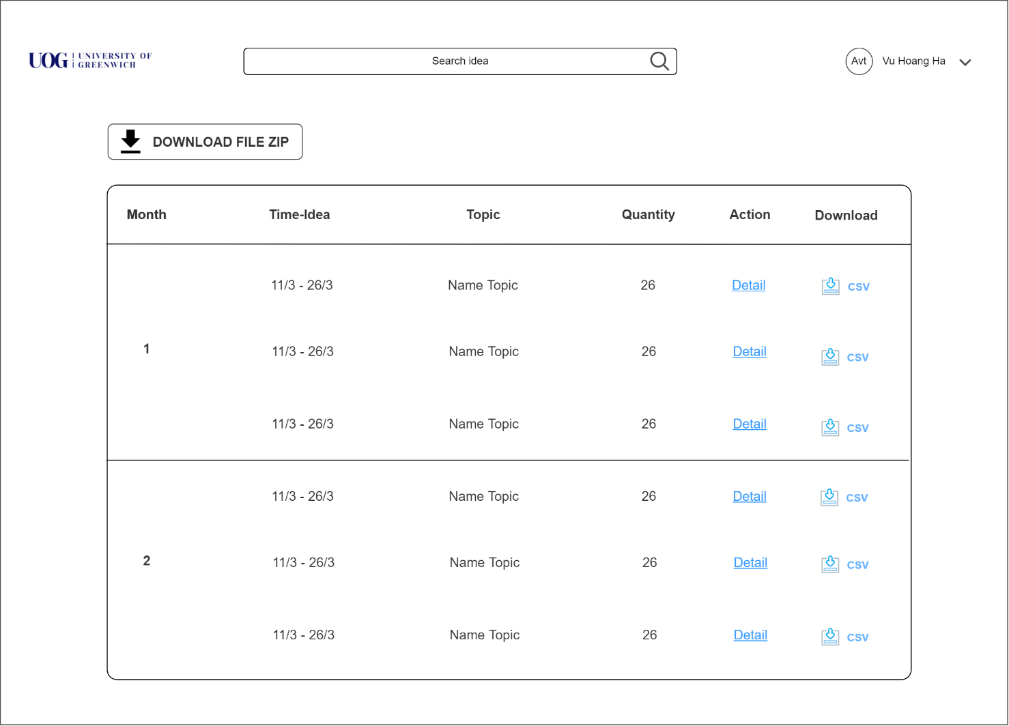

Figure 20. Wireframe-Document download page with zip and CSV formats for manager

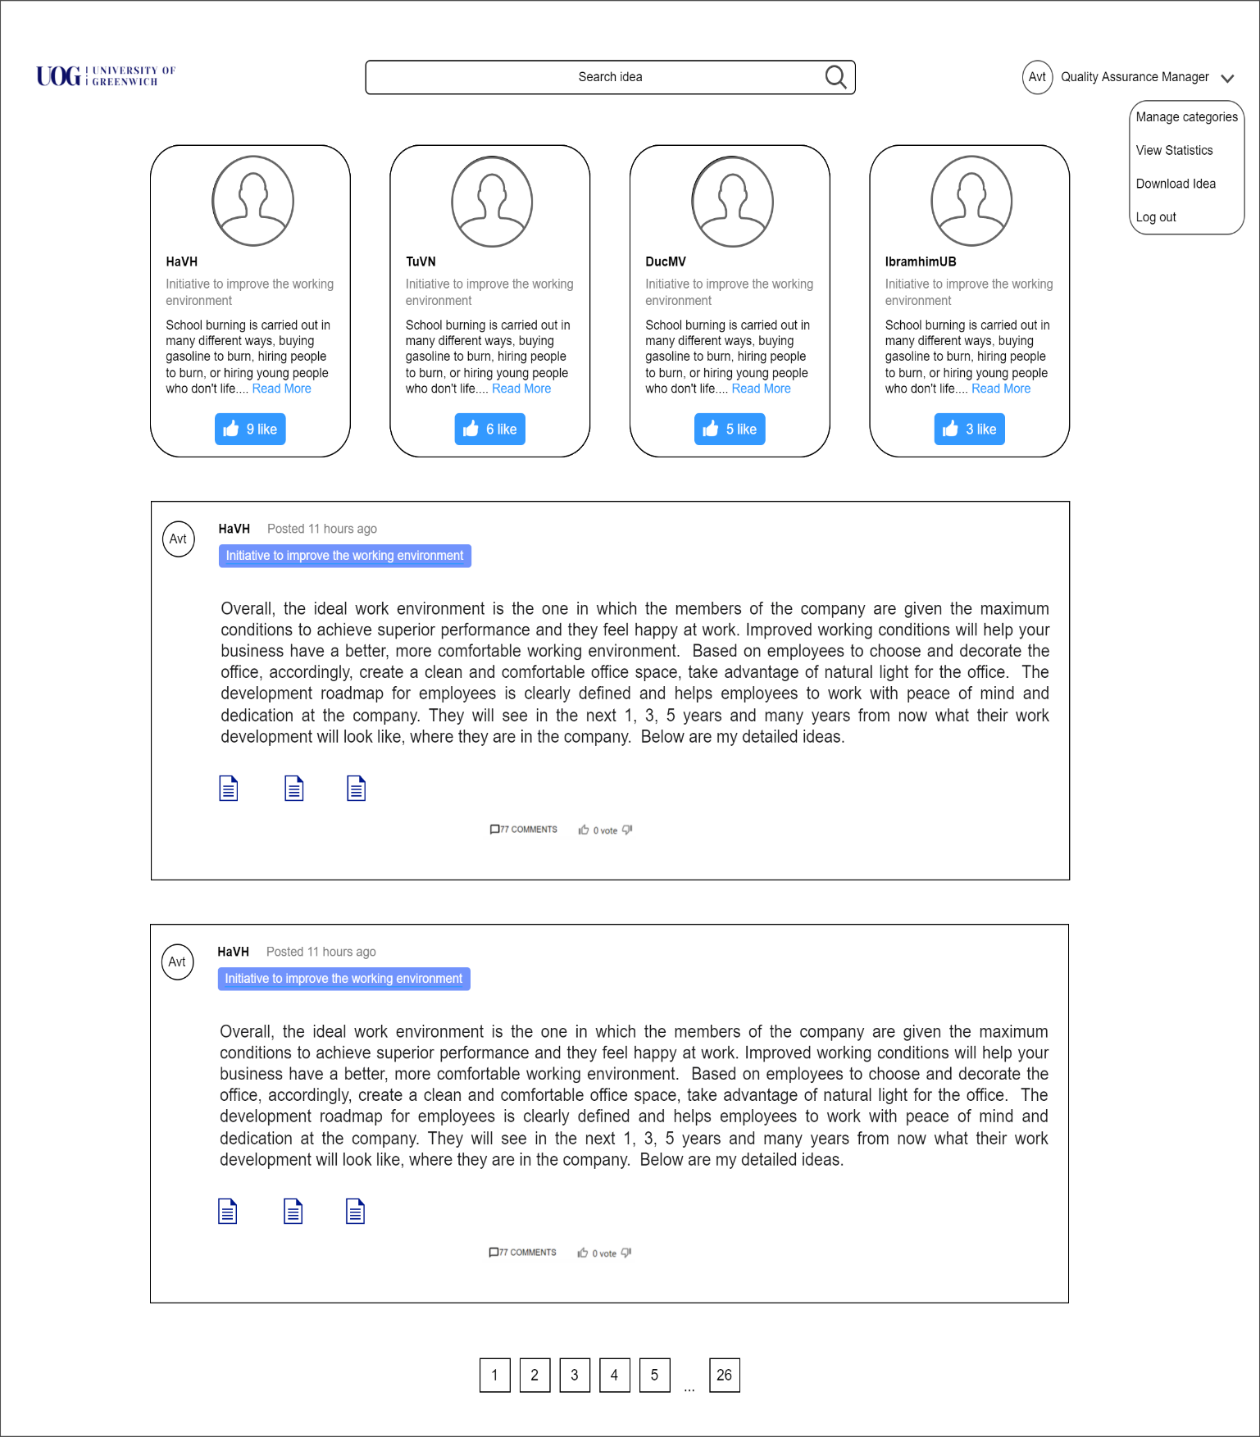

Figure 21. Wireframe-Manager's homepage

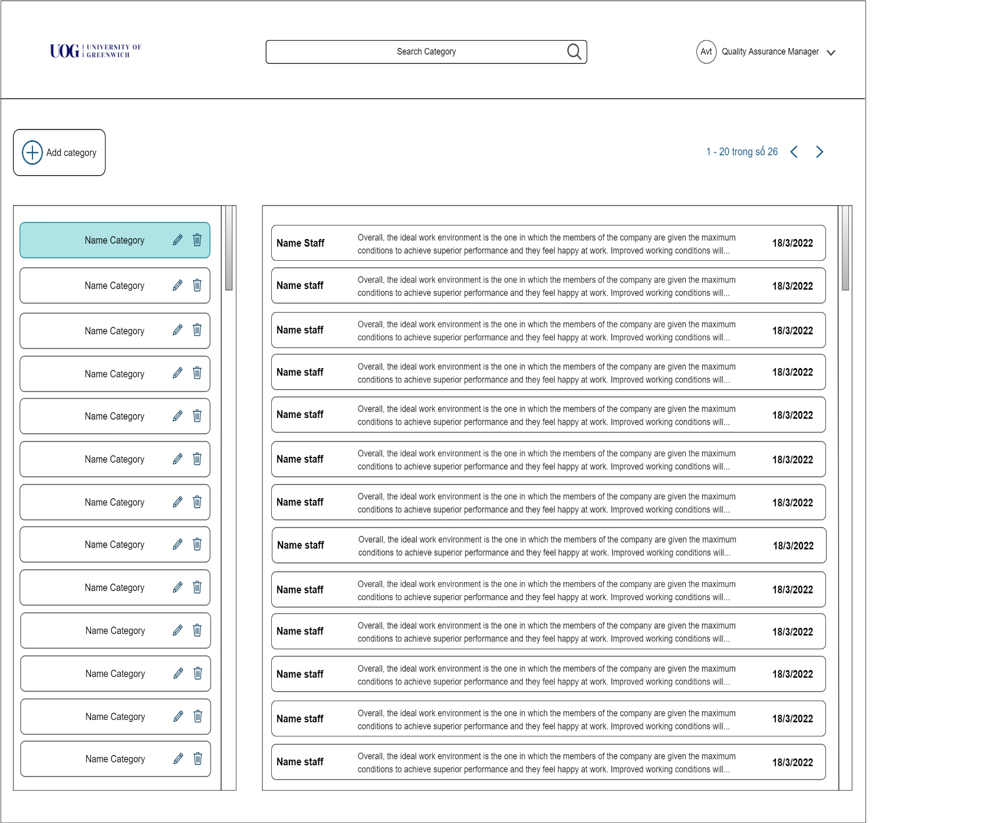

Figure 22. Wireframe-Add a category of ideas for managers

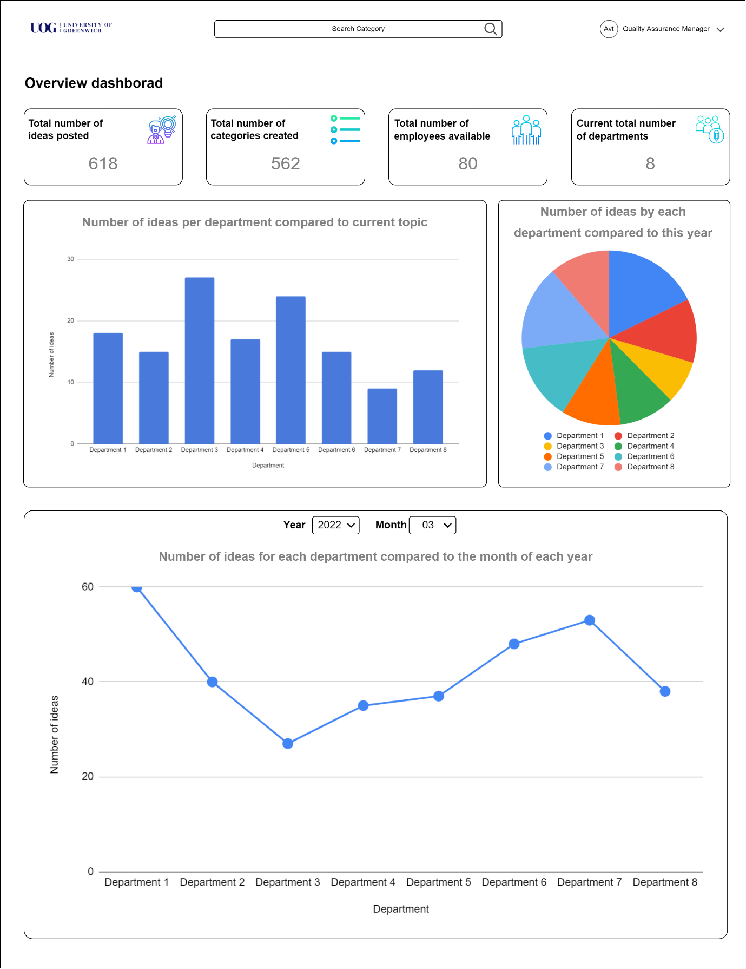

Figure 23. Wireframe-Manager Dashboard

# Implementation

## Techniques

### Wireframe design tool

Currently, there are many tools to support the wireframe design of a website. For example, Adobe Photoshop, Web Easy Professional, draw.io, ... most of this software have basic functions to help us draw wireframes, but this software needs to cost money or require downloading to use. use. So, we chose draw.io, this is a tool that supports interface design, flowchart drawing, etc. can be used always on the web, at the same time, it also supports us to share drawings for each other and can be edited on it. Most importantly this is a completely free website for us to use.

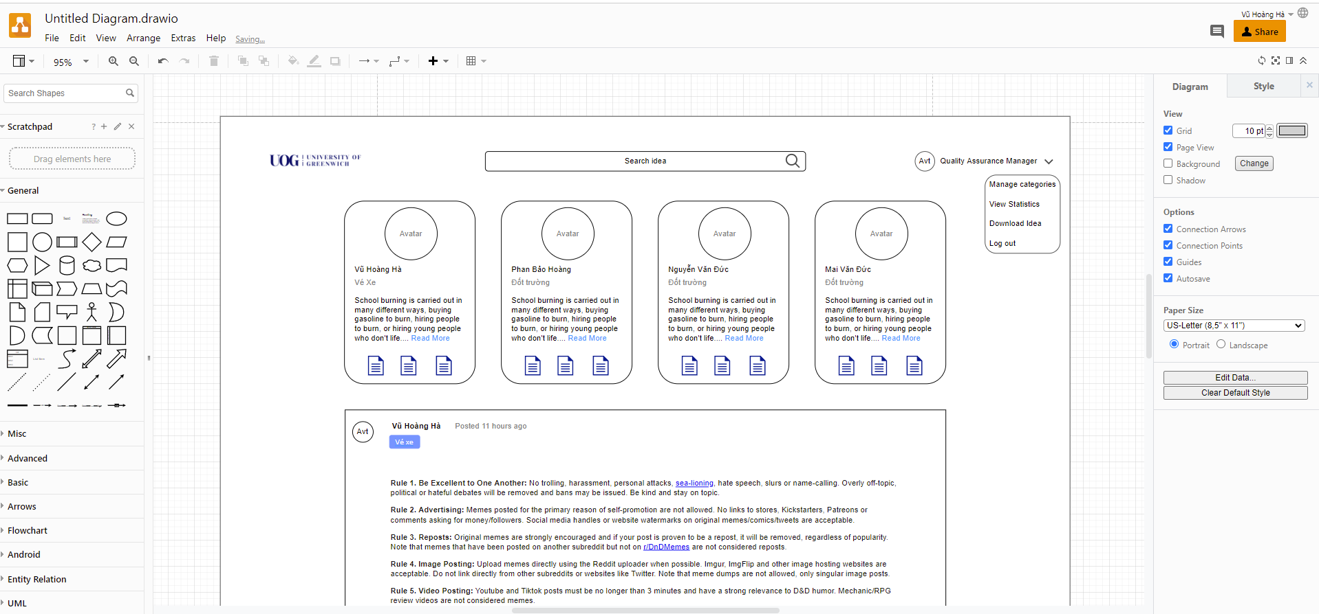

Figure 24. Drawio

### Front-end

For the front end, we also have many options to do this project with different technologies that we have known and used before for example: Angular: is a framework for front-end code. end, it also has a lot of support libraries for front end work. Angular uses type scripts to code and it requires quite a bit of knowledge and is often used for large projects we find it unsuitable for a short project like this. Next, we were intending to use HTML, CSS, Bootstraps and frontawsome to code pure for this project but we realized that pure code without libraries will take us quite a lot of time. front end handling. So, we thought of another technology to work with facebook's powerful front end which is reactjs which is also a big library it's developed by facebook open source on github for everyone to use and it has a lot of features. many libraries support working with front end such as material UI… In the end our team chose to use reactjs to work on this project.

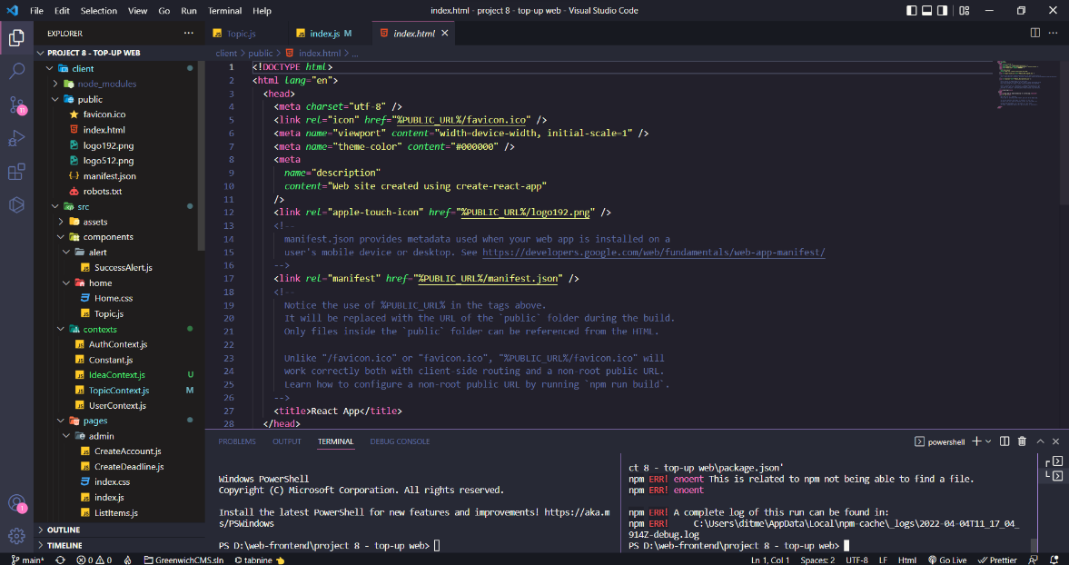

Figure 25. Display code ReactJS by VSCode

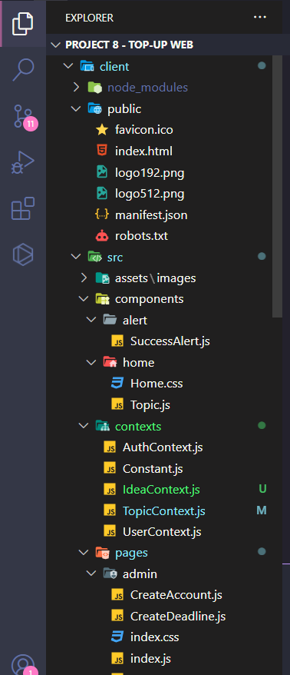We use VSCode to be able to code ReactJS because VSCode is free and easy to use, and it also provides a lot of extensions to help with coding.

Figure 26. ReactJS file organization

Using ReactJS and organizing files also makes it easier for us to manage and maintain our code periodically, or while we are working on a project

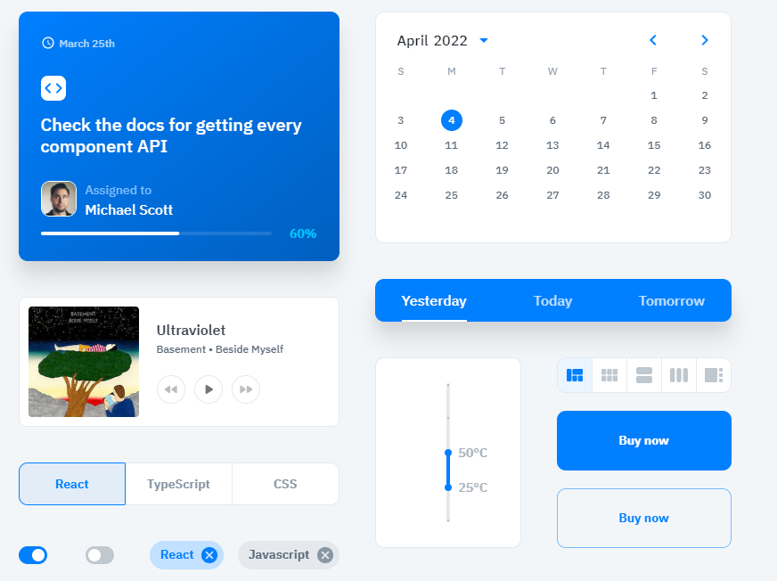

Figure 27. Material UI of ReactJS

Material UI makes it possible for us to code faster with some pre-built interfaces and our job is to take it out and use it.

### Back-end

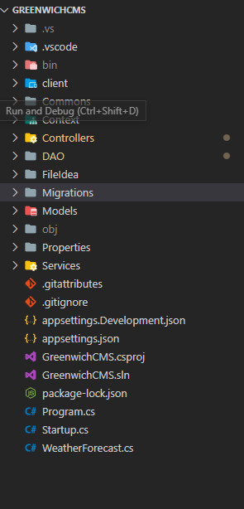When we started this project, we thought about using one of two main technologies, Nodejs or ASP.NET which are both good technologies to work with back-end. As for NodeJS it's been widely used lately and can work easily with database but for our team no one has a deep understanding of NodeJS it's almost just working with it and not understanding. about NodeJS and don't know many of its libraries. As for ASP.NET, our team has a person who is familiar with it and understands it well, so using ASP.NET can help us work more conveniently and when we encounter an error, we can also easily handle it. than. Through that, it can help us have more time to work on the project and fix as well as troubleshoot problems when encountered more easily.

Figure 28. Code directory structure

## Features

### System flow

*Example of the system's flow (login example): when the user enters his information in the login displayed on the website and then clicks login, the information will be transmitted to the front end of the system. then through the back-end API, then from the back-end controller, it will manipulate the database to compare the input data is the same in the database or not, then notify the user of success or failure to log in to the system.*

### Back end

#### Create idea

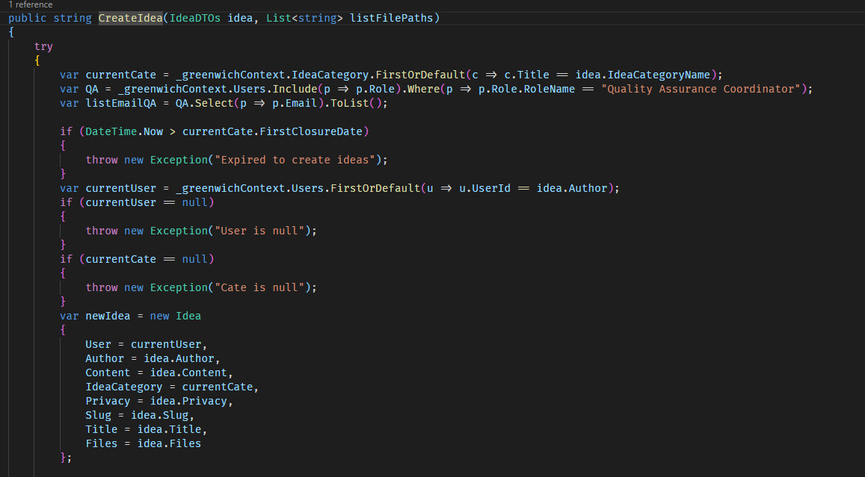

Code 1. Back-end create idea

Create Idea: find the title of the category if it exists, then do it

#### Update category

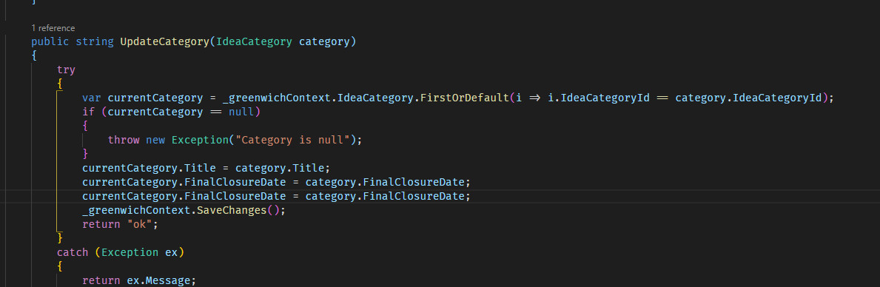

Code 2. Update category

Create a variable curruntCategory and store its value equal to the data of the user whose id is Ideacategory equal to the searched ideaCategory. if it is null, it returns a message, otherwise null it will let us change the information of that category.

#### Delete Category

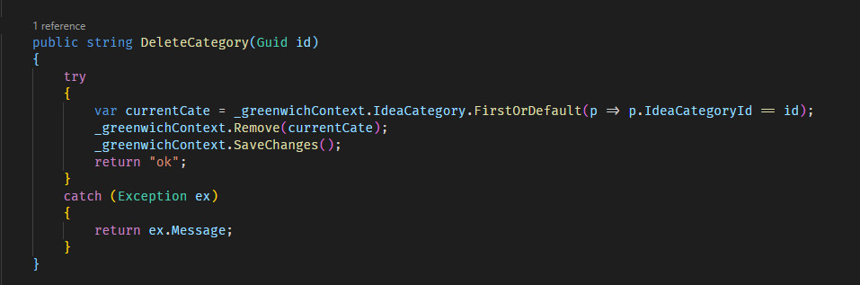

Code 3. Back end Delete category

Delete category this function will get id if that id exists then allow to delete that category and if not exist in the database it will return an error message

#### Send email reaction idea and comments

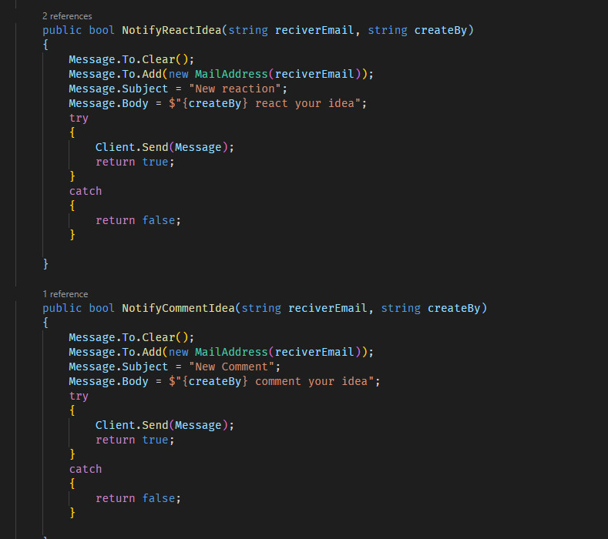

Code 4. Notify email about reaction and comment

When there is a new reaction or a new comment, a Gmail will be sent to the owner of that post

#### Update user

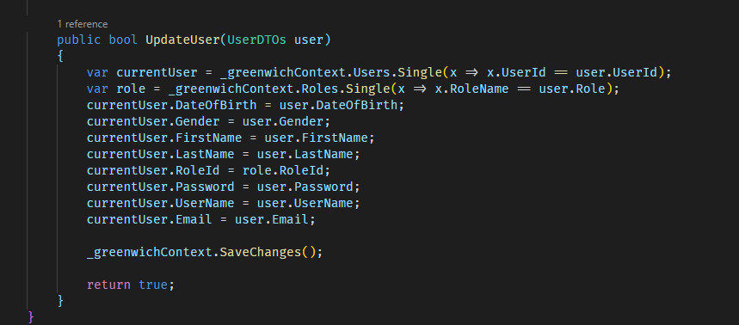

Code 5. Back-end update user

Update User: create a variable to store the user's information, which is currentUser. When we search by id that user exists, we just need to call the fields of that user to change. After the change is successful, the new data will be saved to the database.

#### Change password

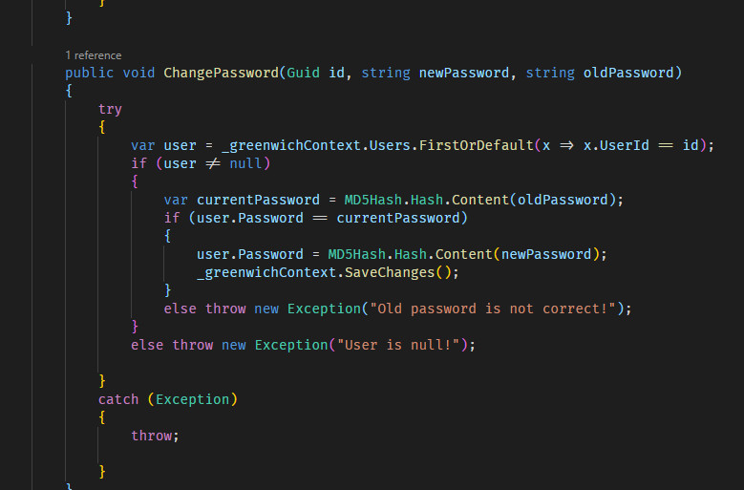

Code 6. Back-end change password

Change password: create a user variable to store information of the user whose id matches the searched id. If that id exists, we will change the password by entering currentpassword to capture the input data. . If the input data matches the old password, the user is allowed to change the password. By entering newpassword and assigning the password in the database with it.

#### Delete User

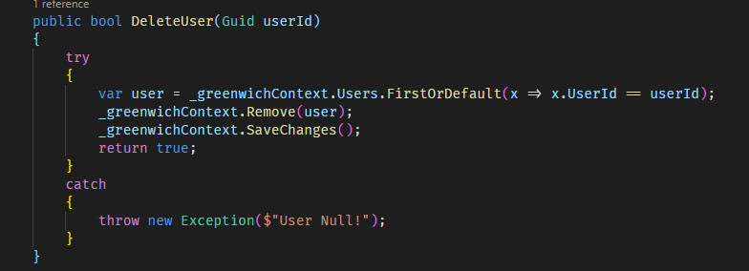

Code 7. Back-end delete user

Delete user: check if the user id exists or not, if it exists, remove and then save it.

#### Create user

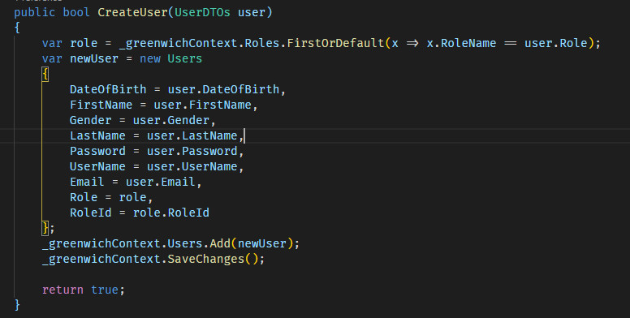

Code 8. Back-end create user

Create user: creates a role variable to define the role of the user you want to create and then assigns the user's fields using the information entered from the keyboard. Finally, add the added information to the user table in the database and save it.

### Front end

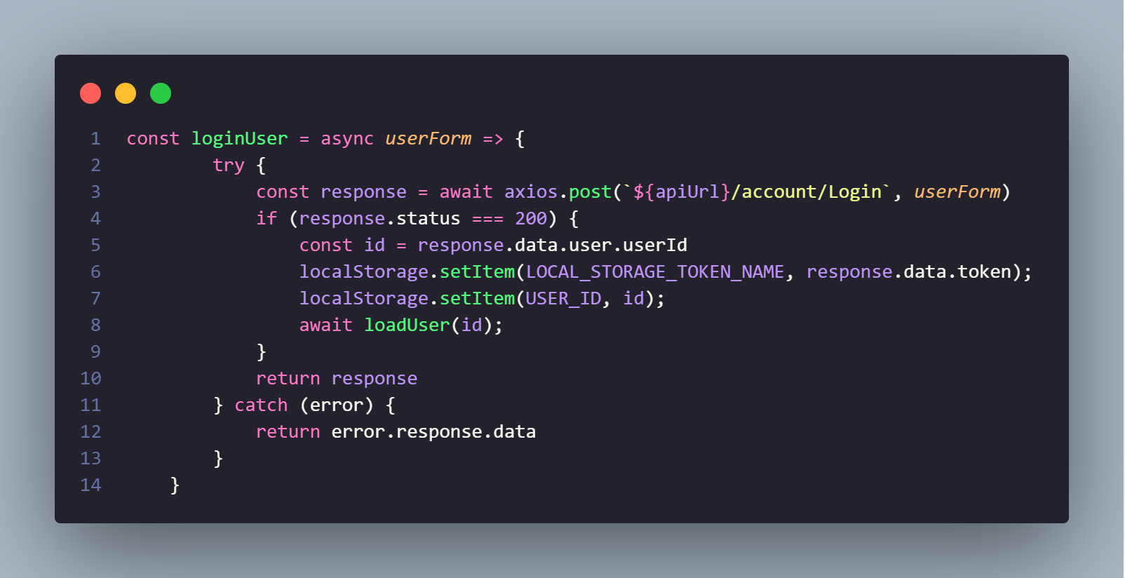

Code 9. Login

Initialize the loginUser function. Call api using axios with post method. If the response returns status equal to 200 save the user's id and token back to local storage and then call the loadUser function and pass in the user's id.

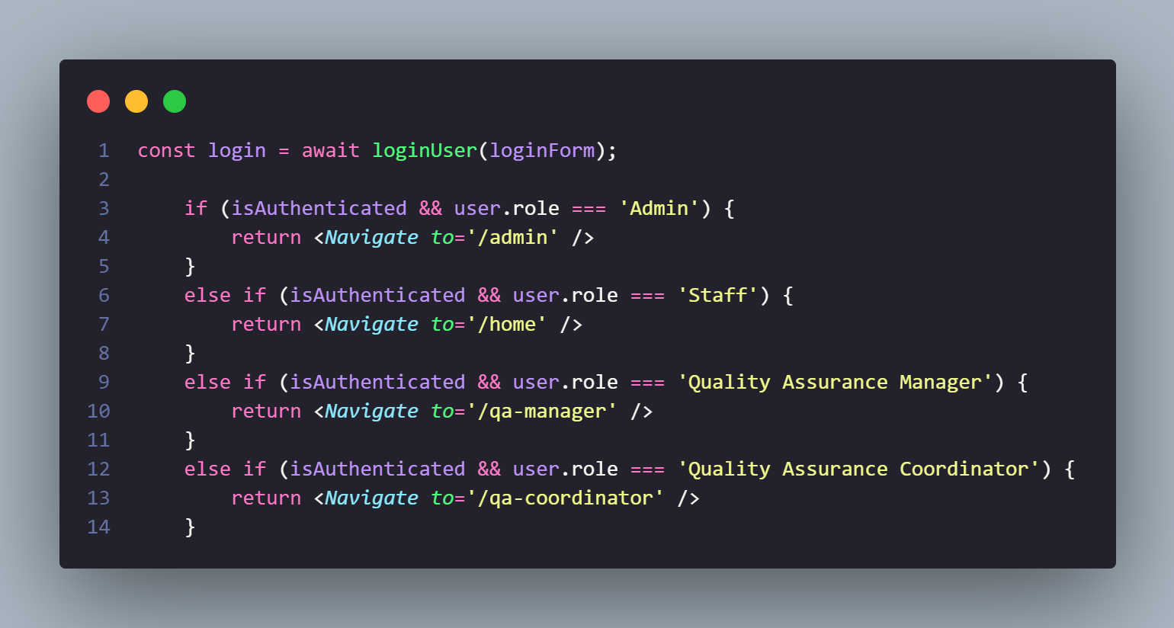

Code 10. Set role

call loginUser and pass in the data the user entered on the login page. Check what role the user account has and redirect to the appropriate page for each of those roles.

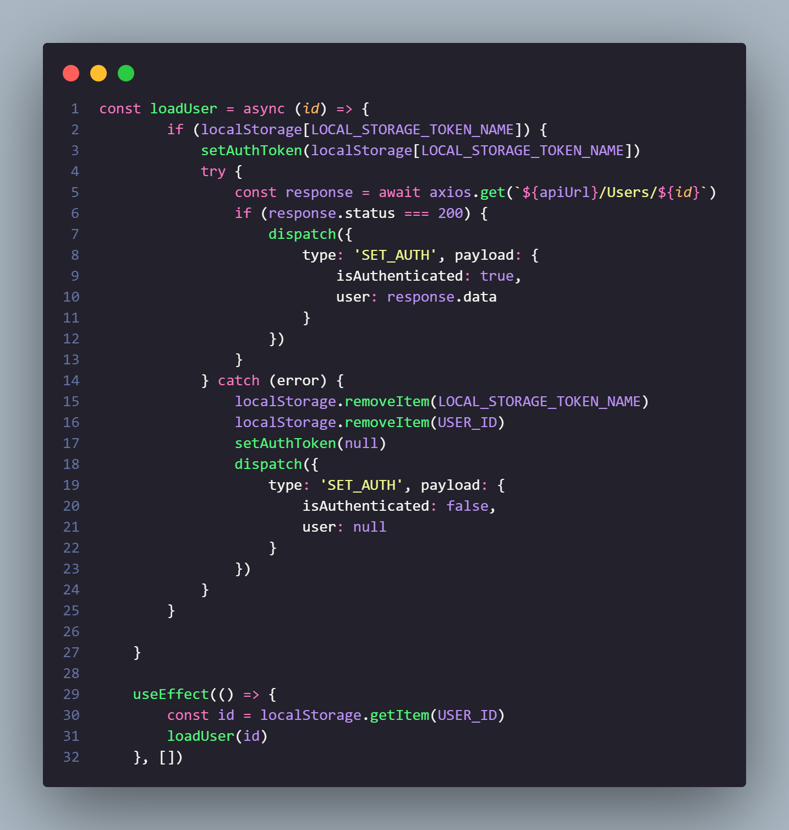

Code 11. Load user

Initialize the loadUser function. Checking if there is a token in local storage call the setAuthToken function to set the header for the request to be transmitted. Here checks again the user with the id stored in local storage exists or not. If you send an action with type “SET_AUTH” and the payload is the data returned from the api. If the user with id does not exist, the system also sends an action with type “SET_AUTH” and payload equal to null.

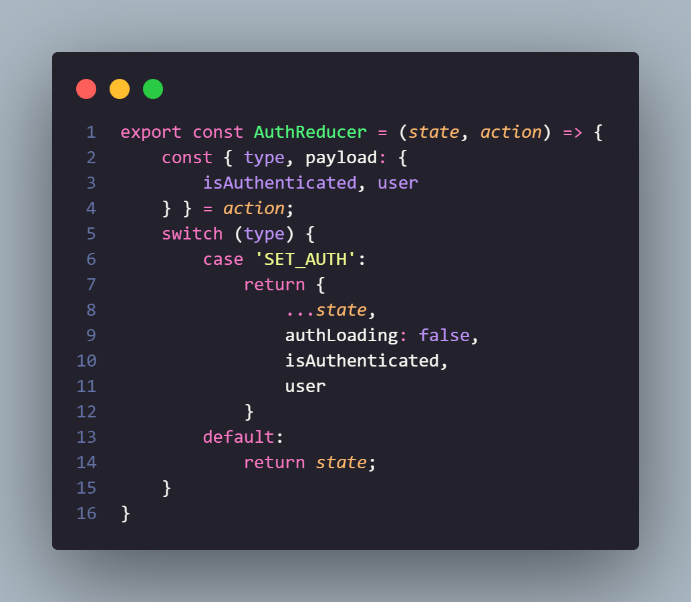Code 12. AuthReducer

Initialize the AuthReducer function to receive the action sent from the loadUser. With the received type of “SET_AUTH” , the system assigns a variable to initialize the state equal to the received payload.

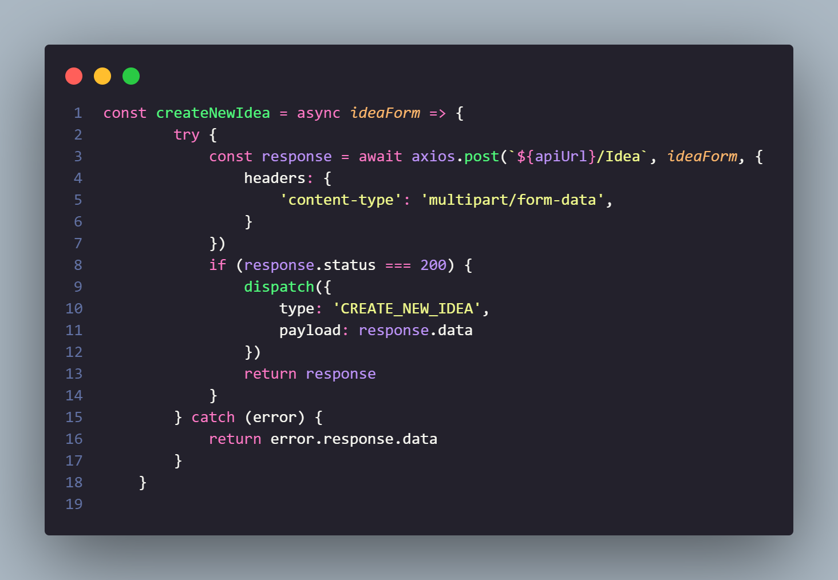

Figure 29 Create new idea

Initialize the CreateNewIdea function with a form as an input parameter including the idea's information. Call api and set header with 'content-type' of 'multipart/form-data' to be able to pass both json and file. If the response received has a status of 200, perform an action of type “CREATE_NEW_IDEA” and the payload is the returned data.

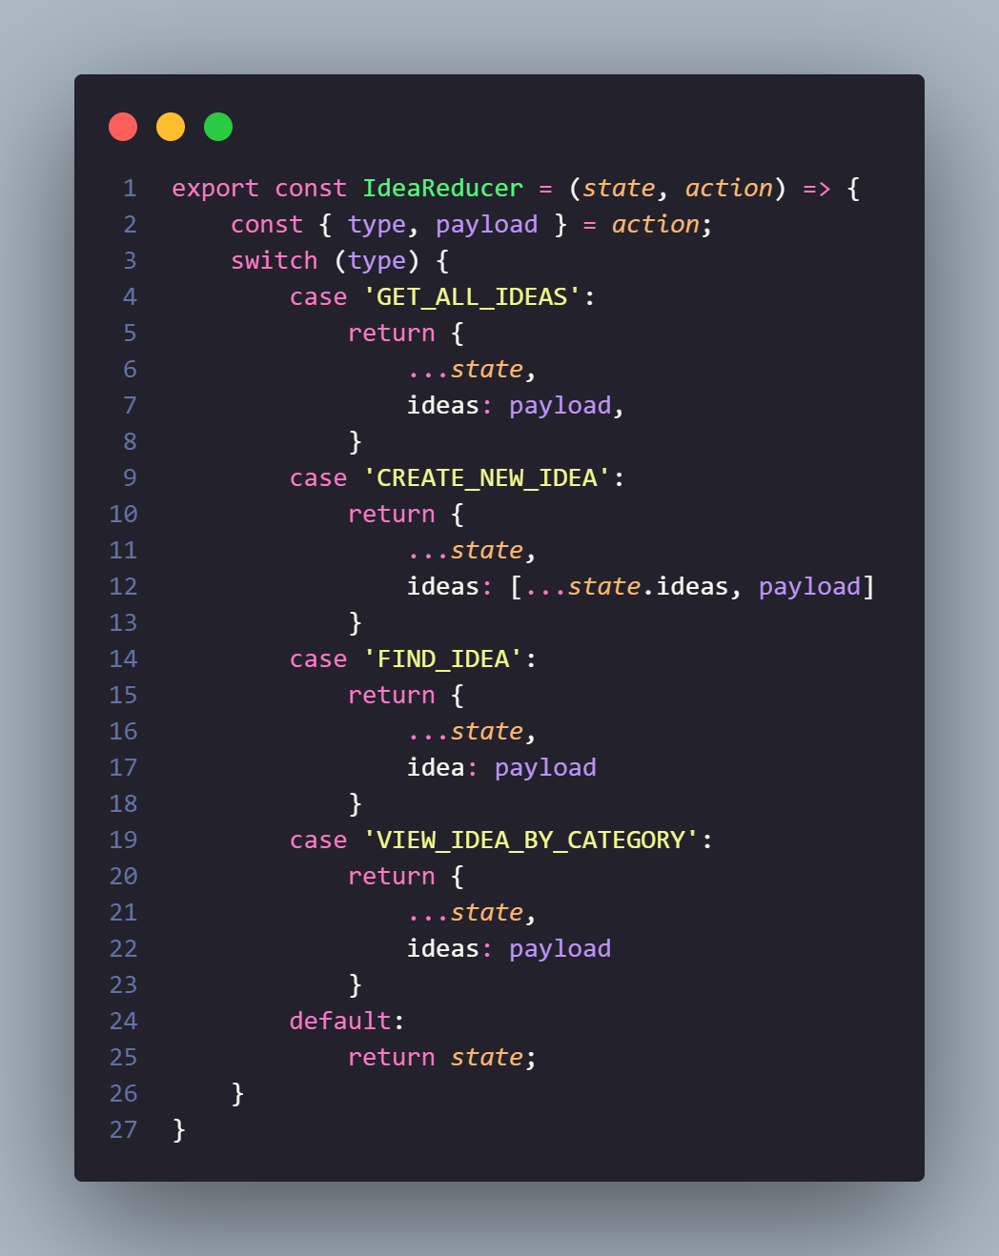

Figure 30 Idea Reducer

Initialize the IdeaReducer function to get and act. Consider the case that the action has type "CREATE_NEW_IDEA" which will assign the state variable (array) to add new data as the returned payload.

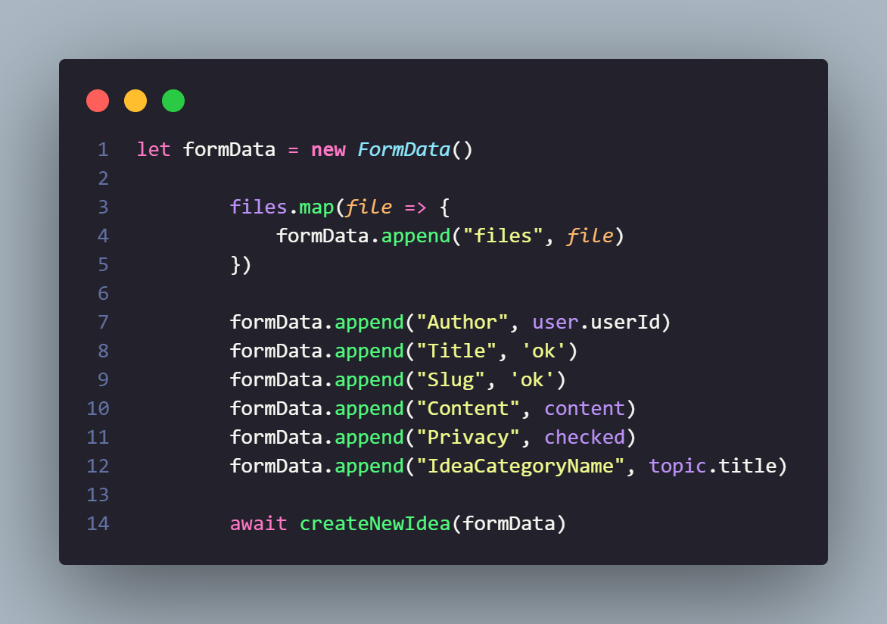

Initialize a FormData to save the files posted by the user, and at the same time save the post idea information such as topic, idea content, whether the user wants to post anonymously or not, etc. Then, call the createNewIdea function and pass in the formData just save.

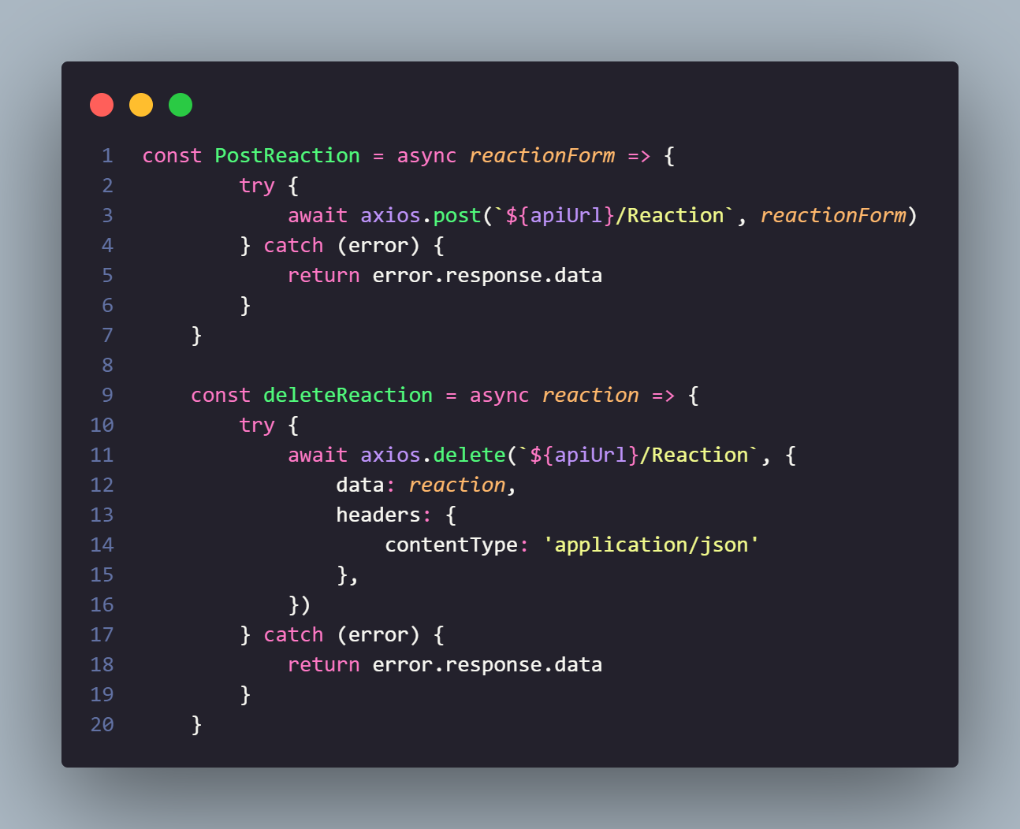

Code 13. Post Reaction

Initialize the PostReaction function. Call api to post reaction

Initialize deleteReaction function. Call the api to remove the reaction. Pass in header with contentType of application/json

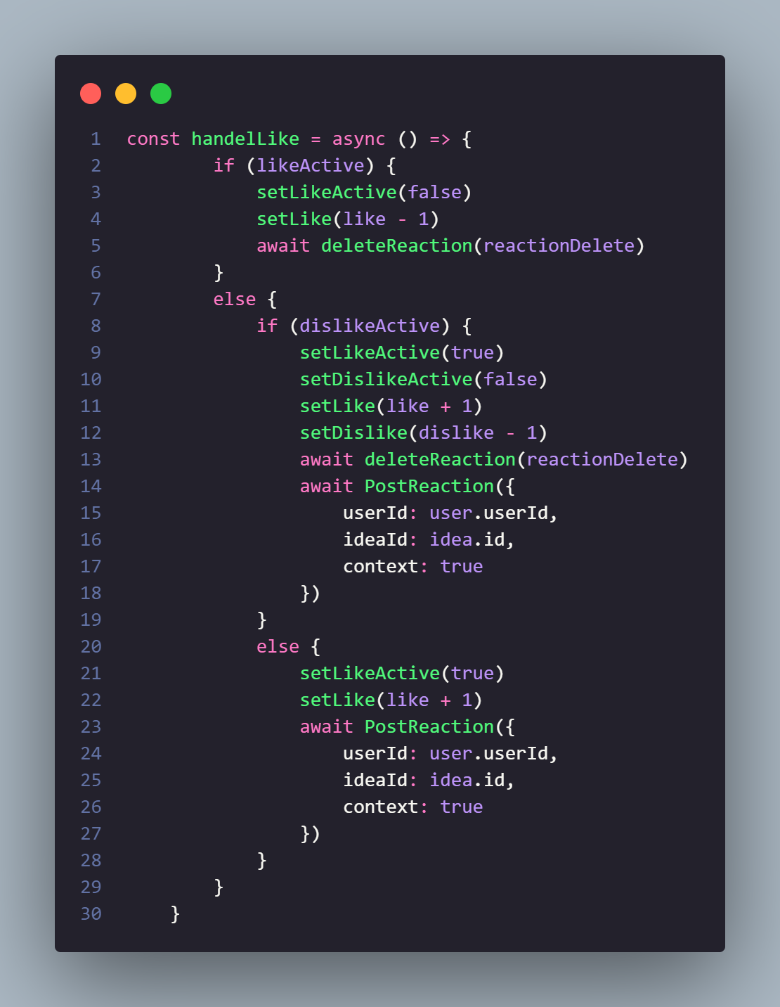

Code 14. Like

Initialize the handelLike function to handle the user performing the action of clicking like or disliking a post. If the post has been liked by the user, the user who clicks it again will cancel the activation of the like button on the interface, and call the deleteReaction function and pass in the reaction that has just been clicked. If the post has been disliked by the user, then when clicking the like button, the system considers the like button active and deactivates the dislike button, and calls the deleteReaction function to delete the dislike reaction and calls the PostReaction function to repost the like reaction. In case the user has not done like or dislike on the post, when pressing like, the system will activate on the like button and call the PostReaction function to post the reaction like.

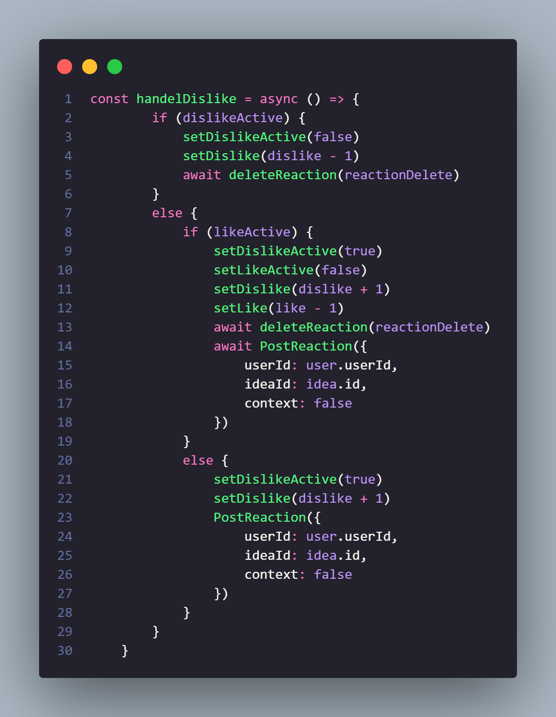

Code 15. Dislike

Initialize the handleDislike function. This function is similar to handelLike welding but instead of checking the like button case, the function will check the dislike button case.

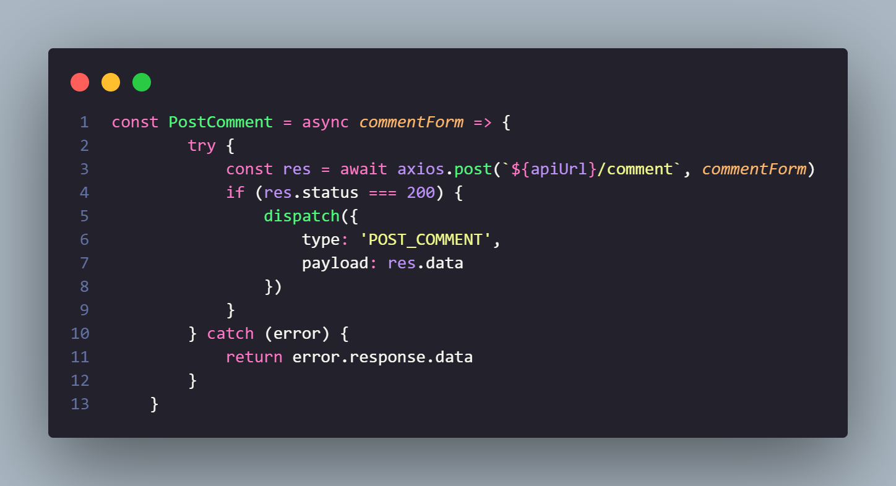

Code 16. Comment

Initialize the PostComment function. Call api, if the response returns a status of 200, it will transmit an action of type "POST_COMMENT" and the payload is the data received from the response.

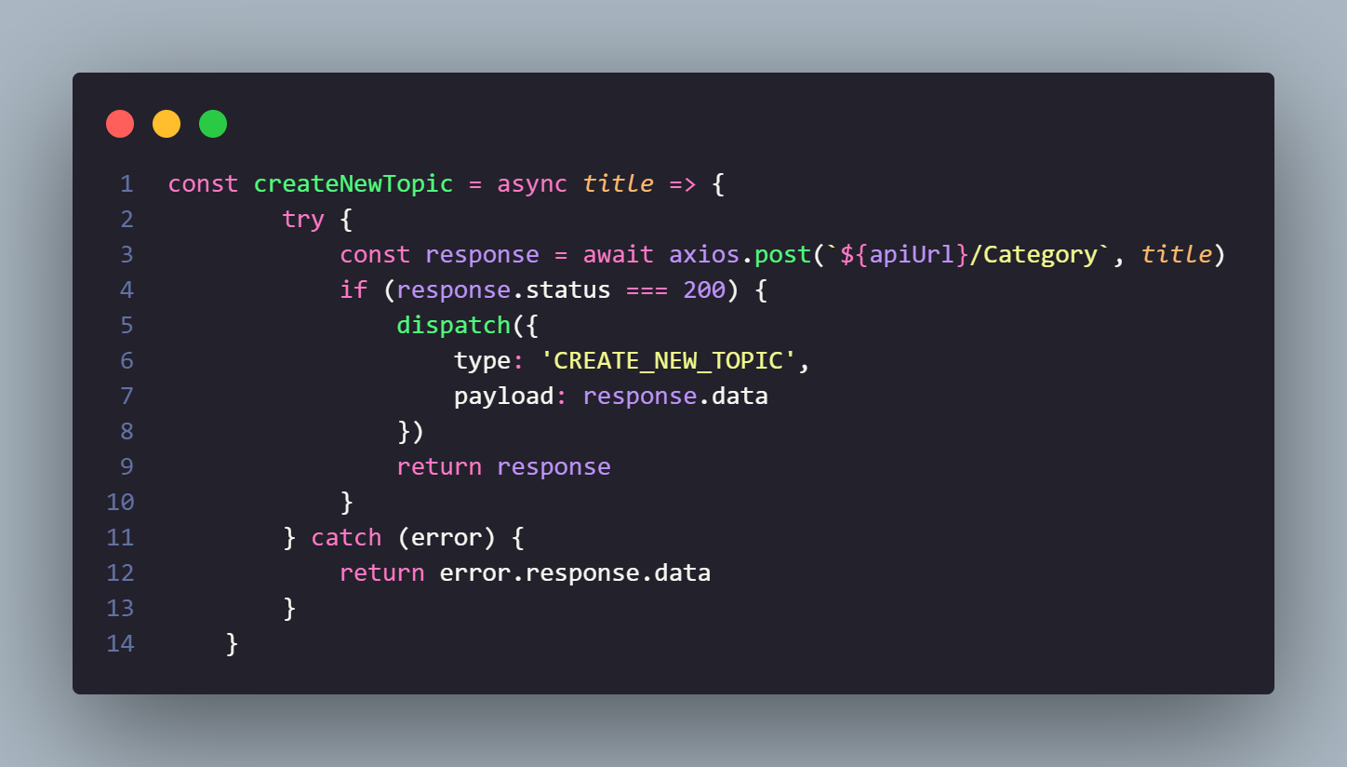

Code 17. Create topic

Initialize the CreateNewTopic function. Call api with post method. If the response returns a status of 200, send an action of type “CREATE_NEW_TOPIC”

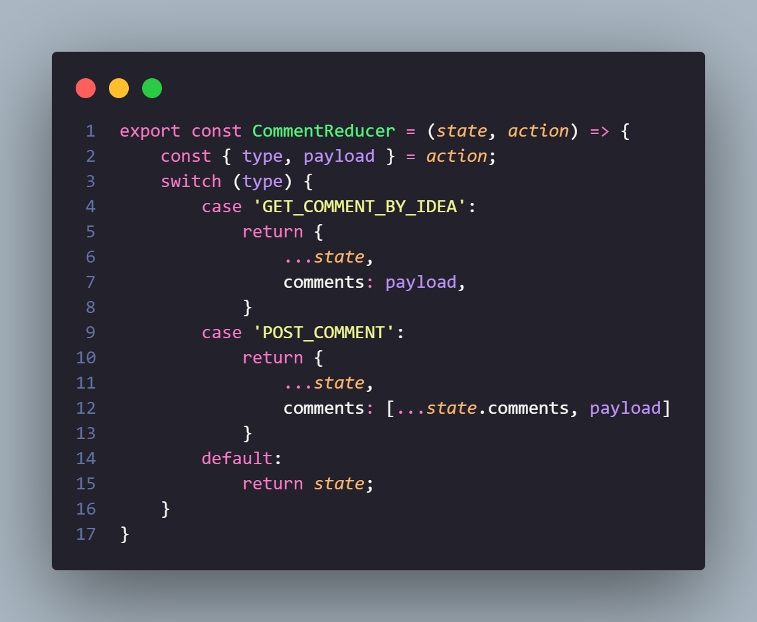

Figure 31 Comment reducer

Initialize the CommentReducer function. Check the case that the action has type "POST_COMMENT" to set the state variable (array) to add a new element that is the payload passed.

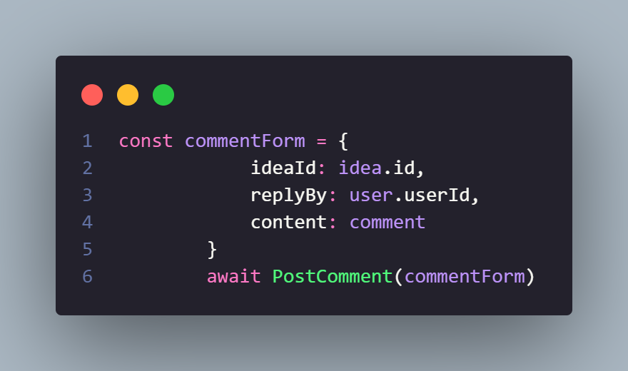

Initialize the commentForm variable passing in the entire value of the comment. Call the PostComment function and pass the commentForm variable.

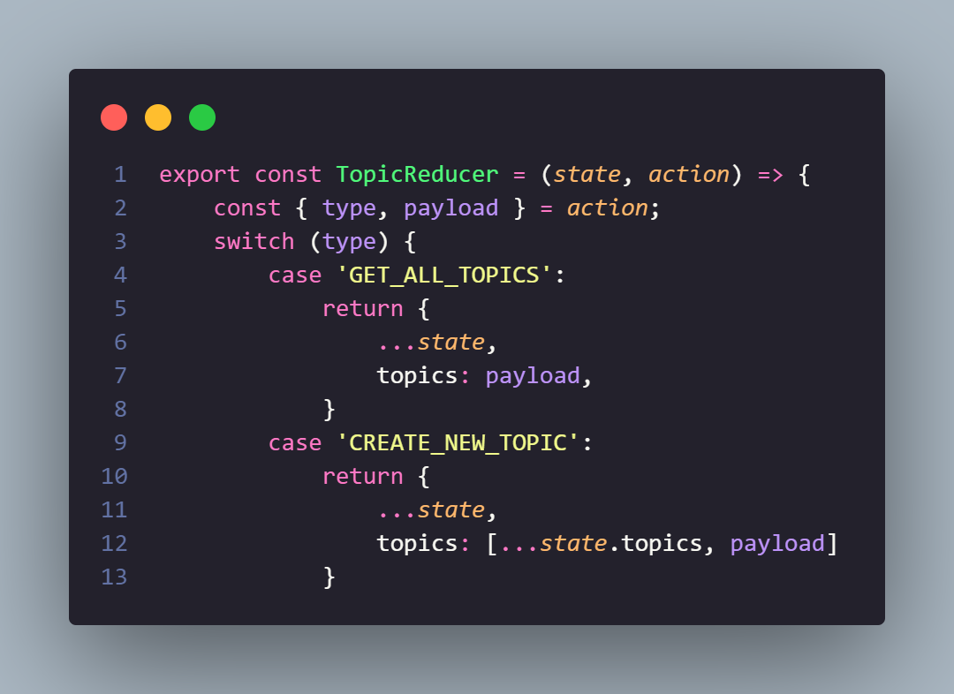

Code 18. Topic reducer

Initialize the TopicReducer function. Check the case that the action with type "CREATE_NEW_TOPIC" will assign the state variable (array) to add an element called payload.

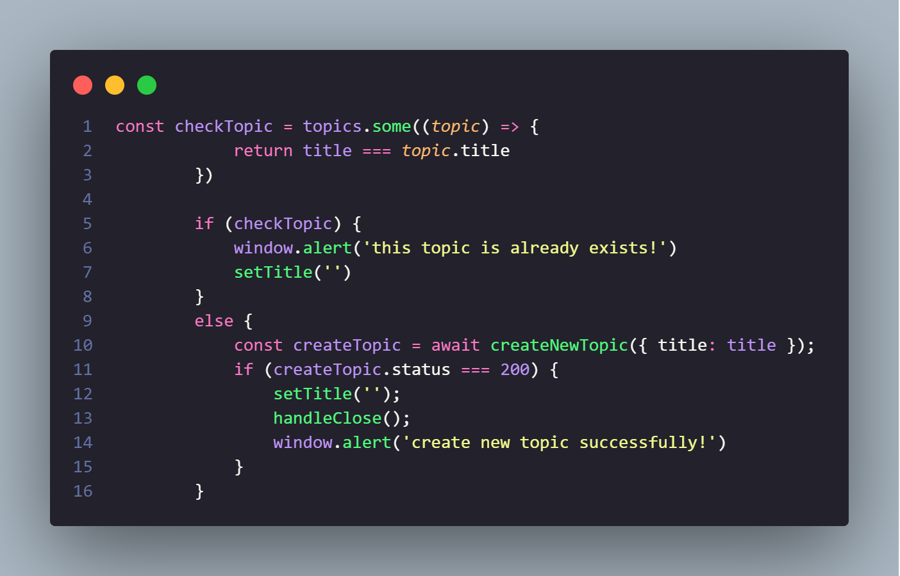

Check if the topic the user just entered exists in the list of old topics. If there is a message that the topic already exists. otherwise call CreateNewTopic function. If the status returns equal to 200, t=a message of successful topic creation. At this point, the topic will have a default deadline.

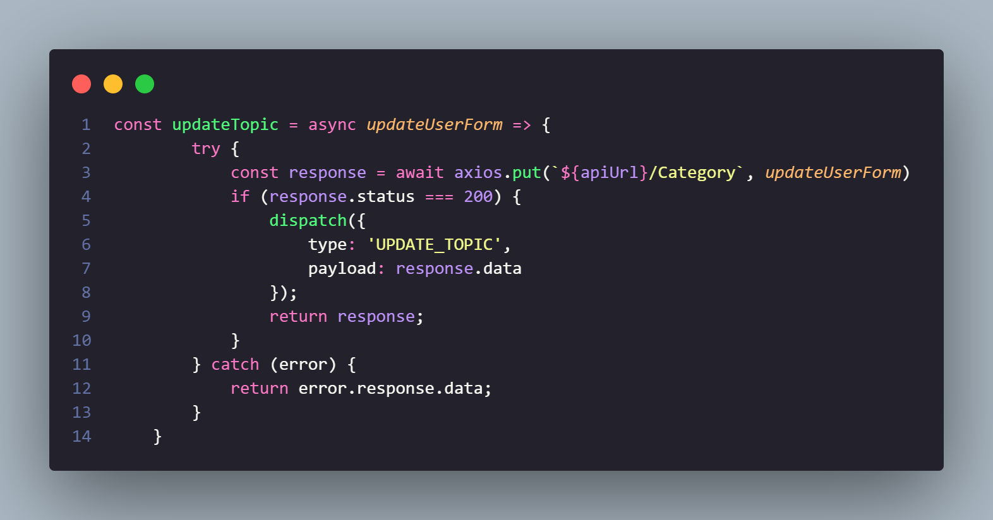

Code 19. Update topic

Initialize the Topic update function. Call api with PUT method. If the response returns a status of 200, send an action of type “UPDATE_TOPIC” and the payload is the returned data.

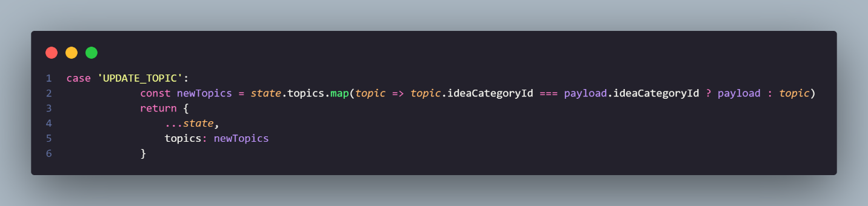

In the TopicReducer function check in case the action has type "UPDATE_TOPIC", perform a map through the state variable (array) to change the topic value.

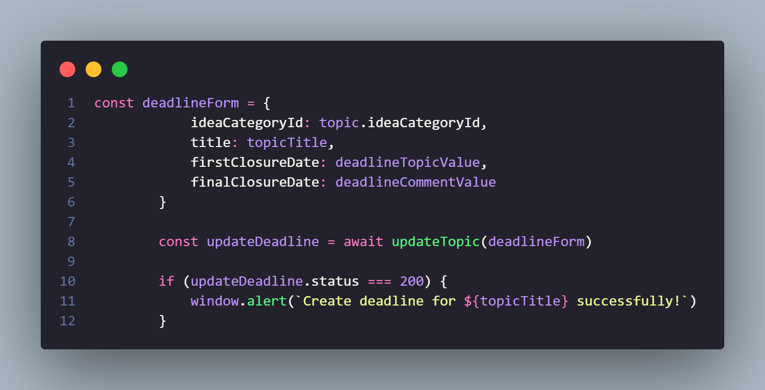

Users who want to set a deadline for a topic will update that topic. Initialize the dealForm variable with the value passed including the deadline time for the topic. Call the updateTopic function and pass the deadlineForm variable. If the update is successful, the system will send a notice of successful creation of the deadline for this topic.

## Flowcharts

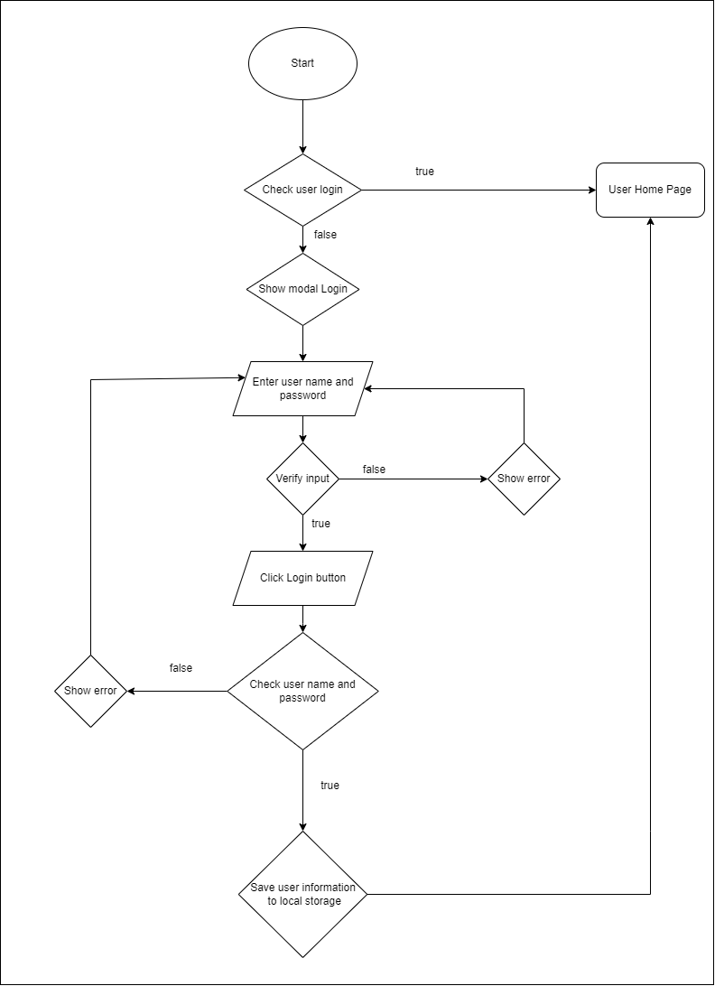

Flowchart 1. Login

Here is the flow chart of the website's login. When the user starts to login to the website, the website will ask the user to enter an account and password to be able to log in to the website. When entering information, the user presses login to access the website, if the account and password are used, the user will be redirected to the homepage. If wrong, the user will be given a message about entering the wrong account or password and asked to re-enter it to be able to log in to the website. This will log in until the user can access the website or stop logging in.

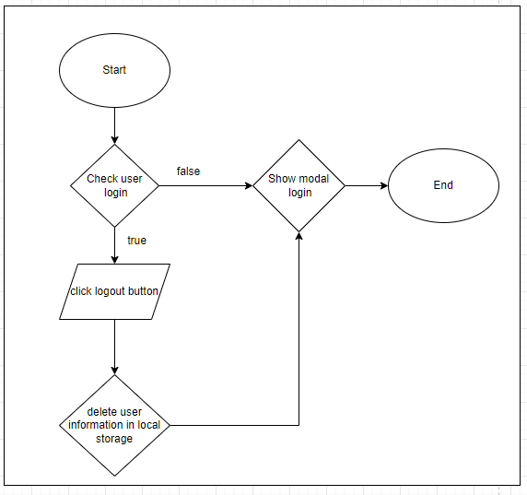

Flowchart 2. Log out

With logout, when users want to log out, they will click on the log out button to be able to log out of the web site.

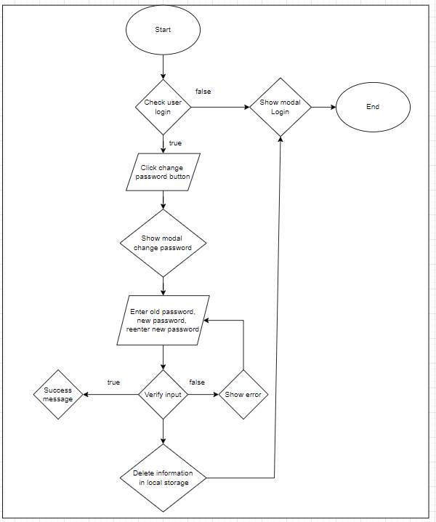

Flowchart 3. Change password

For password change, first need the user to go to the personal information section and then select change password it will take the user through the interface of the password changer, here it asks the user to enter the old password and the new password. If the password is not correct, it will display a message and ask the user to re-enter it, if it is correct, a successful password change message will appear.

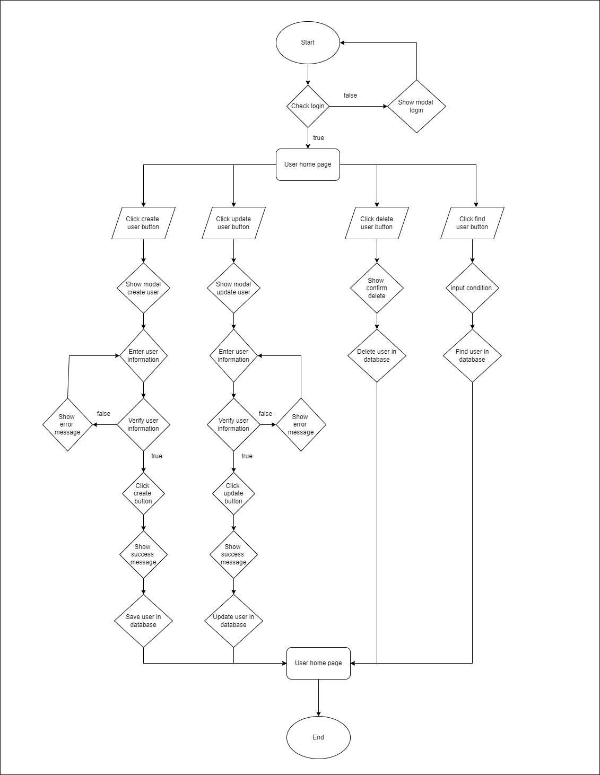

Flowchart 4. Admin

Admin: first of the user will log into the system, if the login fails, the user will return to the login page, if the login is successful, it will be taken to the admin's home page. Here we have 4 functions: create user, edit user, find user and delete user:

* Create user: click on the user button, then it will display the user interface, then click on create user and enter user information, if the entered information is not valid, the system will ask to re-enter it. If the information is valid, the system will notify the input successfully.
* Update user: select the user who wants to update the information, then start editing the user's information. If the edit is valid, a message will appear to update the user information successfully, if the information is not valid. then the system notices that the update information is invalid and asks to re-enter it
* Click on the user you want to delete, then a message will appear whether you want to delete this user or not, if you click OK, the user will be deleted.
* Find user: admin click on the search bar then enter the username to search

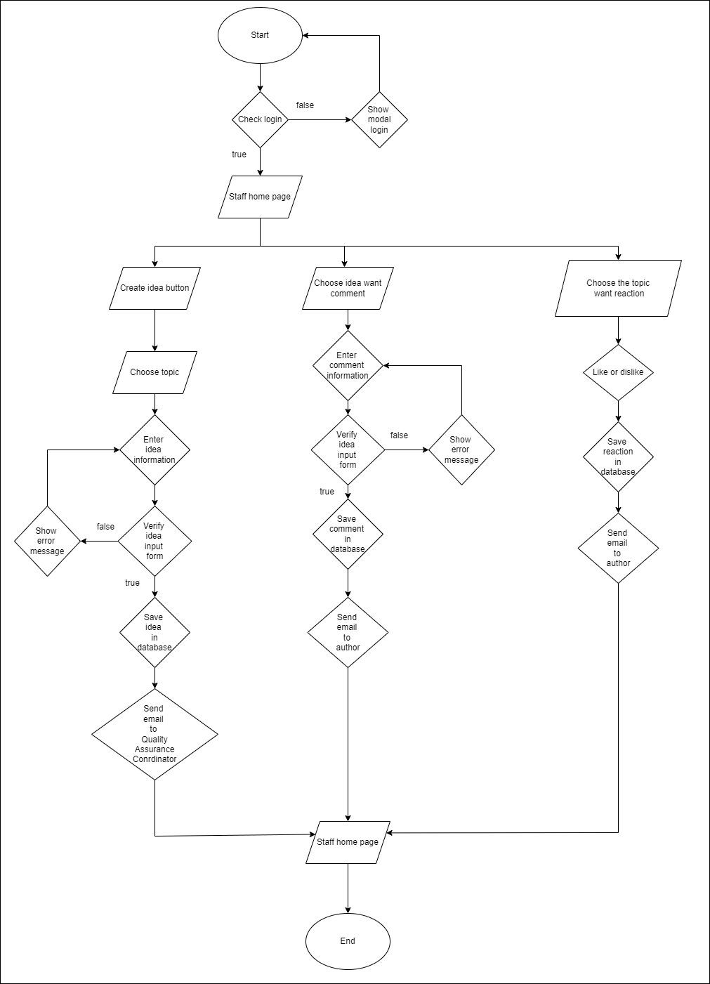

Flowchart 5. Staff

Staff: first of the user will log into the system, if the login fails, the user will return to the login page, if the login is successful, it will be taken to the Staff’s home page.

* After entering the home page, the staff can post ideas by category by clicking on that category and then entering the information of the article they want to post, then clicking post, the system will display information about the terms before posting if the user If you click agree, the post will be posted to the system.
* Comment on the ideas that have been posted by clicking on the comment of the post the staff wants to comment on
* Reaction post Staff just click on the like or dislike button of the posts

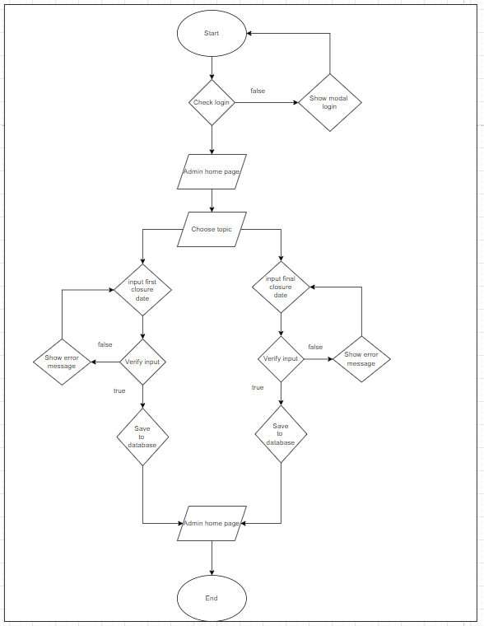

Flowchart 6. Set date for post idea and comment

User Admin can set the date of posting ideas and comments. If the date is set less than today, the system will display a message asking to re-enter if the date is greater than today, the renewal message is successful.

## Activity diagram

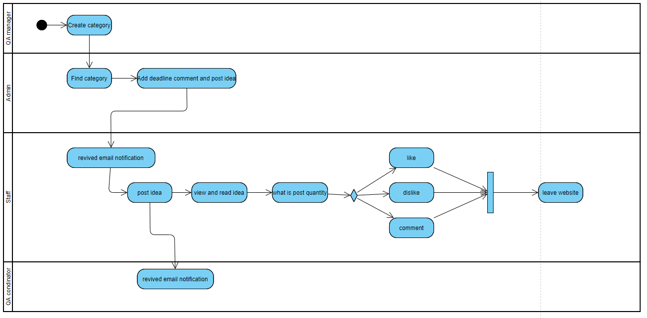

Figure 32. Activity diagram

The website will start operating from the position of QA manager when QA manager adds category(topic), Admin will receive a notification that there is a new topic, then Admin can add a deadline for staff about posting ideas for that topic on the system... When the Admin successfully adds the deadline, the staff will receive an email informing that there is a new topic and need to post an idea. After posting the idea, the Staff can see and read other ideas posted by other Staff and can also evaluate other ideas through commenting and dropping reactions, when the Staff posts the idea, the QA coordinator will receive an email about it. Staff post ideas for the system. Finally, the process of a system is terminated.

# Interface (screenshots)

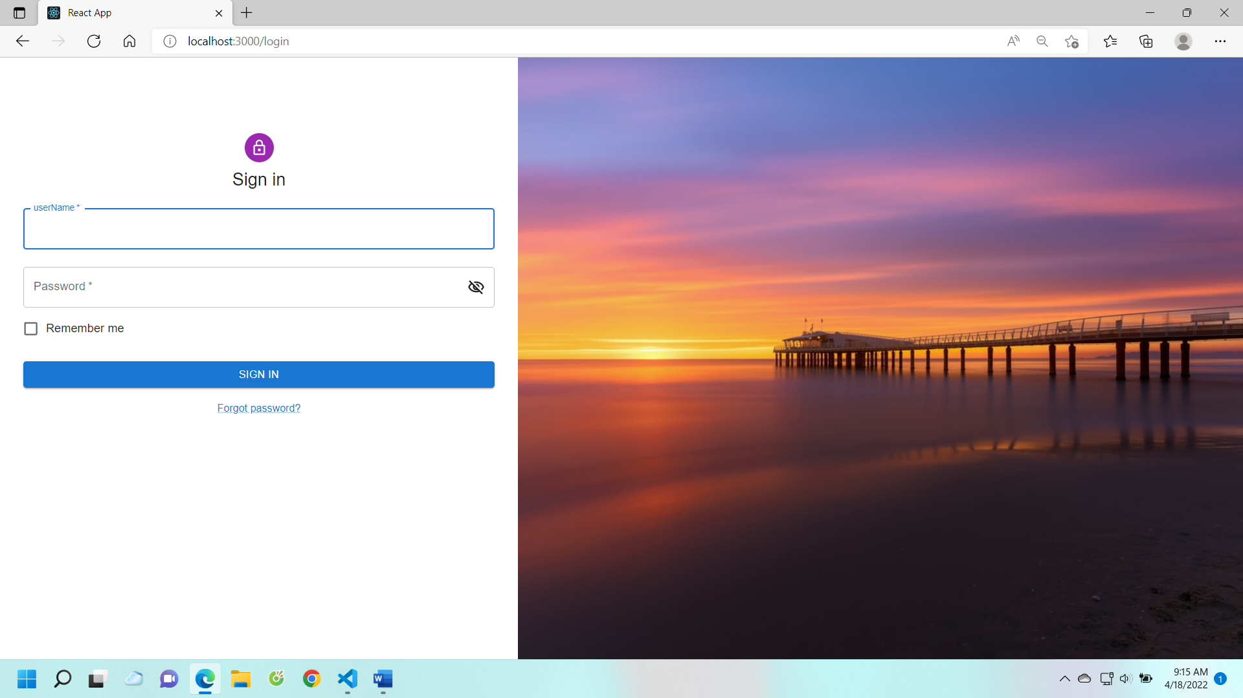

Figure 33. Login

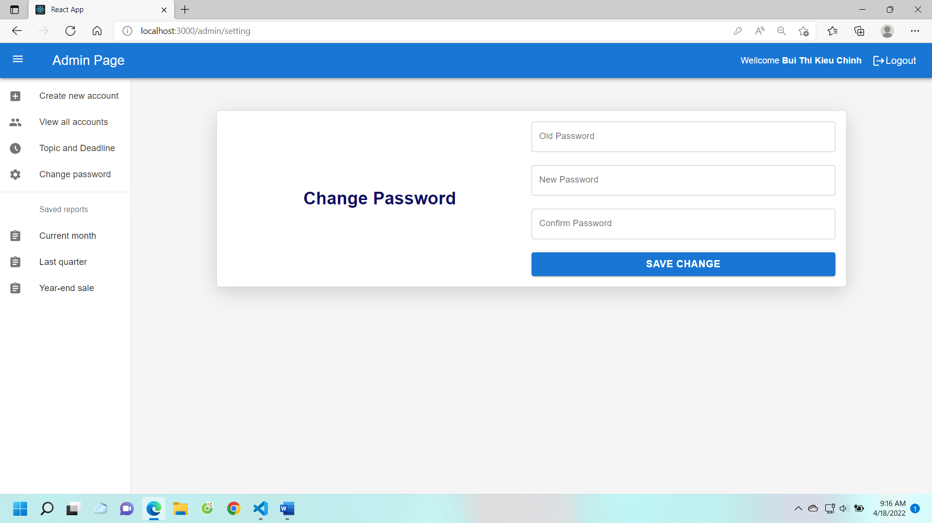

Figure 34. Change Password

When using the system, the user will be granted a separate account, the default passwords are very predictable, so when logging into the system, the user can change his or her own password. Besides, if the user forgets the password, the admin can edit or create a new account for the user.

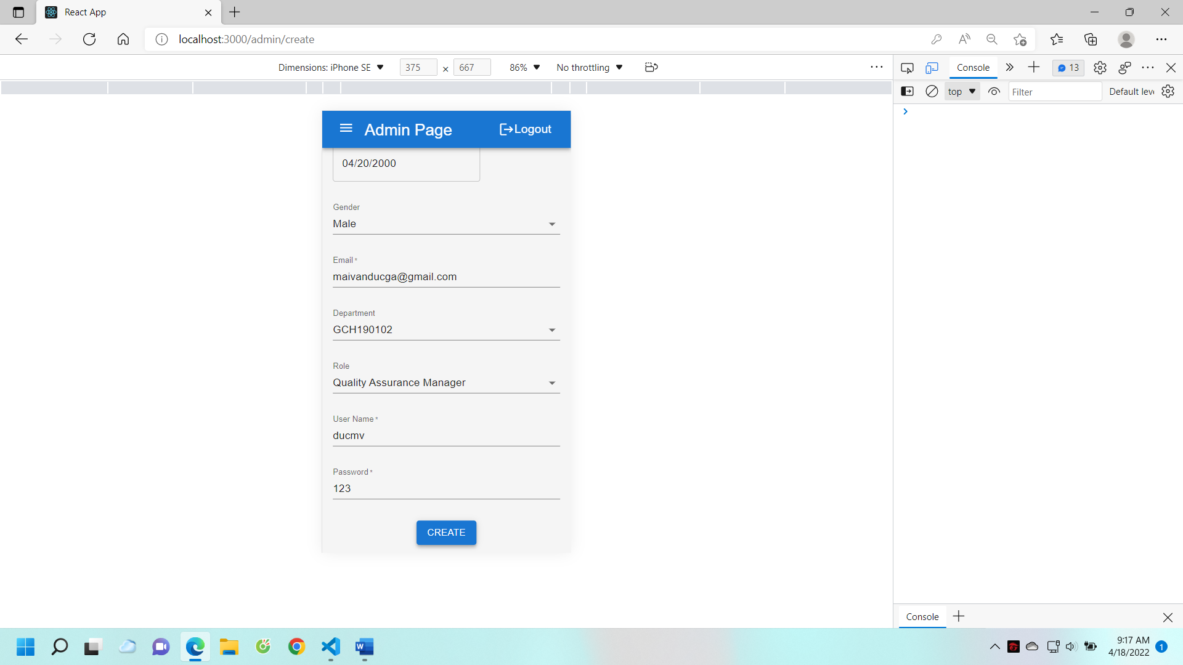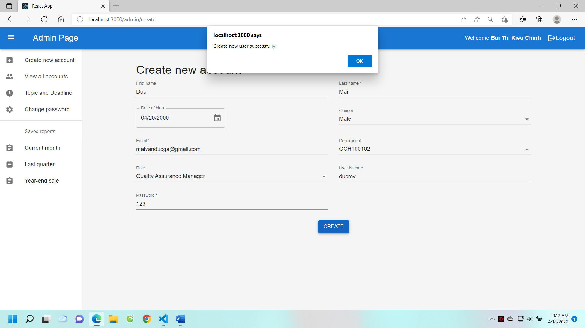

Figure 35. Admins create user account

This is the interface that creates a user account for admins, including the user's details. The image next to it is a mobile interface, which makes it easy for users to use with different devices.

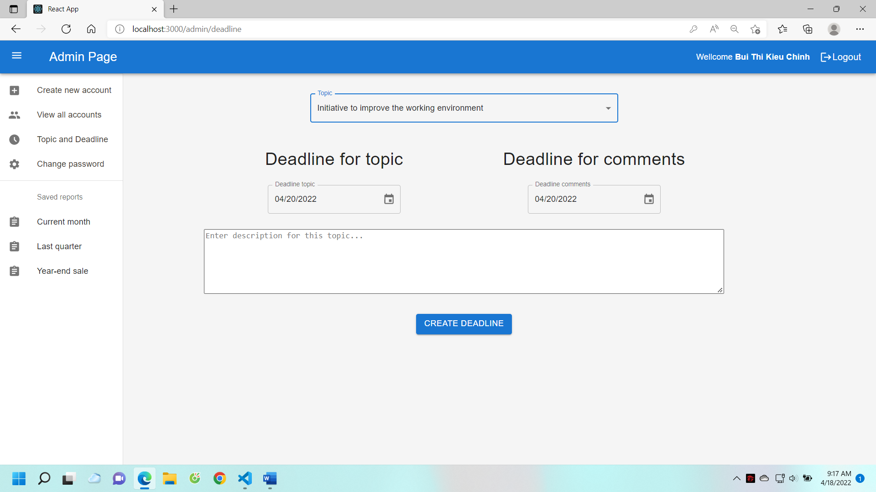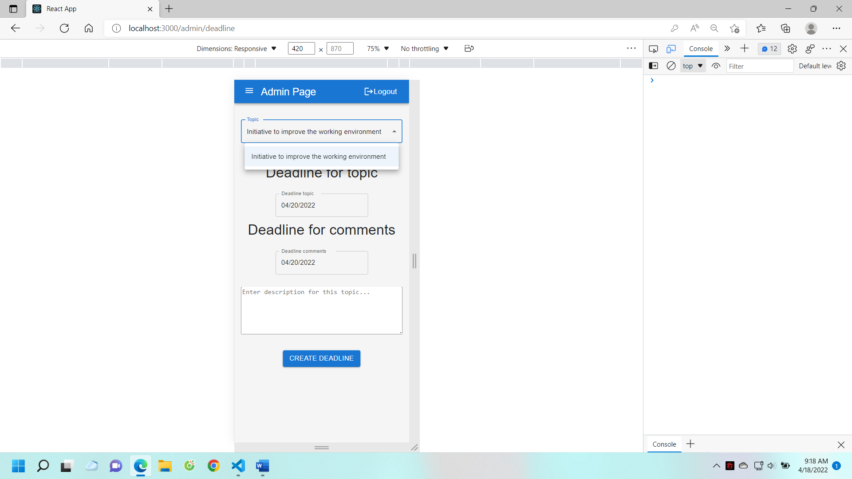

Figure 36. Admin creates deadline

This interface is for admins, admins can put dealine ideas and dealine of comments

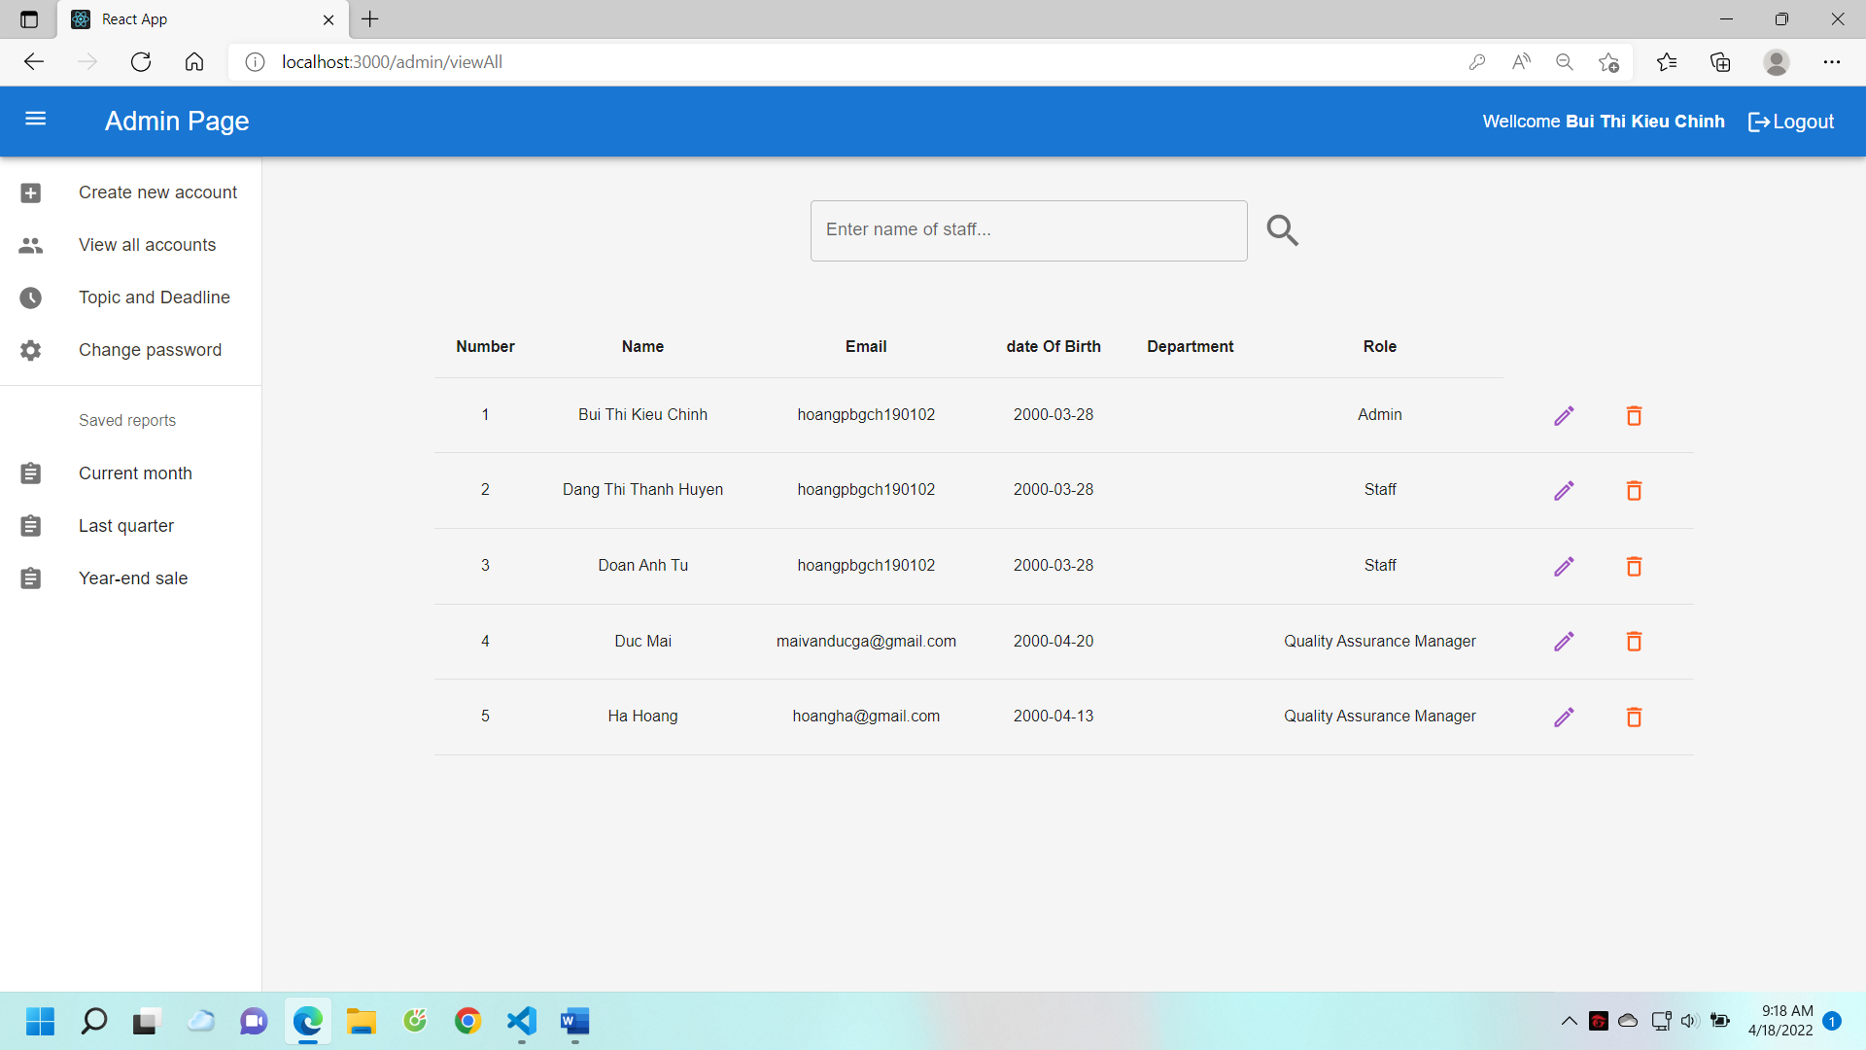

Figure 37. Admin edit user account

Admins can add, edit, delete any account in cases where the account is no longer in use, or forget the password.

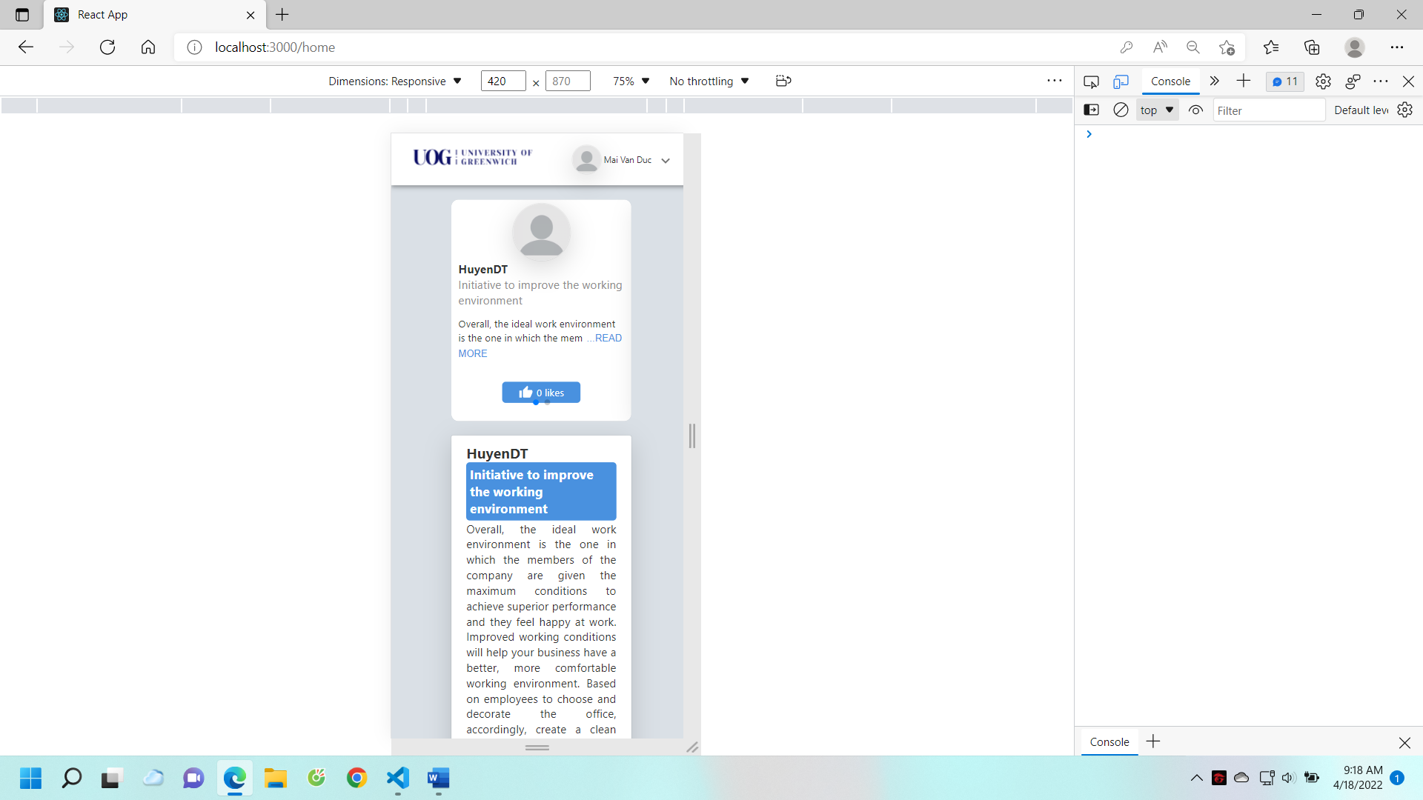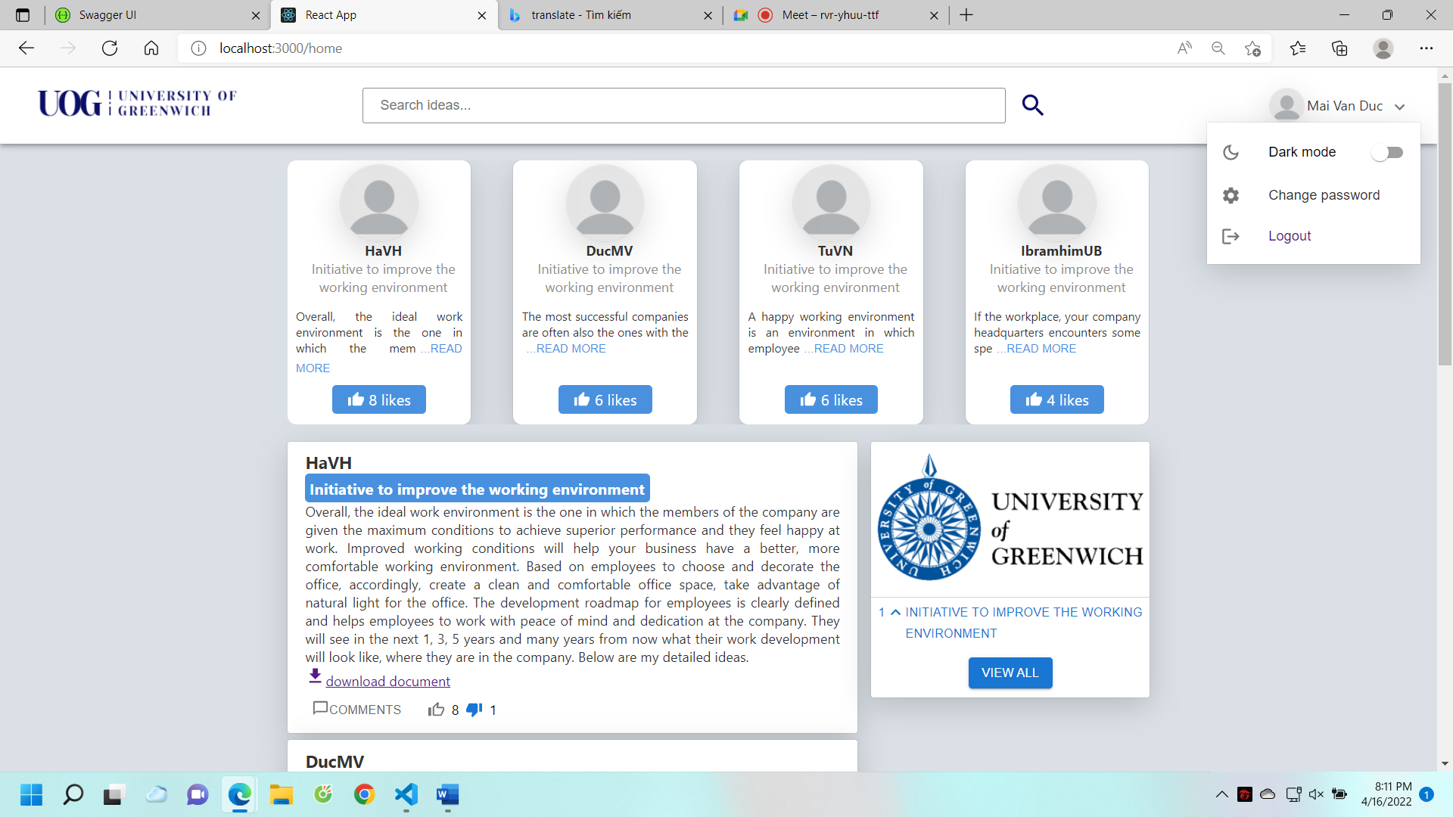

Figure 38. Staff homepage

This is the interface for staff, employees can see popular ideas, the most likes on top, the latest generated ideas will also show the top.

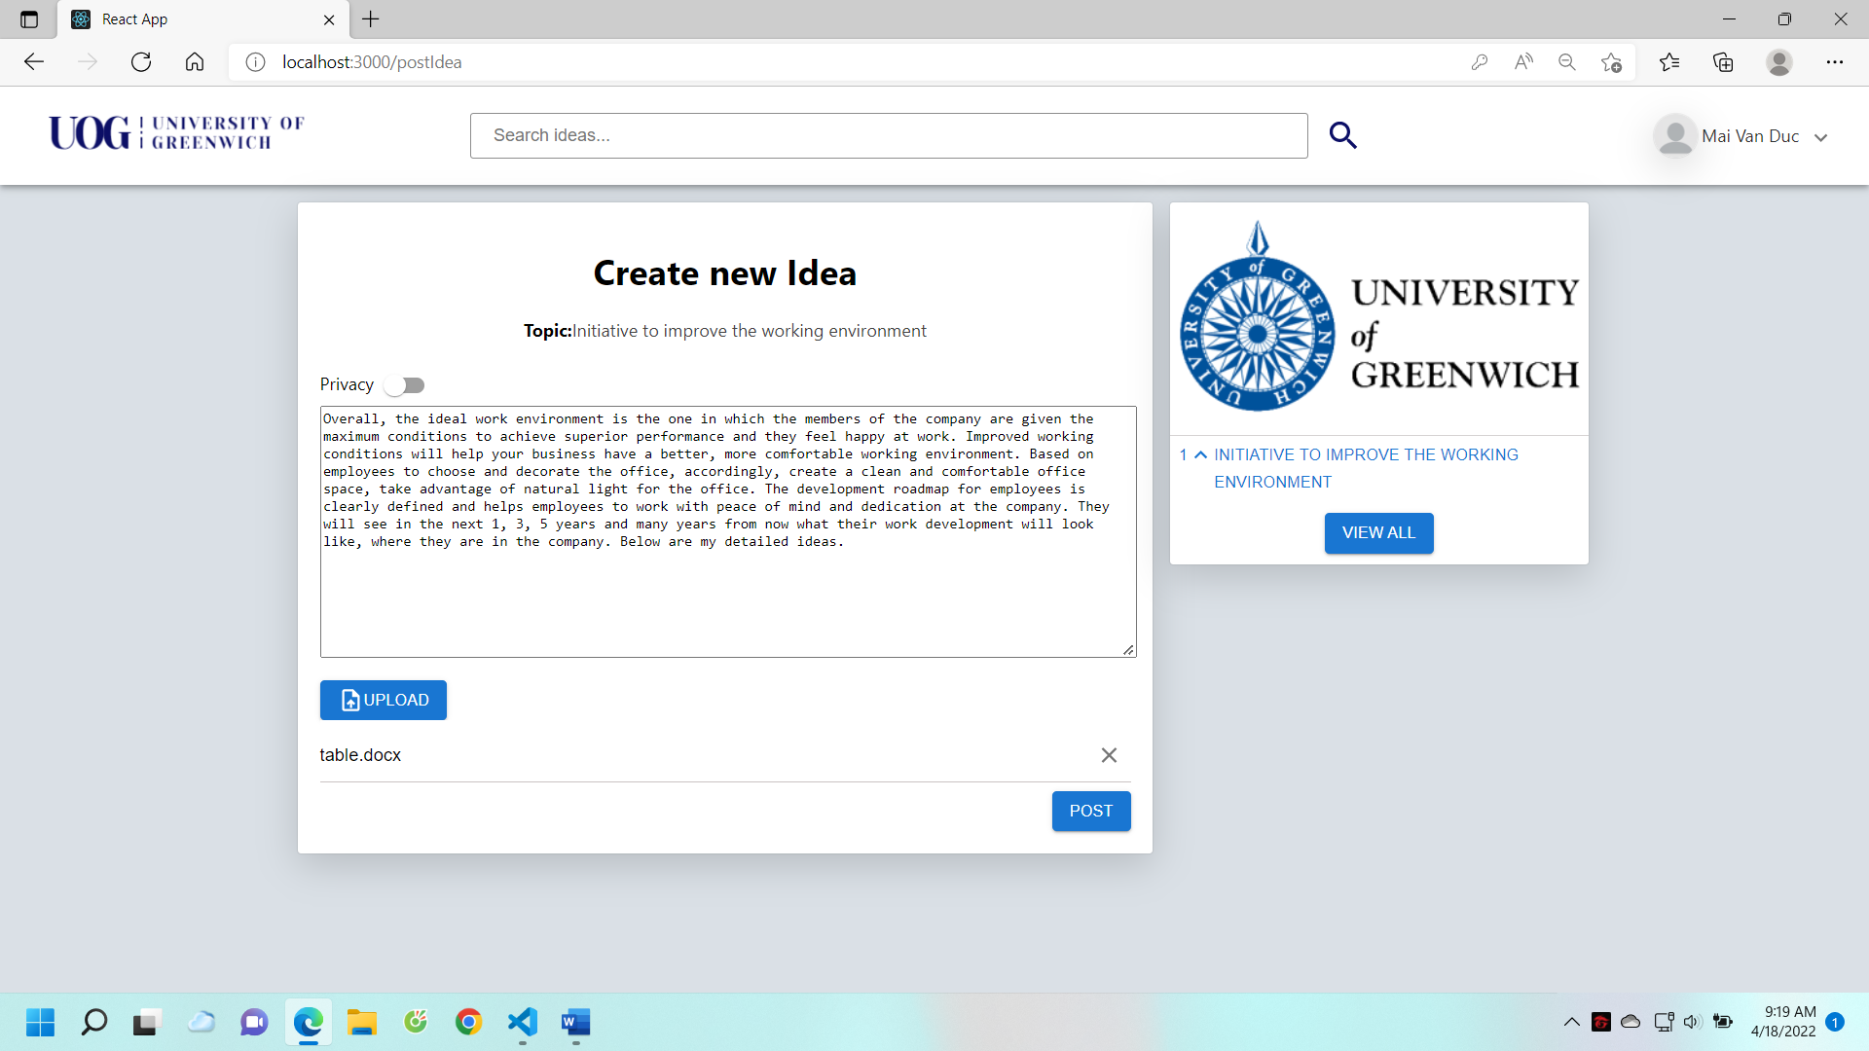

Figure 39. Staff posted ideas

This is the interface that posts the idea of employees, employees can upload documents in different formats. Also when posting ideas, employees can choose to post anonymously or publicly with the "Privacy" button.

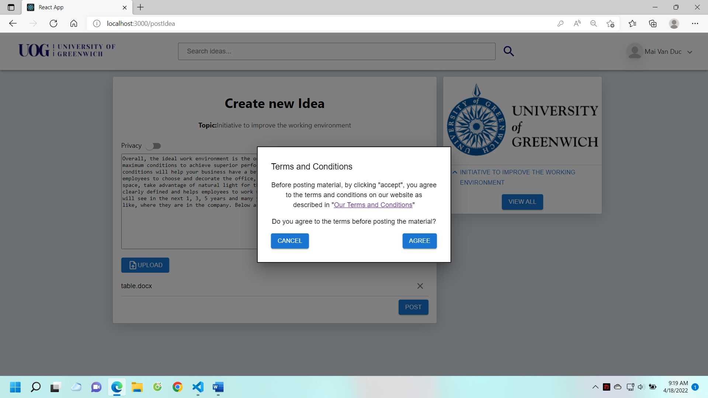

Figure 40. Before posting the idea, the terms and conditions will be popup

Before staff post ideas, the system displays conditions and terms information, and when staff agree to the terms, they can post ideas.

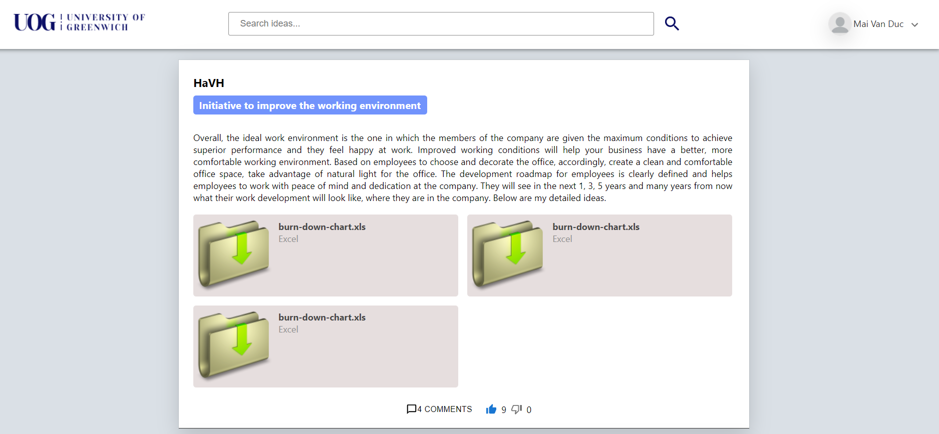

Figure 41. Post details

This is the interface of the idea detail page, it will show the detailed information of the post including the document file, in this page the user will be able to see the comments and comments on the post (figure 42)

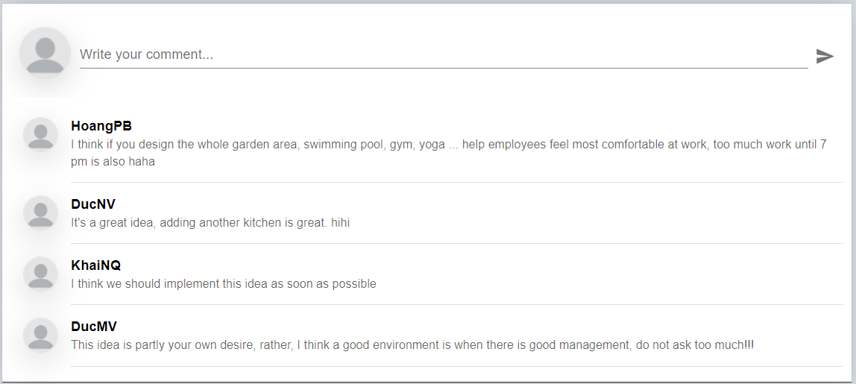

Figure 42. Comment

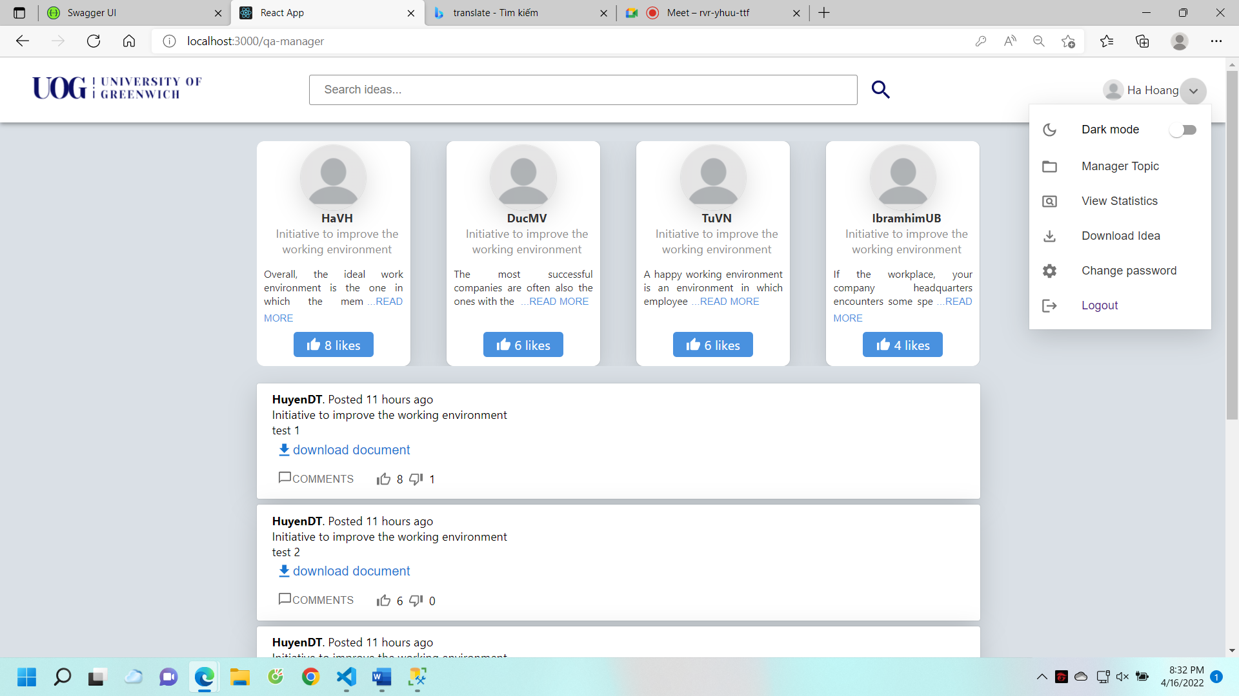

Figure 43. Manager's homepage

This is the manager's home page interface; they can see popular ideas and the latest idea posts.

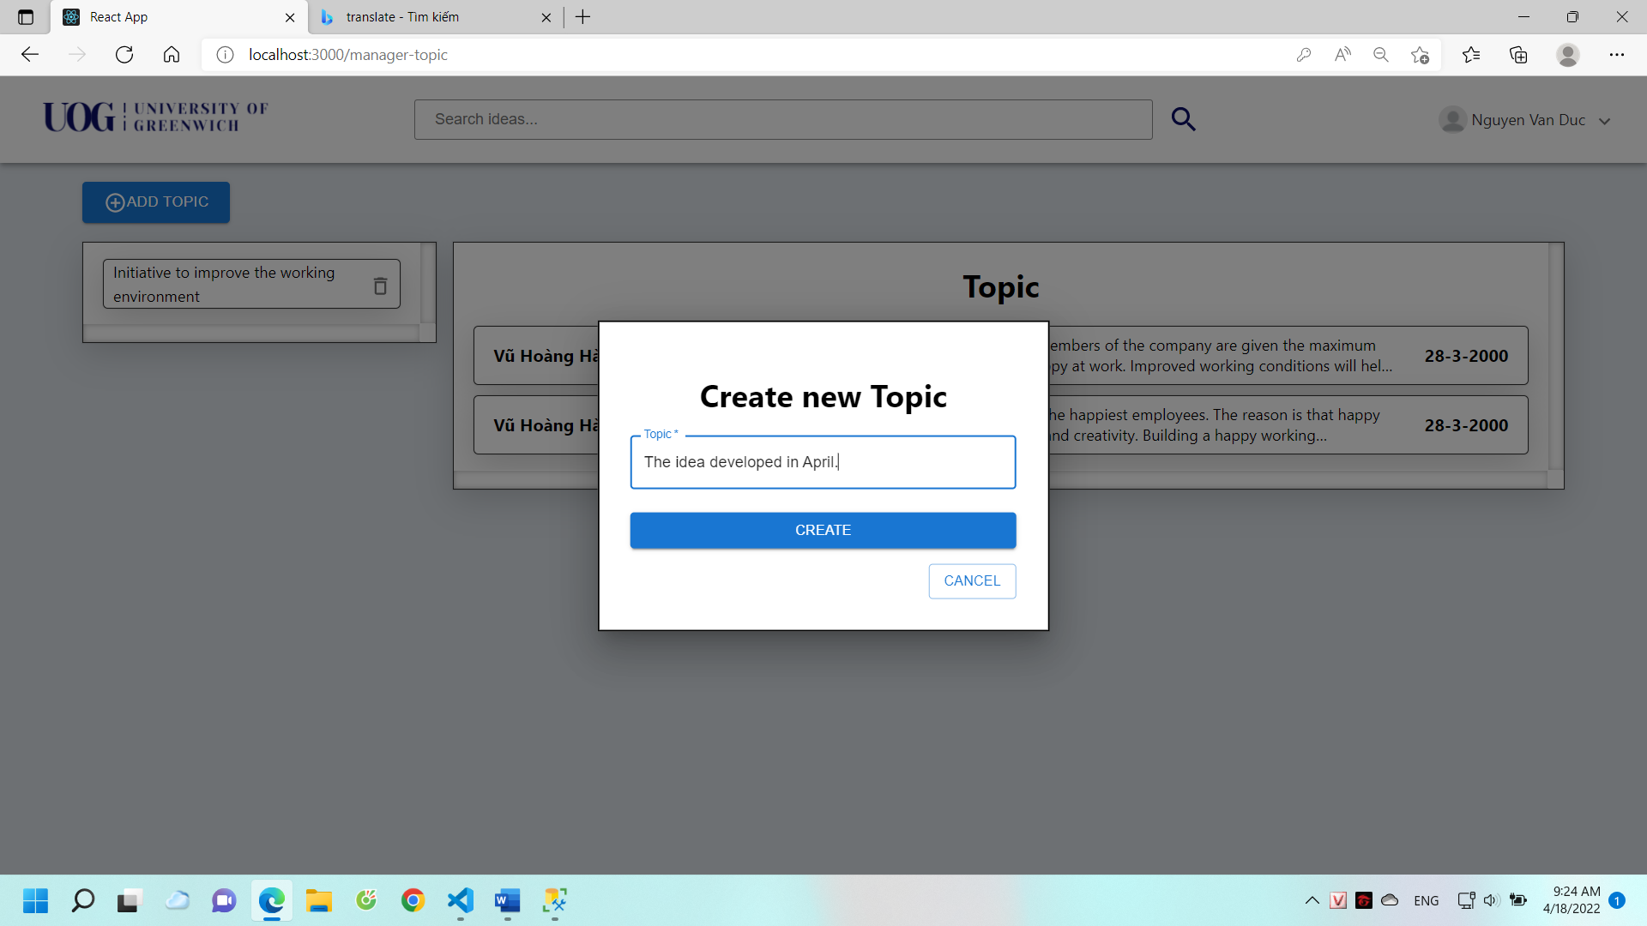

Figure 44. Managers create the topic

The manager can create a topic in this page, besides, when the manager clicks on the topics, the system will show the staff who have tagged the topic into their post will be shown in detail.

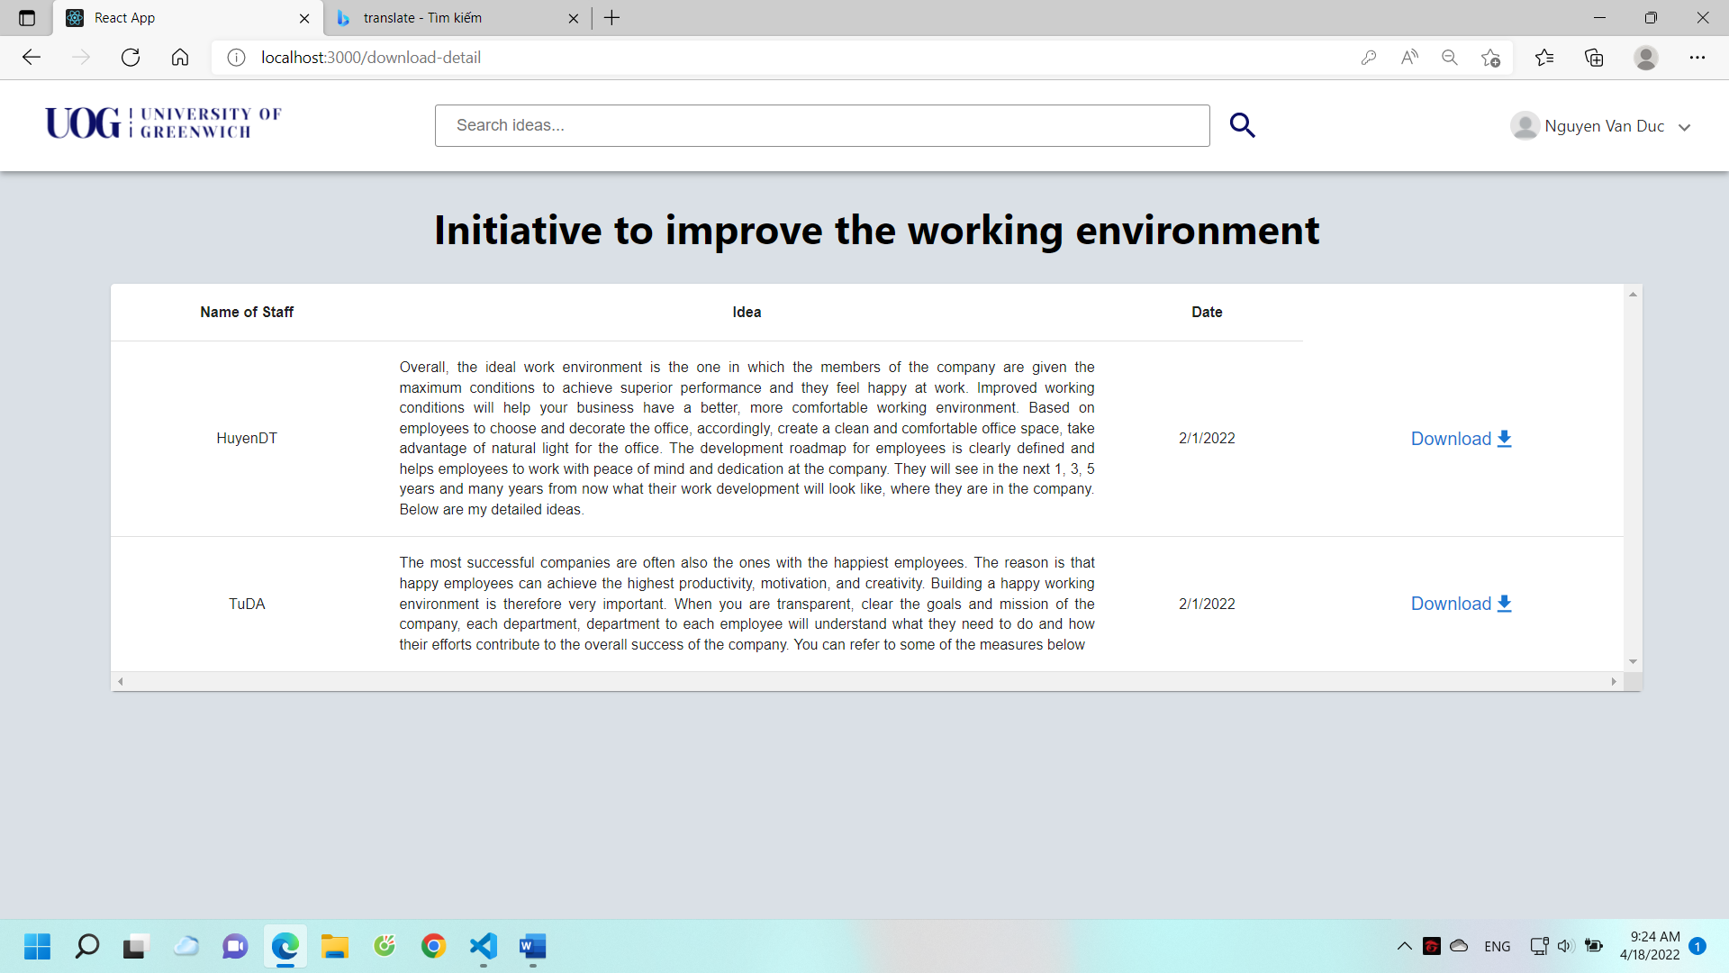

Figure 45. File download manager

This is the interface on which the manager can download data files in csv format.

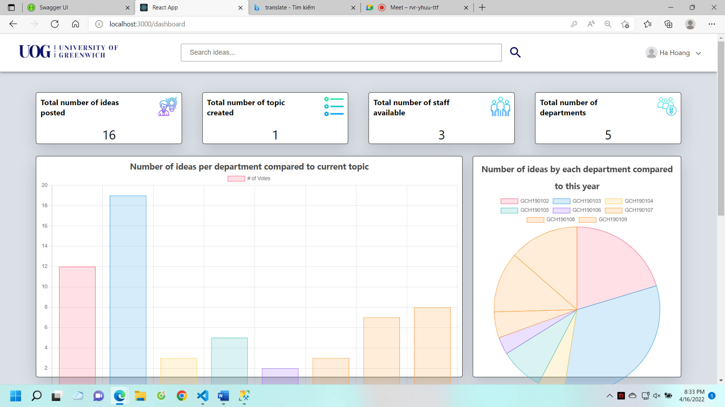

Figure 46. Manager dashboard page

Finally, the manager can see the statistics of the system.

# Testing

## Test Plan

### Scope

The goal of this document is to check all the requirements, the specifications that have been provided from the beginning.

#### Functions required to be checked

* All functions inside the request document have been provided
* System performance
* Check the security features of the system
* Detailed examination of the logical functions of the system
* Check the system's flexible interface level with different devices

#### Functions that are not required to be checked

* No other function section (8.1.1.1)

### Quality Objectives

#### Primary Objectives

The main objective of this test is to ensure that the system can fully meet the required features. Includes quality requirements for system features and requirements on the interface of the system, testing the features that the user uses the system. This test will provide test case and test log documents so that users can understand that the system can meet their requirements.

The most important thing is that there are any changes from the request or removed from the system requirement. The specification document requires the design to be recorded and tested in the most rigorous way, which is to ensure that the requirements are not missed.

#### Secondary Objectives

The team will assign the project manager as the csrum master to plan the risks when testing the project, if there is a problem in the testing, the scrum master will identify and communicate information about the problems that are encountered to the team members.

### Test Approach

The team's approach is that after creating a list of functional requirements, the scrum master will predict and design the tests. Test cases will be added during system testing. After completing each feature, the tester will test the planned cases and report back to the scrum master.

### Roles and Responsiblities

|  |  |  |
| --- | --- | --- |
| **Role** | **Name** | **Responsibilities** |
| Project Manager | Vu Hoang Ha | * Take full responsibility for the progress of the project. * Plan a project test * Analyze the requirements of the project |
| QA Lead | Mai Van Duc | * Conduct the most up-to-date inspection of the project's testing plans * Note any problems that occur during the test * Report on career progress with project manager |
| QA | Ibrahim | * Understand the requirements to be tested * Review and evaluate test cases * Update the plans to test if changed * Coordinate with QA lead when testing is problematic * Note the system error |

### Test Strategy

#### Role of QA in system testing

**Understand project manager's requirements analysis:**

* Documents analyzing user requirements
* Capture the testing methods offered by Project Manager

**Prepare test cases:**

* QA will make test cases, then report back to Project Manager for confirmation.

**Creating Test Data:**

* The test data is generated by qa lead, the data needs to correspond to the requirements from the user.

**Conducting test cases:**

* Project Manager will be the same level for QA test case table
* QA will record errors and give results to test cases

**Retesting:**

* Retesting will be carried out by QA. After the errors are resolved by the developers, QA will test again and then report the results to Project Manager.

**Deployment/Delivery:**

* After all the problems, the errors of the system are fixed, QA will send the entire report on the test cases and test log to the Scrum master to conduct the project review.

#### Testing types

**Test the functions:**

* The functions are rigorously tested with different cases
* The tester must ensure that the system's output and input data have been checked in detail.

**Test the performance of the system:**

* Testers need to check page reloading levels with all functional requirements
* Check system speed when entering real data into each page

**User interface testing:**

* Check the interface in accordance with the design requirements of wireframe
* Check the flexibility of switching systems between devices

**System testing:**

* QA will test a life cycle of some user games. "Staff" test example: Sign into the account -> Create Idea -> Like -> comment -> change password -> logout.

### Resource And Environment Needs

#### Testing Tools

|  |  |
| --- | --- |
| **Process** | **Tool** |
| Create test cases | Google Sheets |
| Create a table of test case assessment factors | Google Sheets |
| Perform experiments | Google Sheets |
| Record high-severity test cases | Microsoft Word |
| Write a test report | PDF |

#### Test Enviroment

**Browsers:**

* Win 10: Chrome, Coc Coc, Edge, Firefox, Opera
* Mac OS: Safari, chrome, Opera

**Devices:**

* Iphone SE, IPhone 6/7/8 Plus, Iphone 11/12 Promax, Samsung Galaxy Note 5/20, Ipad air 2.

## Test case

|  |  |  |  |  |  |
| --- | --- | --- | --- | --- | --- |
| **Number** | **Test case name** | **Datatypes** | **Expected Result** | **Actual Result** | **Pass/Fail** |
| 1 | See the website |  | The homepage can be viewed when successfully logged in | can see home page while typing | Pass |
| 2 | Login to roles |  | When you log in to different accounts, you can access different roles | Access to different roles with different accounts | Pass |
| 3 | Test login wrong |  | Displays a message that the account or password is wrong | Nothing is displayed | Fail |
| 4 | Test logout |  | Can log out of current account | Log out of the currently logged in account | Pass |
| 5 | Create user | Abc, 123 | New users can be created | Create a new user | Pass |
| 6 | Create user | #!&$*% | Message with invalid characters | Created normally | Fail |
| 7 | Delete user |  | Can delete users | Can delete user | Pass |
| 8 | Update user | Abc, 123 | User can be updated | Update user | Pass |
| 9 | Update user | @#$*%&^ | Notifications with special characters cannot be updated | Update user | Fail |
| 10 | View topic |  | Topics can be viewed | Can see topic | Pass |
| 11 | Upload idea |  | ideas can be uploaded | Ideas can be uploaded | Pass |
| 12 | Like |  | Like successfully, the number of likes + 1 | Like it | Pass |
| 13 | dislike |  | Can dislike | Can Dislike | Pass |
| 14 | Comment text |  | Can comment | Can comment | Pass |
| 15 | Comment photo |  | Can't comment | Can comment | Fail |
| 16 | Upload multiple files |  | Can be uploaded | You can upload multiple files | Pass |
| 17 | Upload file |  | Can be uploaded | Can upload files | Pass |
| 18 | View the topic with the most likes |  | Viewable | View the topic with the highest likes | Pass |
| 21 | Searching for ideas | Ideas exist | Couldn't find it | find ideas | Fail |
| 22 | Searching for ideas | Idea doesn't exist | Haven't checked | The idea doesn't exist (or returns nothing) | Fail |
| 23 | Search user's name | Username exists | Can search for users | Returns the users with the name searched for | Pass |
| 24 | Search user name | Name does not exist | Couldn't find it | Returns nothing | Fail |
| 25 | deadline extension | Start date is less than end date | Error message cannot be renewed | Notice cannot be extended | Pass |
| 26 | Deadline extension | The start date is greater than the end date | Deadline can be extended | Notice of unsuccessful renewal, please renew it again | Pass |
| 27 | Close the idea post when the submission deadline is over |  | When the idea expires, it can't be posted anymore | Notice can't post ideas because of expiration | Fail |
| 28 | Close comment posting when submission deadline |  | Can't comment when it expires | Notice of idea is overdue for comment | Pass |

Table 3. Test case

## Test log

|  |  |  |  |  |  |  |  |
| --- | --- | --- | --- | --- | --- | --- | --- |
| **Number** | **Date** | **Test name** | **Input data** | **Expected Result** | **Actual Result** | **Results** | **Test evidence** |
| 1 | 4/13/2022 | Test login admin | Account: admin  Password: 123 | Login successfully put on home page | Take to home page | Pass |  |
| 2 | 4/13/2022 | Test login admin fail | Account: admin1  Password: 222 | Wrong message re-login | Notice of incorrect account or password input | Fail |  |
| 3 | 4/13/2022 | Tests create user | Firstname: duc  Lastname: mai  dateOfbirth:08/24/2000  email: maivanducga@gmail.com  username: ducmv  password:123  gender: male  department: gch190102  role: staff | Notice of successful account creation | Create Account Success | Pass |  |
| 4 | 4/13/2022 | Test create user | Firstname: duc#$%@  Lastname: mai  dateOfbirth:08/24/2000  email:maivanduc@gmail.com  username: ducmv1  password:112  gender: male  department: gch190102  role: staff | Notice with special characters in the name | Create success | Fail |  |
| 5 | 4/15/2022 | Test create user | email:maivanduc | Notifications require @ to work | Notice to add @ | Pass |  |
| 6 | 4/13/2022 | Test user post idea | Content: duc12331  File: doc1.doc | Notice of successful post | Notice of successful creation | Pass |  |
| 7 | 4/15/2022 | Test create deadline for topic | Enter the date: 4/14/2022 | The message has an error that the date entered must be greater than today | Error message | Pass |  |
| 8 | 4/15/2022 | Test create deadline for topic | Enter date: 4/16/2022 | Notice of missing comment deadline | Error message missing deadline comment | Pass |  |
| 9 | 4/15/2022 | Test create deadline for comment | Enter the date: 4/14/2022 | The message has an error that the date entered must be greater than today | Error message | Pass |  |
| 10 | 4/15/2022 | Test create deadline for comment | Enter the date: 4/16/2022 | Notice that you need to enter the deadline of the post idea | Error message | Pass |  |
| 11 | 4/15/2022 | Create deadline comment and post idea | Enter the date: 4/16/2022 | Successful deadline creation | Successful deadline creation | Pass |  |
| 12 | 4/15/2022 | Change password | Enter new password: hoang | Create success | Create success | Pass |  |
| 13 | 4/15/2022 | like | Click the like button | Like successfully | Like successfully | Pass |  |
| 14 | 4/15/2022 | dislike | Click the dislike button | Dislike successfully | Dislike successfully | Pass |  |
| 15 | 4/15/2022 | comment | Click the send button | Submitted successfully | Submitted successfully | Pass |  |
| 16 | 4/15/2022 | Create idea | Do not select category | Post failed | Notice that no category has been added | Fail |  |
| 17 | 4/15/2022 | Create an idea when the category is overdue | There is content but the deadline has passed | The category notice is out of date | The category notice is out of date | Pass |  |
| 18 | 4/15/2022 | Create an idea when the category has not expired | There is content but not expired | Displays a notification to agree to post or not | A notification will appear whether you agree to post or not | Pass |  |
| 19 | 4/15/2022 | Click agree | Click agree | A successful creation message is displayed | Show successful creation message | Pass |  |
| 20 | 4/15/2022 | View details ideas by topic | Click topic | View all ideas | View all ideas | Pass |  |
| 21 | 4/15/2022 | Create new topic | Click add topic | Create successful | Create success full | Pass |  |
| 22 | 4/15/2022 | Create topic already exists | Add an existing topic name | Announce the topic already exists | Announce the topic already exists | Pass |  |
| 23 | 4/15/2022 | Delete user | Delete any 1 user | Notice if you want to delete that user | Show message whether you want to delete or not | Pass |  |
| 24 | 4/15/2022 | Edit user | Select any user, edit that user's information without special characters in the name | Editing information successfully | Update information successfully | Pass |  |
| 25 | 4/15/2022 | Edit user | Select any user, edit that user's information with special characters (for example, $^&(($@& ) in the name | Notice the name has special characters | Update successful | Fail |  |

Table 4. Test log

# Agile

To make it easier for the team to approach the agile model, the scrum master directs team members to use the "Jira" tool. This is a tool to manage and track project progress, this tool is also easy to plan and help team members have a more intuitive view of agile models when first approached.

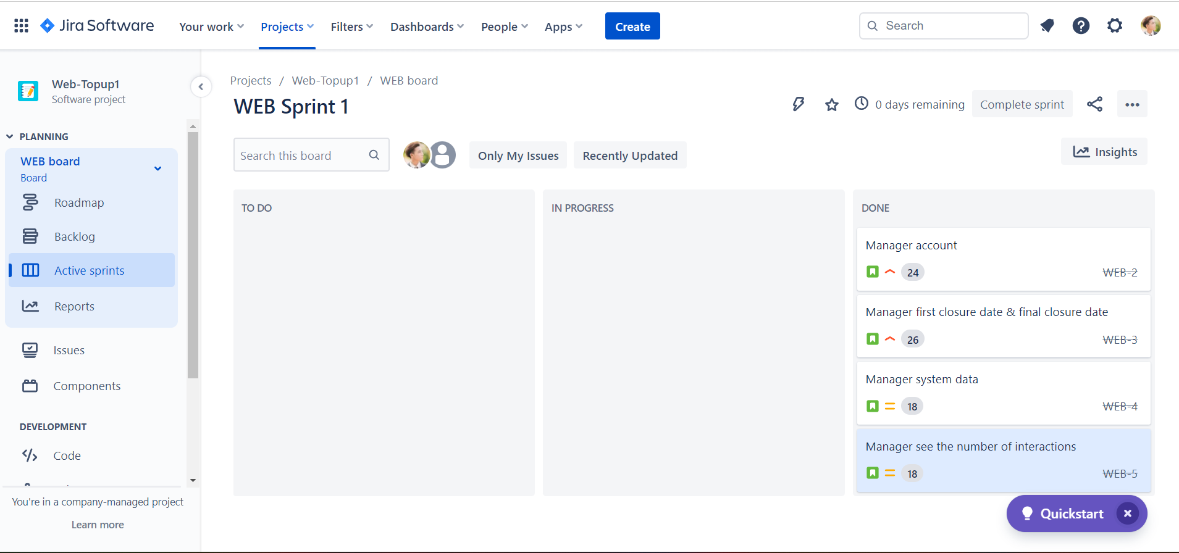

## Product backlog and User story

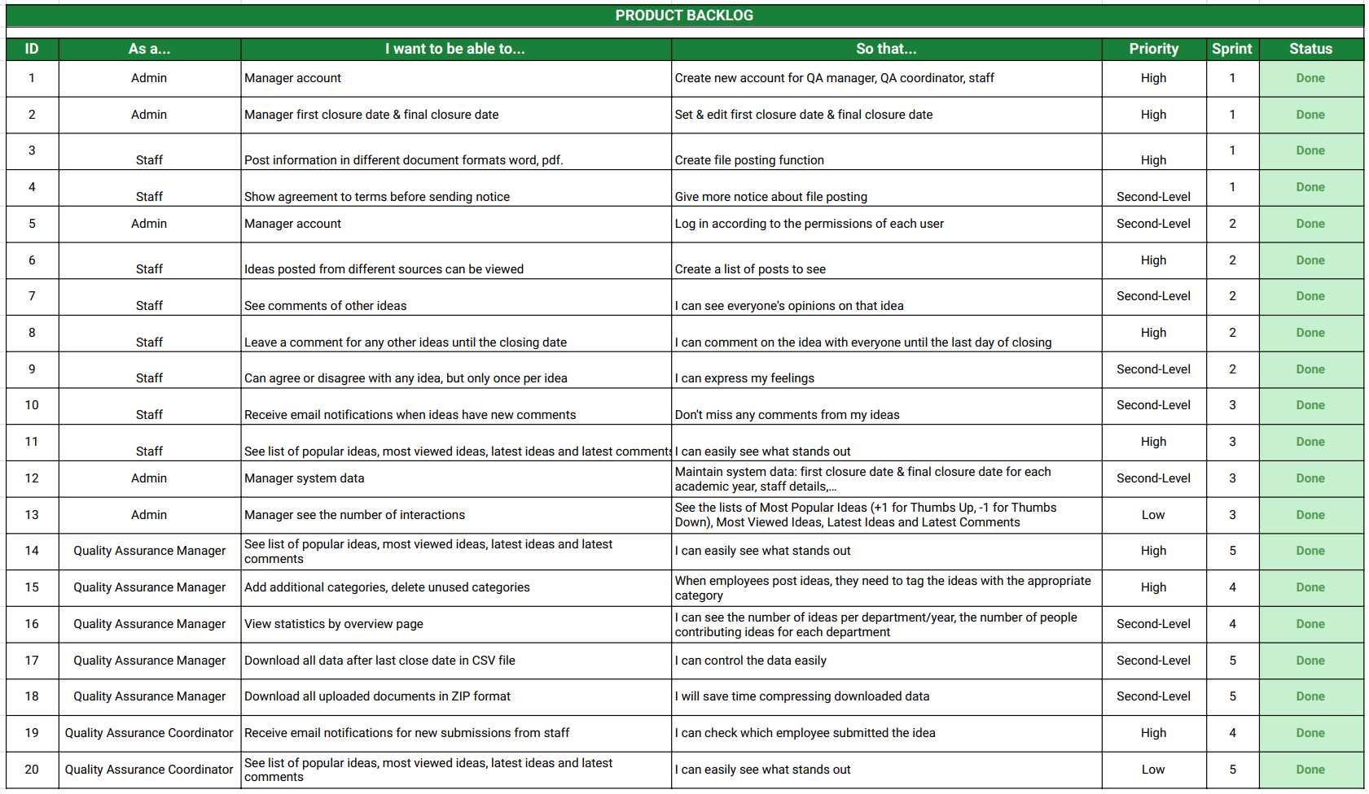

## Sprints backlog

### Sprint 1

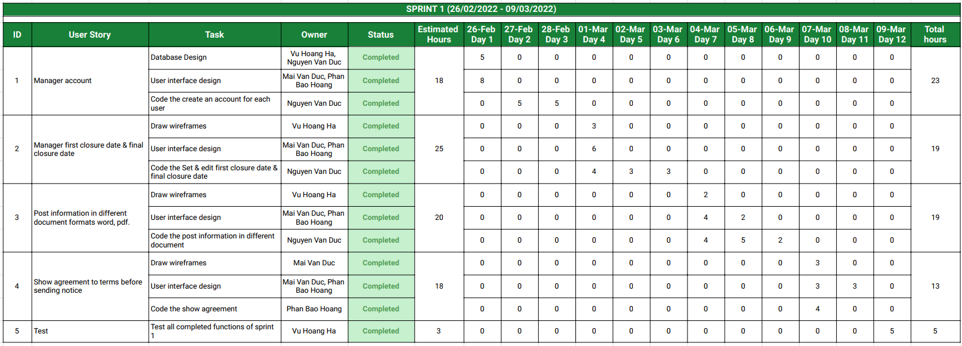

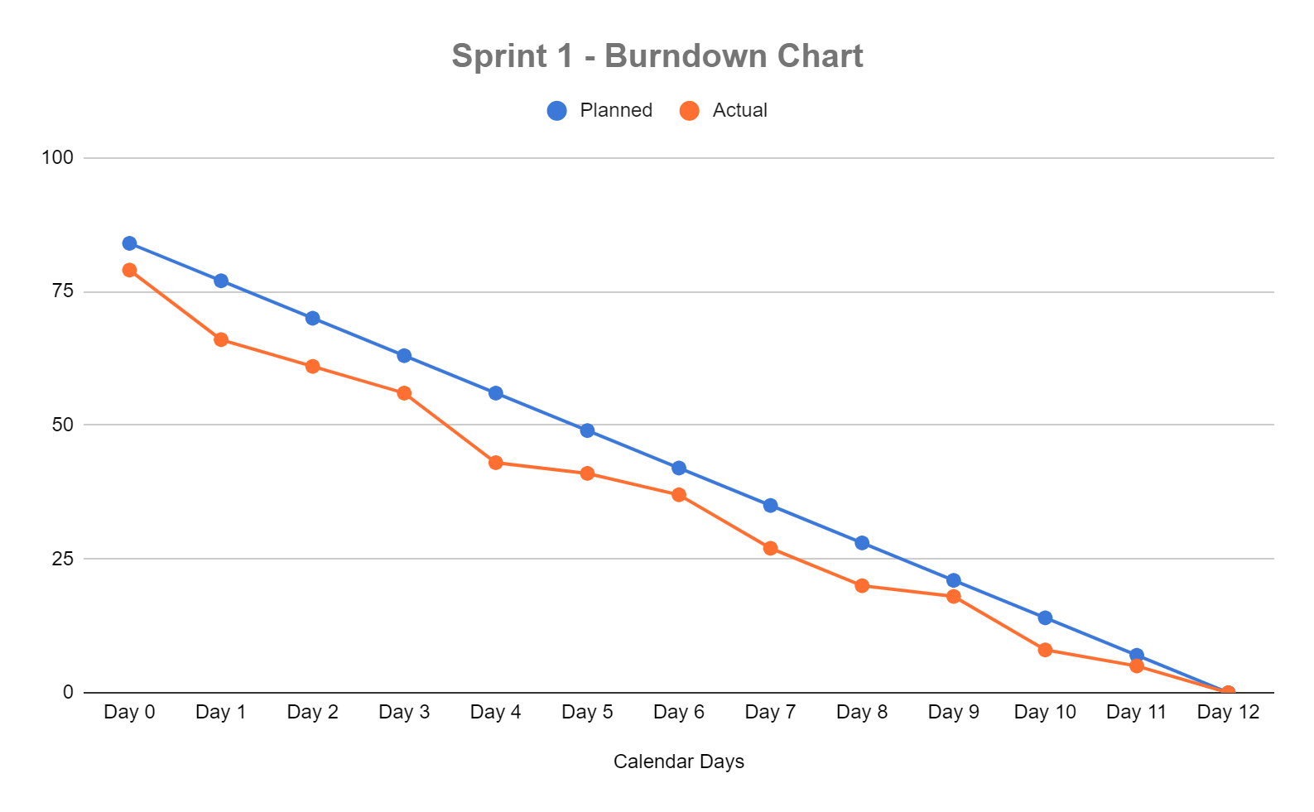

### Sprint 2

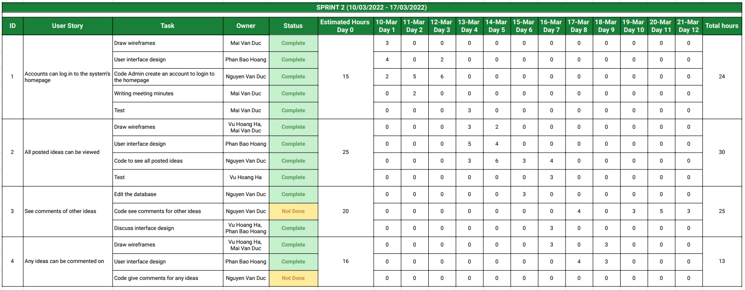

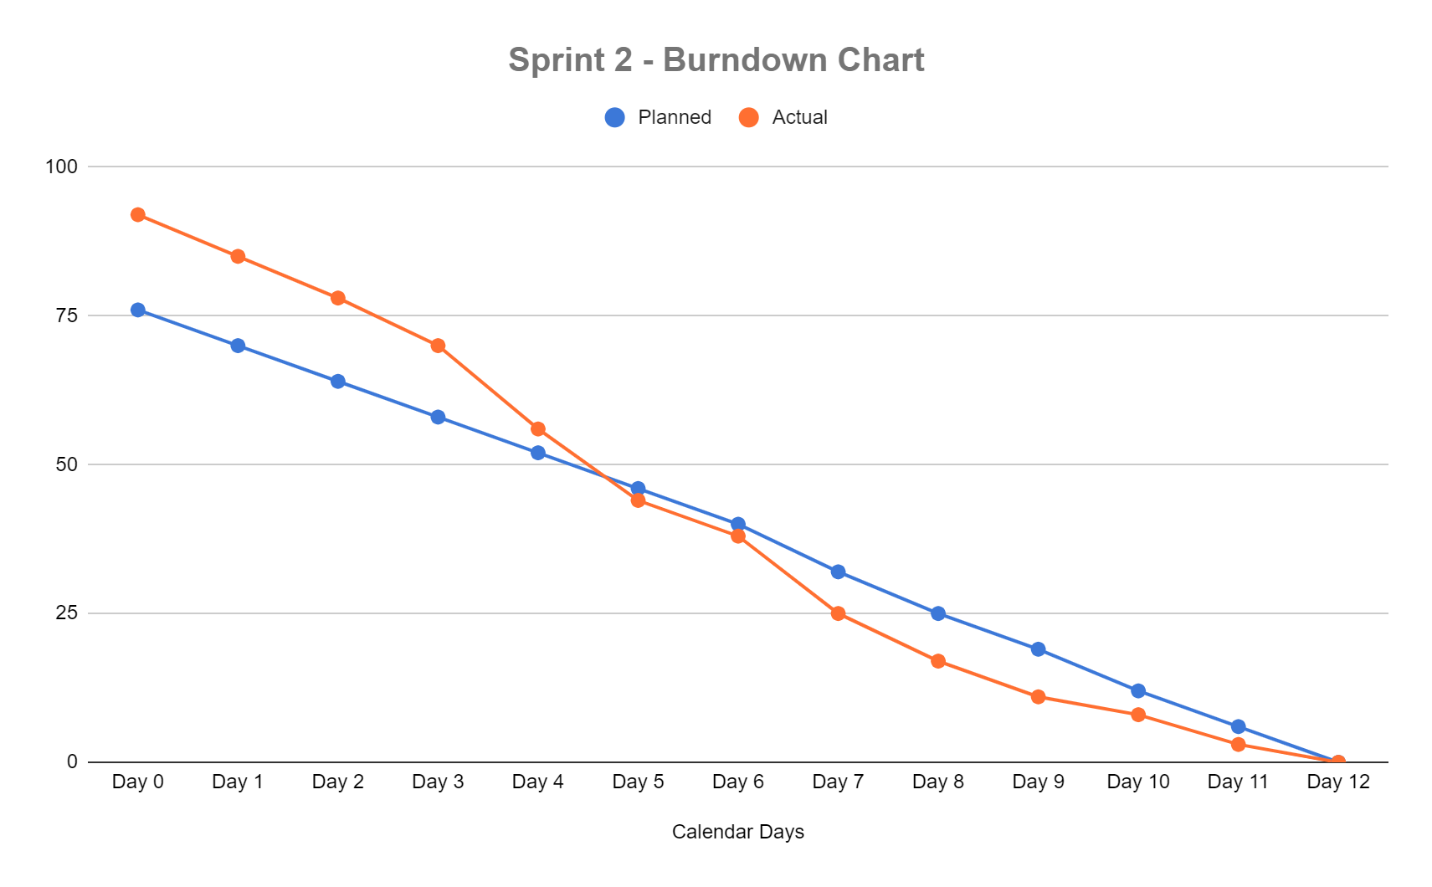

### Sprint 3

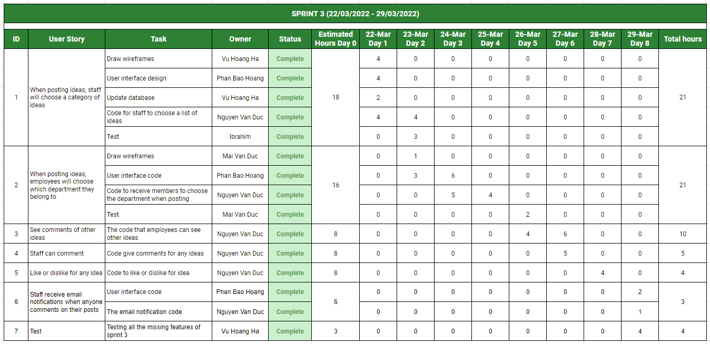

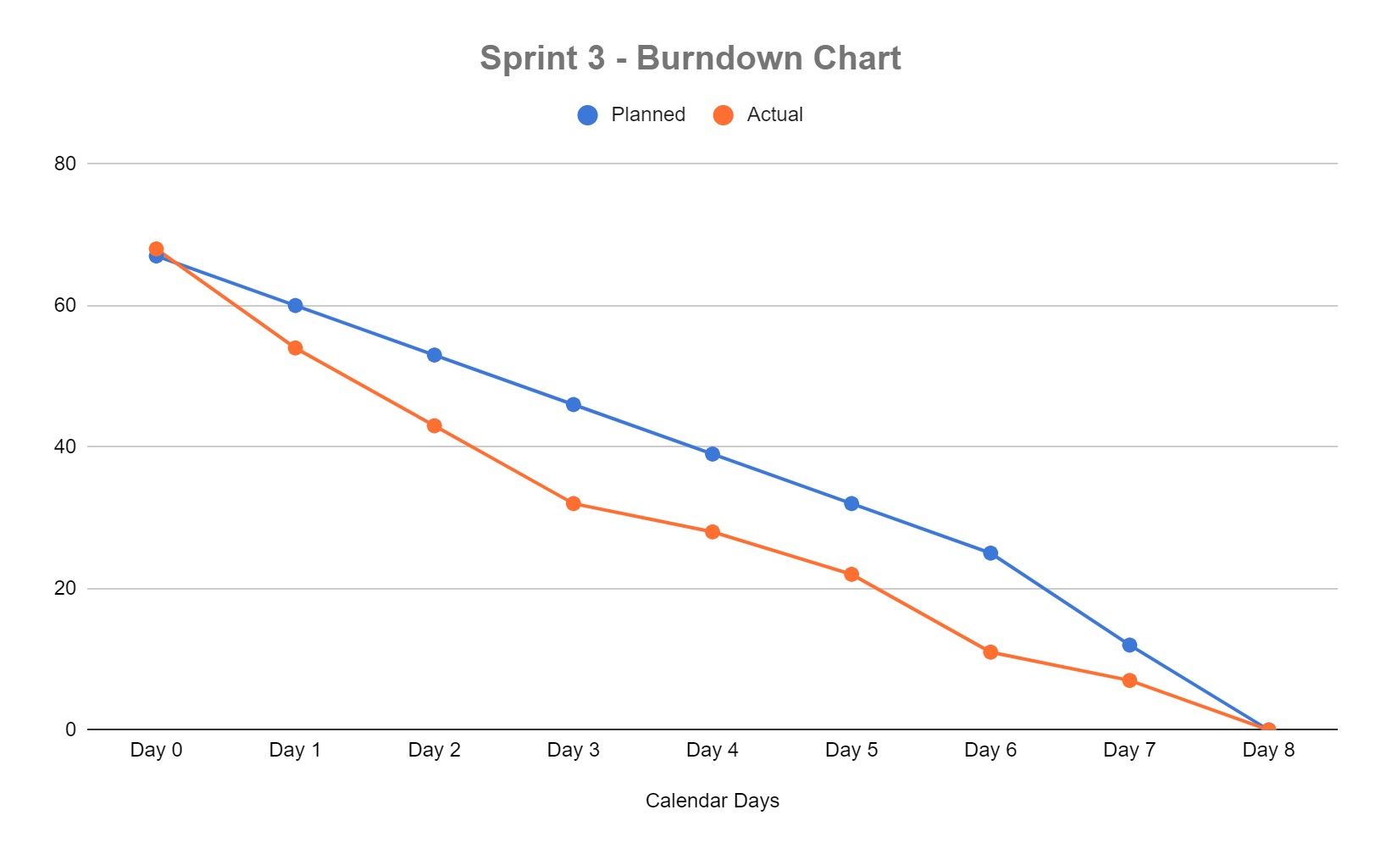

### Sprint 4

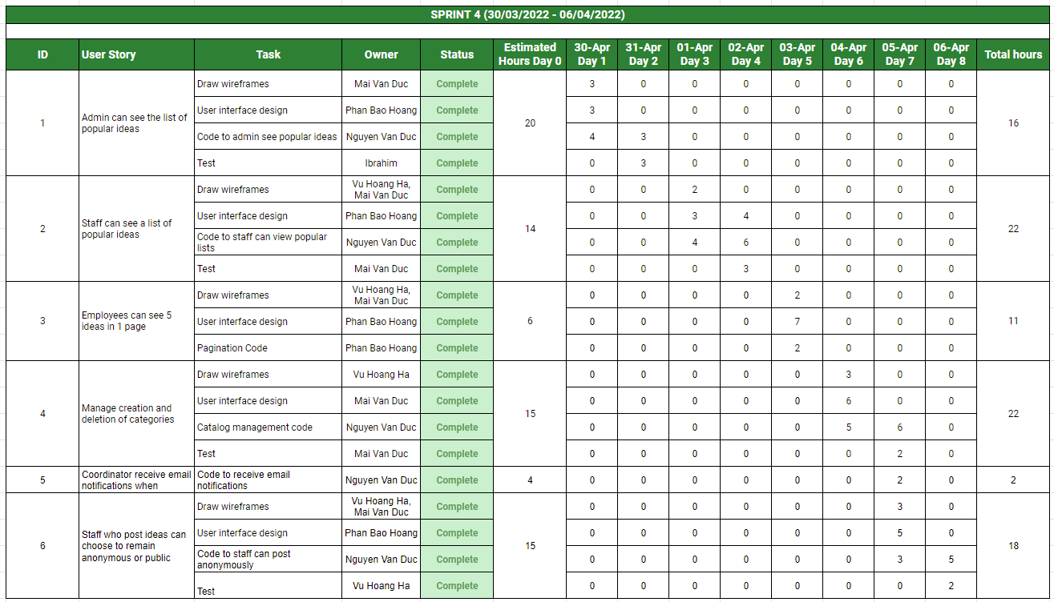

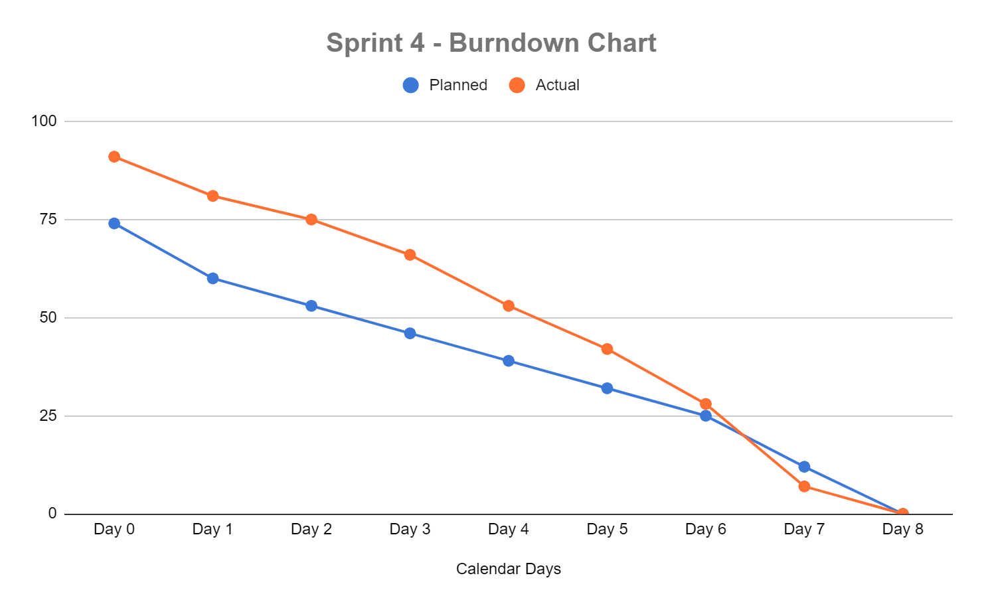

### Sprint 5

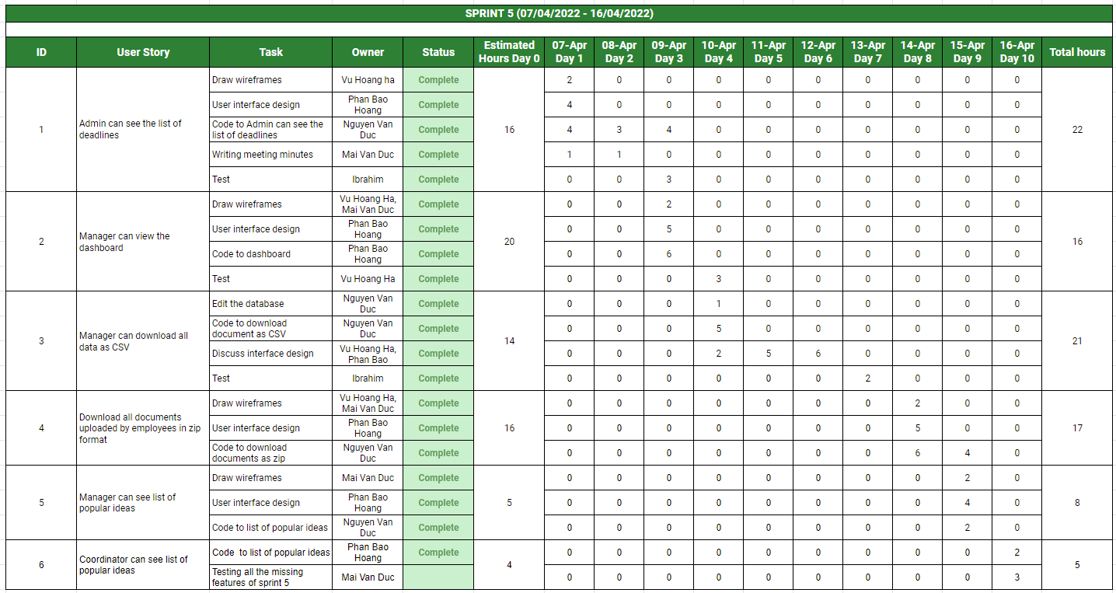

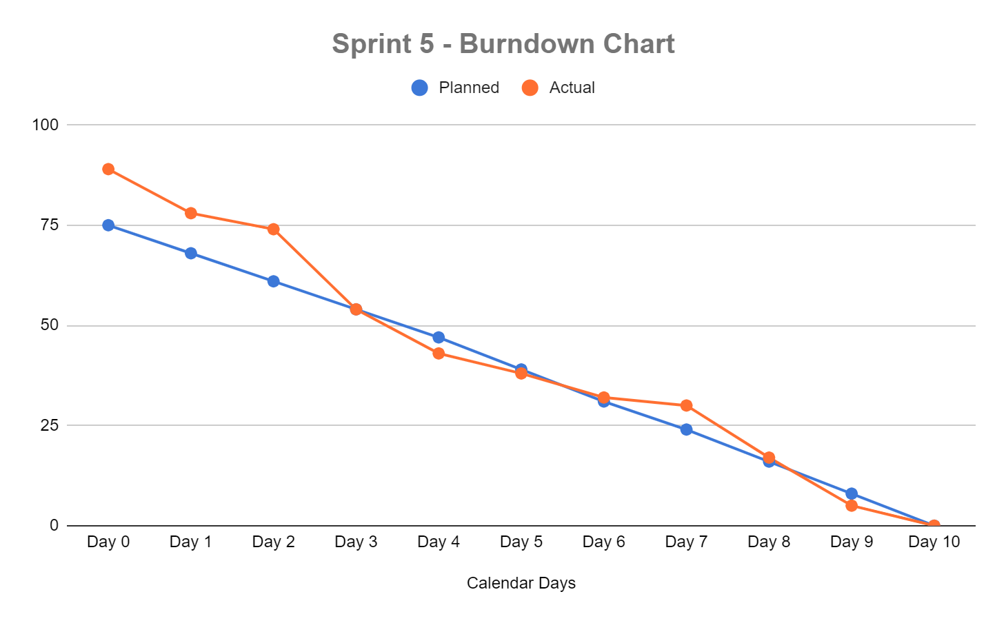

## Team challenges

**Difficulty in approaching agile model**

* When starting to implement the project with an agile model, team members had difficulty approaching this model, and reading and understanding sprints also happened to some team members when it was their first time using it.
* Solution: First the Scrum Master learns why team members have trouble reading and understanding sprints. After learning that the main reason was the use of sprint tables to divide the work, the members found it difficult to understand. Finally Scrum Master instructs every use of the agile model support tool is "Jira", this model is quite intuitive, which helped solve the problem.

**Slow progress due to lack of human resources**

* In the process of developing the project, backend developers are sick due to covid, the group is now quite lacking human resources
* Solution: The application of agile model helps the team change tasks easily, scrum master pushes interface design tasks to the top, features not related to the backend, the team will focus on doing first. After the backend developer returns to complete the features will be easier.

## Meeting minutes

### Meeting 1

|  |  |  |  |
| --- | --- | --- | --- |
| **Web Project Team Meeting** | | | |
| **MINUTES** | 2/23/2022 | 10am | Online: Google meet |
|  | | | |
| **MEETING CALLED BY** | Team | | |
| **ATTENDEES** | Vu Hoang Ha; Mai Van Duc; Nguyen Van Duc; Phan Bao Hoang; Usman Ibrahim | | |
| **ABSENTEES** |  | | |
| **MINUTES** | Vu Hoang Ha | | |
|  | | | |
| **Agenda topics** | | | |
| ***30 minutes*** | ***Discuss project*** | | |
| **DISCUSSION** | Discuss sprint backlog and technology | | |
| Changed sprint to speed up progress | | | |
| Discuss the backend and frontend technology | | | |
| Discuss the task again for the team members | | | |
| Update the presentations in the next session | | | |
| **CONCLUSIONS** |  | | |
| Discuss the work of each member of the group | | | |
| Select technology for the project:   * Front-end: ReactJS * Back-end: ASP.NET core | | | |

|  |  |
| --- | --- |
| **GENERAL NOTES** | Mobile details:   * Ha 0834220174 * N Duc 0337612806 * M Duc 0346358843 * Hoang 0868243907 * Ibrahim 0416 791 928 |

### Meeting 2

|  |  |  |  |
| --- | --- | --- | --- |
| **Web Project Team Meeting** | | | |
| **MINUTES** | 2/28/2022 | 10am | Online: google meet |
|  | | | |
| **MEETING CALLED BY** | Team | | |
| **ATTENDEES** | Vu Hoang Ha; Mai Van Duc; Nguyen Van Duc; Phan Bao Hoang | | |
| **ABSENTEES** | Usman Ibrahim | | |
| **MINUTES** | Mai Van Duc | | |
|  | | | |
| **Agenda topics** | | | |
| ***30 minutes*** | ***Discuss project*** | | |
| **DISCUSSION** | Discuss the small parts of the project | | |
| Discuss database | | | |
| Draw wireframe | | | |
| Code interface Admin’s page | | | |
| Code creates account user | | | |
| Write sprint backlog | | | |
| Write meeting minutes report | | | |
| **CONCLUSIONS** |  | | |
| Start design database | | | |
| Design wireframe | | | |
| Write sprint Backlog | | | |
| Write meeting report | | | |

### Meeting 3

|  |  |  |  |
| --- | --- | --- | --- |
| **Web Project Team Meeting** | | | |
| **MINUTES** | 3/5/2022 | 10am | Online: google meet |
|  | | | |
| **MEETING CALLED BY** | Team | | |
| **ATTENDEES** | Vu Hoang Ha; Mai Van Duc; Nguyen Van Duc; Phan Bao Hoang; Usman Ibrahim | | |
| **ABSENTEES** |  | | |
| **MINUTES** | Mai Van Duc | | |
|  | | | |
| **Agenda topics** | | | |
| ***30 minutes*** | ***Discuss project*** | | |
| **DISCUSSION** | Discuss the function of the system | | |
| Set deadline idea for staff | | | |
| Post idea in pdf, word format | | | |
| View home page and details staff | | | |
| Add roles user | | | |
| Edit burndown chart | | | |
| Draw more wireframe | | | |
| Code front-end like the wireframe | | | |
| **CONCLUSIONS** |  | | |
| Back-end code function project | | | |
| Design wireframe | | | |
| Front end code interface | | | |
| Edit burndown chart | | | |

### Meeting 4

|  |  |  |  |
| --- | --- | --- | --- |
| **Web Project Team Meeting** | | | |
| **MINUTES** | 3/12/2022 | 10am | Online: google meet |
|  | | | |
| **MEETING CALLED BY** | Team | | |
| **ATTENDEES** | Vu Hoang Ha, Mai Van Duc. Nguyen Van Duc, Phan Bao Hoang, Usman Ibrahim | | |
| **ABSENTEES** |  | | |
| **MINUTES** | Vu Hoang Ha | | |
|  | | | |
| **Agenda topics** | | | |
| ***30 minutes*** | ***Discuss project*** | | |
| **DISCUSSION** | Discuss the function of the system | | |
| Discuss the user’s role | | | |
| Comment with incognito status | | | |
| Delegating to employees | | | |
| Design interface comment | | | |
| Edit burndown chart | | | |
| Create API | | | |
| **CONCLUSIONS** |  | | |
| Design interface comment | | | |
| Edit burndown chart | | | |
| Delegating to employees | | | |

### Meeting 5

|  |  |  |  |
| --- | --- | --- | --- |
| **Web Project Team Meeting** | | | |
| **MINUTES** | 3/20/2022 | 10am | Online: google meet |
|  | | | |
| **MEETING CALLED BY** | Team | | |
| **ATTENDEES** | Vu Hoang Ha; Mai Van Duc; Nguyen Van Duc; Phan Bao Hoang | | |
| **ABSENTEES** | Usman Ibrahim | | |
| **MINUTES** | Vu Hoang Ha | | |
|  | | | |
| **Agenda topics** | | | |
| ***30 minutes*** | ***Discuss project*** | | |
| **DISCUSSION** | Discuss the function of the system | | |
| Design interface QA manager | | | |
| Code like, dislike, comment, upload idea | | | |
| Problem with backend | | | |
| Design interface comment | | | |
| Code front end like wireframe | | | |
| Front end gets some API | | | |
| **CONCLUSIONS** |  | | |
| Using API for front end | | | |
| Write meeting report | | | |
| Design interface download | | | |

### Meeting 6

|  |  |  |  |
| --- | --- | --- | --- |
| **PIIT Project Team Meeting** | | | |
| **MINUTES** | 3/26/2022 | 10am | Online: google meet |
|  | | | |
| **MEETING CALLED BY** | Team | | |
| **ATTENDEES** | Vu Hoang Ha, Mai Van Duc, Phan Bao Hoang, Usman Ibrahim | | |
| **ABSENTEES** | Nguyen Van Duc | | |
| **MINUTES** | Vu Hoang Ha | | |
|  | | | |
| **Agenda topics** | | | |
| ***30 minutes*** | ***Discuss project*** | |  |
| **DISCUSSION** | Discuss group report and Export API from backend for front-end to process | | |
| Write report group | | | |
| Back-end export API | | | |
| Front-end import API and use | | | |
| Discuss some function finish to draw use case | | | |
| **CONCLUSIONS** |  | | |
| Write report group | | | |
| Front end import API to use | | | |

### Meeting 7

|  |  |  |  |
| --- | --- | --- | --- |
| **PIIT Project Team Meeting** | | | |
| **MINUTES** | 04/12/2022 | 10am | Online: google meet |
|  | | | |
| **MEETING CALLED BY** | Team | | |
| **ATTENDEES** | Vu Hoang Ha, Mai Van Duc, Phan Bao Hoang, Usman Ibrahim | | |
| **ABSENTEES** | Nguyen Van Duc | | |
| **MINUTES** | Vu Hoang Ha | | |
|  | | | |
| **Agenda topics** | | | |
| ***30 minutes*** | ***Discuss project*** | |  |
| **DISCUSSION** | Discuss the remaining functions in sprint 5 | | |
| Reallocation of test plans | | | |
| Design the interface for mobile devices | | | |
| Summary of group reports | | | |
| Scrum master summarizes the remaining features | | | |
| **CONCLUSIONS** |  | | |
| Scrum master gives detailed test plan including test case, test log | | | |
| Phan Bao Hoang completes the remaining features | | | |

# Conclusion

Overall, this system has fully met the requirements that were originally set out. Through this project, our team learned a lot, from teamwork experience to developing a web system from start to finish, to applying agile model to project development. Meetings are held daily for team members to discuss. The tasks of each team member are allocated according to each sprint. When applying the agile model, our team can know the current progress of the project, thereby giving analysis and evaluation to break down the tasks, suitable for some of the games of each team member. After completing the functions, our team conducts a test plan with a variety of test cases, to ensure the quality of the system. Although during the development of the project encountered some risks of technological change and lack of human resources, thanks to the application of agile model, my team easily flexibly changed sprints to complete the progress. Our team found that, for a project that is not too large and has many changes or risks that come with it, the agile model would be the best choice when developing projects like this.

# References

Denning, D.E. and Denning, P.J., 1979. Data security. ACM Computing Surveys (CSUR), 11(3), pp.227-249.

Beeri, C., Bernstein, P.A. and Goodman, N., 1989. A sophisticate's introduction to database normalization theory. In Readings in artificial intelligence and databases (pp. 468-479). Morgan Kaufmann.